

A Study on the Evolution and Future of the Hotel Industry: Innovation, AI, and the Rise of Smart Hospitality

Student name: - Ankit Tomar

Student ID: - DE240059

Submission Date: - 11 April 2025
Table of Contents
1. Introduction 3
1.1 Background of the research 3
1.2 Objective of the research 3
1.3 Scope of the research 4
2. Main body 4
2.1 Historical Evolution of the Hotel Industry 4
2.2 Technology and Digital Transformation in Hospitality 5
2.3 The Disruptive Impact of Airbnb and the Sharing Economy 8
2.4 Emerging Trends Shaping the Future of the Hotel Industry 10
2.5 Strategic Implications and Industry Adaptation 12
3. Conclusion 14
References 16
Appendix 19

1. Introduction

1.1 Background of the research
The hotel industry, which remains one of the oldest and most vibrant segments of the global economic market, has changed over the centuries (Ruel & Njoku, 2020). Drawing its roots from the historical past as both an inn and wayside rest, has gradually developed into the contemporary complex, high-tech accommodations with customized services. This transformation has been done as a result of altering customer needs, development in technology, and globalization. The hotel industry is one of the crucial segments of the tourism and hospitality market that has a huge impact on employment, gross domestic product, and cultural interchange at the global level. The industry has been very dynamic in the last few decades, mainly due to the truncation impacts of digital innovation. The development of Internet-based channels for booking, portable property management, and work-related technological advancements have greatly transformed the operations of such companies and their interactions with clients (Zahidi et al., 2024).
The experience tourism has become another emerging phenomenon that moves the emphasis from service provision to the actual tourist experiences (Ruel & Njoku, 2020). These have transformed the business models and also led to increased competition through changes such as Airbnb, capsule hotels, among others. The world is in the process of the Fourth Industrial Revolution. Technologies like AI, IoT, and Big Data are becoming vital for the development of hospitality in the future. The hotels are no longer going forward to AI-based concierge services, voice-activated Smart Rooms, Facial recognition-enabled devices for quick entry, and other analytics for forecasted customization. These could be looked at in terms of improving the functionality, productivity, or convenience for the user and the guest. They also bring some difficulties that raise issues of privacy, security, issues to staff displacement, and problems of digital infrastructure (Zahidi et al., 2024).

1.2 Objective of the research
1. To discuss the timeline and evolution of the hotel industry of the world and recognize several significant changes and developments that took place in the process of its progress from early prototype to more complex forms of hospitality services.
2. To assess the advanced technologies and shifting customer choices as concerning the future pertinence of the hotel industry: the role of Artificial Intelligence, Smart Hotels, and innovative accommodation types.

1.3 Scope of the research
The purpose of this report is to outline the history of the hotel industry development up to the present day and determine the main milestones in it (Ruel & Njoku, 2020). It will then proceed to look into change, with the technological focus being on how artificial intelligence and smart rooms are affecting the field. It will assess new developments like the personalization of the services, automation, and the shifts in the model of accommodation. This report aims to focus on the analysis of the development of the given sector and the evaluation of the historical development of the industry, its key characteristics, and indicators.
The report includes a brief history of the hotel industry, changes manifested in the global hotel industry, and a presentation of hotel industry transformation supported by examples of different cases. This paper will use a strategic and operational perspective to determine how digital transformation influences the hospitality industry and how hotels are reacting to this change. It will then describe changes in consumer behaviour, in the delivery of services, and in the competitive trends that the report will capture. It is intended to provide significant recommendations about issues concerning hotel executives, investors, or policy makers, who have to work in a changing and increasingly competitive environment (Zahidi et al., 2024).

2. Main body

2.1 Historical Evolution of the Hotel Industry
Origins of Hospitality
The explication of hospitality has its origin in the history of civilization. Mesopotamia, Egypt, and Greece began as agrarian and peripatetic cultures, and it is traditional to offer the traveller food and shelter (Nam et al., 2020). Inns and shrines provided accommodation to travellers, business people included. In ancient Rome, the first cauponae and mansions enjoyed a similar lifestyle and gave shelter to travellers through the empire’s roads connecting cauponae or taverns (Leung, 2020).
Medieval and Renaissance Periods
Monasteries offered courtesy in the medieval age in Europe. Inns that started opening along the routes provided food, lodging, and shelter for animals and other related services (Nam et al., 2020). Renaissance brought ideas of commerce and culture, so there were many secular inns and lodgings established in Europe. These were simple, basic but comfortable establishments that were meant for the merchants and middle-class travellers (Leung, 2020).
Industrial Revolution and the Birth of Modern Hotels
The 18th and 19th centuries witnessed more changes with the advent of the Industrial Revolution (Nam et al., 2020). Late nineteenth-century transportation networks, such as the railways and steamships, made the journey long-distance possible. Splendid examples of grand hotels for the upwardly mobile travellers are the Savoy in London and Hotel Sacher in Vienna. Local hotels and other such establishments started providing amenities like elevators, electric lighting, individual baths, and room service, which were real improvements in luxury (Leung, 2020).
Rise of Hotel Chains in the 20th Century
In the 20th century that commercial international hotel brands like Hilton, InterContinental, and Marriott were established (Chen et al., 2021). They established standardization in the service and the type of rooms that any hotel provided across the world. It was possible to open new units through franchising, and other ventures were started to encourage customers to return for more business (Aggarwal & Mittal, 2024).
Globalization and Diversification
After the war, there was an era of economic reconstruction and liberalization that contributed to the development of more industries. Airline companies established a common venture with the hotel companies, and airport hotels gained importance (Chen et al., 2021). To cater to business people, tourists, and long-term residents in the same facility, hospitality brands started to innovate their services. New concepts came into play in the shinning and the end of a tithe structure of cardiac approaches in the early nineteen nineties, such as boutique and lifestyle hotels for tourists, that targeted designing and culture and outstanding experiences (Aggarwal & Mittal, 2024).

2.2 Technology and Digital Transformation in Hospitality
Evolution of Booking Systems
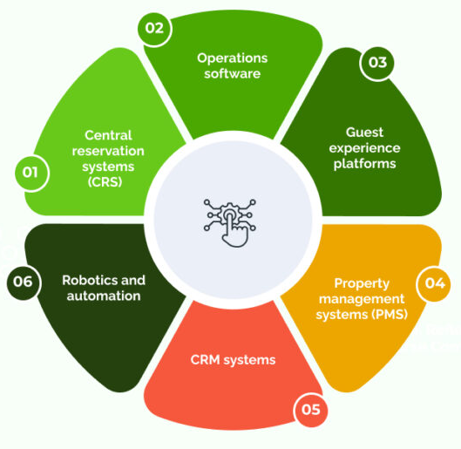
Figure.1: Digital Transformation in Hospitality
Source: (Aggarwal & Mittal, 2024)
The advance in the population of bookings saw the operations in the hospitality industry change from manual handling to computer-based systems (Chen et al., 2021). CRS led to a capability to track inventories in real-time and also advance guests’ management. The OTAs like the Booking.com and Expedia subsequently became major players in selling hotel accommodations to consumers that got access to price comparisons, photos, and reviews (Law et al., 2021). Indeed, these platforms extended market access; they raised the commission fees and competition. Hotels have counteracted this by adopting direct bookings, implementing loyalty programs, and improving metasearch management to recover consumers’ relations and lessen reliance on third parties (Aggarwal & Mittal, 2024).
Property Management and Automation
Internet-based Property Management Systems (PMS) have emerged as the arteries of hotel operations (Law et al., 2021). Some interfaces include check-in/check-out, billing, housekeeping management, and guest preference solutions through systems like Oracle OPERA and Room Raccoon. Automation reduces the workload and error-prone steps that criticize the human hand in numerous processes. Other tools, such as the Channel Managers, also enhance efficiency by managing room availability, and the rates are also consistent across the OTAs and direct booking channels. They benefit the staff and the guests in a manner that results in higher levels of efficiency due to increased speed of service delivery. Real-time data is used to assist decisions and increase revenue (Kong et al., 2022).
Mobile and Contactless Guest Services
It accelerated the usage of Mobile and contactless technologies in hospitality to the next level. They demand more mobile check-ins, keyless entry, and in-app service orders (Law et al., 2021). Hyatt, Marriott, and CitizenM are some of the hotel chains that have made changes to their offering and incorporate a digital concierge via a mobile application. This leads to a reduction in waiting time, provides privacy and security to the individuals in the health service system (Marriott, 2024). Other technological solutions are QR-coded menus, voice control of elevators, and contactless payment. Some of these apply the principles of health consciousness to travellers, and others increase operational flexibility at the same time. They also create customer service possibilities based on guest application connections and information (Kong et al., 2022).
AI and Machine Learning
AI and machine learning have become the trends that significantly influence hotels’ communication with guests or internal processes (Law et al., 2021). They are designed to deal with basic customer inquiries, taking the pressure off employees to deal with them. Sentiment analysis tools help to analyse the reviews of the guests to have recommendations on introducing the necessary changes for the better. Some of the practical applications of machine learning include predicting the demand, competitor prices, and booking patterns to determine the best price to charge the customers (Marriott, 2024). “Connie,” developed by Hilton and IBM, Watson’s AI concierge, is potentially helpful in providing answers and directions for the guests. These facilitate guest satisfaction, productivity, and efficient decision-making in real-time technologies (Kong et al., 2022).
Smart Rooms and IoT Integration
A smart hotel room incorporating IoT technology would provide guests with the ability to regulate the environments in the hotel rooms as they wish (Arapou & Kapiki, 2023). Smartphones or voice commands enable the guest to have control over lights, temperature, blinds, and sound systems. Some of them include Marriott’s IoT Guestroom Lab and YOTEL and the technologies that it incorporates, including smart TVs, occupancy sensors, and efficient climatic control systems. These innovations go with the convenience as they play a great role in reducing wastage of energy (Marriott, 2024). It is also possible with IoT-enabled rooms to detect necessary maintenance and respond quickly, which will increase the satisfaction of the guests. As guest demands increase, smart rooms are becoming a necessity for the companies that want to be leaders in the hotel industry (Essien & Chukwukelu, 2022).

2.3 The Disruptive Impact of Airbnb and the Sharing Economy
Introduction to Airbnb
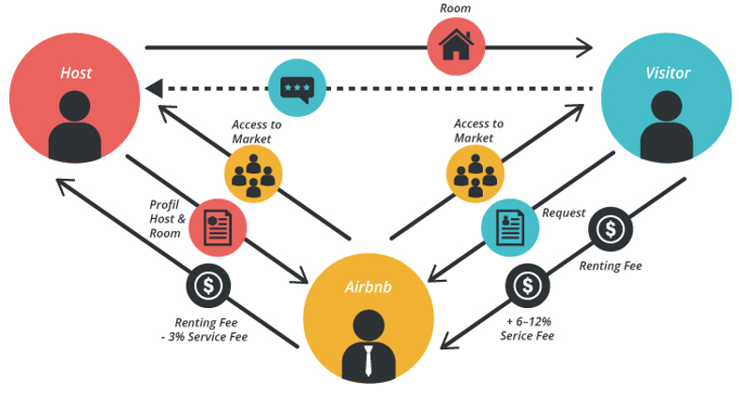
Figure.2: Impact of Airbnb and the Sharing Economy
Source: (Arapou & Kapiki, 2023)
Airbnb is one of the most innovative entrants in the hospitality industries that was launched in 2008 and provided a platform to rent rooms on a peer-to-peer basis (Arapou & Kapiki, 2023). Airbnb does not own property; and it is an online marketplace where hosts can list their properties across the world in more than 190 different countries (Airbnb, 2024). This type of tourism has been popular due to its low cost, versatility, and ‘real life’ experiences of the specific destination. Airbnb is a bookings platform for accommodations that differ from typical hotel stays or renting various types of homes, from apartments and villas to treehouses and houseboats, for various purposes. It is disintermediating traditional hotel business models and using Technology, Generated Content, and trust-based markets to build the community and facilitate technology-controlled and managed guest experience (Essien & Chukwukelu, 2022).
Competitive Pressure on Traditional Hotels
Airbnb has expanded rapidly and is posing a threat to hotels that directly affect the budget and mid-scale accommodation facilities (Arapou & Kapiki, 2023). Airbnb hosts usually have relatively low overhead costs, enabling them to offer greatly competitive prices by providing more home-like accommodations. The hotel chains have adopted various measures to improve guest experience, upgrade their facilities, and venture into the short-term rental business. This is seen by Marriott’s introduction of “Homes & Villas”, where established hotels are trying to change consumer behaviour where they are moving away from basic, homogenized lodging experiences (Marriott, 2024). The hotels have also started emphasizing differentiation, innovative digital, and localized experience as a way to combat Airbnb’s more fluid and experience-based business model (Essien & Chukwukelu, 2022).
Regulation and Community Backlash
Short-term platforms such as Airbnb have grown greatly and have raised concerns from various regulators in large cities globally (Gajić et al., 2024). New York, Barcelona, and Berlin have had to outlaw or strictly regulate short-term lets to address the concerns of density and affordability. Opponents state that this company adds to housing scarcity and, as a result, raises rental prices and prescribes a fragmented social structure (Airbnb, 2024). Several challenges have arisen, and Airbnb has been forced to deal with matters such as zoning laws, licensing, and taxes. It has also enhanced the company’s transparency by sharing some data with the municipalities and enforcing host registration. These regulations pose a test between the need to promote the tourism industry and the welfare of the people (Chen, Tzeng, et al., 2021).
Resilience During the Pandemic
Airbnb was rather responsive during the COVID-19 pandemic as the company changed its approach while responding to new consumer tendencies. Due to COVID-19, travel was restricted mainly to urban areas, so Airbnb started promoting its homes aimed at long-term staying and workation, countryside properties (Gajić et al., 2024). It leveraged the “work from anywhere” model and focused on attracting the niche audience of digital nomads and families looking for safe environments (Airbnb, 2024). It also uses ‘the Enhanced Clean’ protocol of the Marriott brand to ensure that the guests have confidence in their safety and hygiene when they are in the hotel. This case shows that Airbnb’s ability to quickly adapt and focus more on its clients was possible due to a robust business model that made it harder hit than traditional chains (Chen, Tzeng, et al., 2021).
Lessons for the Hotel Industry
The experience of Airbnb is especially useful for the traditional hotel industry. Even though its business model is based on the idea of personalization, digital simplicity, and engaging interaction with the community of travellers, it has changed their expectations significantly (Gajić et al., 2024). Hotels are redesigning their business paradigms that currently emphasise technology-centric guest experiences, a flexible approach to check-ins and outs, and flexible hard product types (Airbnb, 2024). The concept of hosts and guests has shown the strong word-of-mouth factor and important ease of use of mobile applications and hosts responsibility. For hotels to stand a chance in the current world market, they need to incorporate innovation, localization and value addition, and product differentiation (Chen, Tzeng, et al., 2021).

2.4 Emerging Trends Shaping the Future of the Hotel Industry
Hyper-Personalization and Experiential Travel
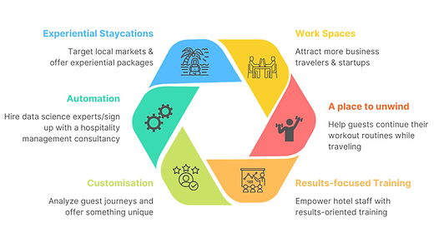
Figure.3: Trends Shaping the Future of the Hotel Industry
Source: (Buhalis et al., 2022).
The traveler is no longer content with obtaining simple services; they wants unique, appealing, culturally sensitive services corresponding to the traveler’s individuality, passion, and norms (Kim & Han, 2022). Hotel chains are embracing Customer Relationship Management (CRM) and ordered data in customer loyalty to tailor guest experience at a new level. This is about selected room categories, meals and drinks, and other exclusive activities that stem from city guide, culinary and art lessons, among others (Buhalis etal, 2022). Some of the brands include Marriott’s The Luxury Collection, and Hyatt’s Unbound Collection that personalize guests’ experience at every possible opportunity, from pre-arrival surveys to the menus for pillows. The Hoxton Hotels are luxury hotels that employ local associations for tourists and residents inclusive of local sight seeing tour and local entertainment peculiar to the place.
Automation and Robotics
Technologization influences the hospitality industry to improve the functionality of the industry and the way for guests (Kim & Han, 2022). There are constantly rising tendencies to automate services that were previously performed by personnel, such as smart concierge services, robotic check-in kiosk, and other AI-based technologies. A relevant case is Hilton’s ‘Connie’ that is the first robot concierge with IBM Watson technology that welcome guests to the hotel and assist them with relevant information regarding accommodation and other tourist attractions within the region in real-time (Buhalis et al ., 2022). These hotels employs facial recognition, scanning check-in stations, and utilize artificial intelligence in regulating the climate in the capsule, reducing contact with people. Airbnb hosts also use some technologies of automation including smart may be used to manage the guest; there are an intelligent conversation bot or an automatic check in out system (D’Souza & D’Souza, 2023).
Wellness and Sustainability
Many hospitality organizations consider sustainability important for themselves due to the increasing guest concern and the global environmental targets. LEED, BREEAM, and EarthCheck are some of the labels utilized in accrediting hotel prowess in the key tenets of sustainability such as energy efficiency, water usage, and waste management . Capsules, because of their size, require less resources, and energy efficient (Kim & Han, 2022). They adopt services like energy-efficient lighting with LEDs, efficient control of building temperature, and mostly adopting minimal building materials that reflect eco-tourism. Airbnb hosts do not own or operate any properties themselves but have a policy of encouraging hosts to engage in environmentally friendly measures such as use of solar energy, provision of recycling, and local carbon footprint experiences. Airbnb also released a Sustainability Report explaining the hosts and guests’ home-sharing experience has turned out to be less environmentally deprecatory than that of hotels (D’Souza & D’Souza, 2023).
Work-from-Hotel and Hybrid Stays
The prevalence of bringing work and leisure closer together, the two phenomena of ‘bleisure’ and remote work, emerged (Nannelli et al., 2023). Hotels are coming up with library-like co-working zones, efficient connectivity, comfortable sitting facilities with excellent internet connection, and special package prices for long-term clients. CitizenM, Selina, and, most recently this year, Zoku hotel brand themselves as targeting the modern nomadic suspicion of digital nomads and other travellers in between traditional categories (Buhalis et al., 2022). These help in increasing the average length of time clients spend in the facility and improve the midweek demand. Some of them also have wellness or local amenities in addition to business-related services and facilities, preparing for those guests that increasingly seek both business and personal development when travelling (Cao et al., 2022).
Social Media and Influencer Marketing
The mobile has emerged as an important marketing tool in the branding of hotels and acquiring customers (Nannelli et al., 2023). Eye-catching interiors, themed venues, and spaces that are perfect for photo and video are important elements to promote sharing. Accommodation organisations today employ travel influencers and lifestyle bloggers to help reach potential customers across the world. The nomadic population is mainly associated with micro-influencers because they provide authentic coverage of niche markets. Two of the most popular sources for inspiration are Instagram and TikTok, while YouTube influences the final decision-making process (Bilgihan & Ricci, 2023). It is a mix of storytelling with beauty by the use of hashtags, reels, and influencer takeovers that fuels the conversations to increase direct bookings and the hotel brand's presence online (Cao et al., 2022).

2.5 Strategic Implications and Industry Adaptation
Rethinking Business Models
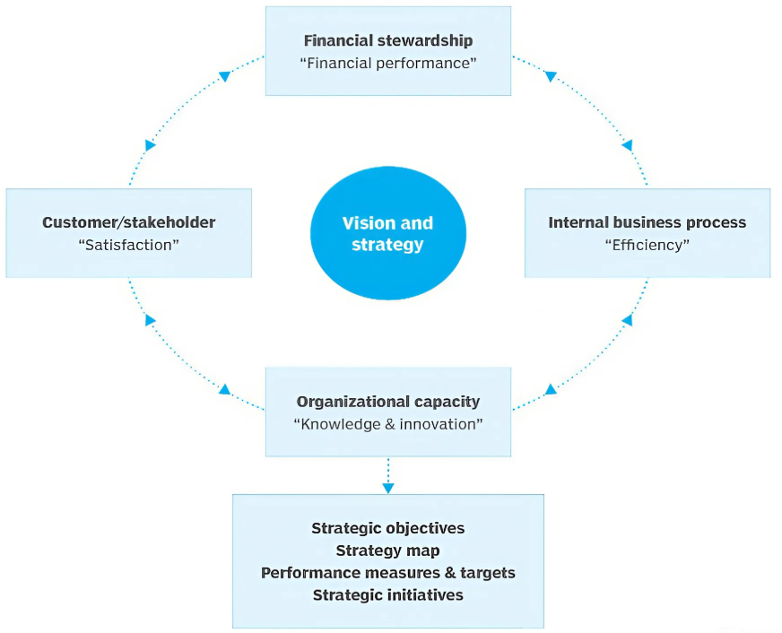
Figure.4: Strategic Implications
Source: (Cao et al., 2022)
To sustain themselves in the extended competition, the hotels are in the process of reinventing their business models (Nannelli et al., 2023). Some are avoiding vertical integration that earlier provided privileged access to consumers and customers to cut on costs and be more adaptable. This has led to the formation of partnerships between hotels and local businesses and experience sellers as it provides additional services such as culinary lessons, safari, and arts and crafts, among others (Bilgihan & Ricci, 2023). These communicational offerings apply to guests that require a more liberating way of experiencing culture. There are diversifying revenue sources by offering clothing with a hotel’s logo, subscribing services, and co-working spaces to interact with customers more than selling rooms (Cao et al., 2022).
Embracing Innovation and Agility
This means that flexibility and creativity have finally become parts of the strategic plan of a hotel (Lee et al., 2024). The agile management is very useful as it allows for a quicker adaptation the changes in the market and consumers’ expectations, and it is especially efficient when it comes to global crises such as the COVID-19 pandemic. To provide flexibility, hotels are adopting immediate analytics, mobility, and modularity of services. For example, dynamic rate-setting tools are those that change rates depending on the demand, and AI used in forecasting optimizes stocks (Bilgihan & Ricci, 2023). Cross-functional teams and design thinking are some of the key approaches used in service innovations. In the current environment, it is possible to constantly introduce new technologies, service delivery, and guest experience ideas in a small scope while gaining crucial valuable experience and insights, allowing hotels to be a step ahead of opponents (Narayan et al., 2022).
Workforce Development and Training
It can be stated that today, the human factor plays an important role in the sphere of hospitality. Hotels must ensure that they develop their workforce regarding changes that the industry may require in their operations (Lee et al., 2024). The current training programmes focus on computer and internet competency, interpersonal skills, multicultural awareness, and interpersonal communication. The staff has to manage himself/herself to be effective in using the related technology and providing customer-oriented and sensitive services (Kim et al., 2024). Training and education programs and opportunities for internal promotion could be useful to improve the staff turnover situation and get the employees ready for the higher ranks. Training through copying, use of virtual simulations, or training through artificial intelligent platforms will prepare and enable staff to work in intelligent environments in hospitality enterprises (Narayan et al., 2022).
Risk Management and Crisis Resilience
The hotel industry is surrounded by several risks that can hinder its operation, such as political instabilities, epidemic outbreaks, natural disasters, cyber threats, or economic decline (Lee et al., 2024). Risk management strategies entail the identification of viable and sustainable solutions to handle all forms of risks in helping organizations survive in the long run. Hotels have to create contingencies, create crisis management communication plans, and maintain supplier relationships (Kim et al., 2024). Focusing on cybersecurity and data management is becoming more important as the utilization of electronic equipment expands. Management strategy tools assist in the early identification of such changes and intervention to prevent or limit the impact of change. Ensuring that insurance and business flexibility, such as offering various policies, are in place may guarantee that hotels can bounce back and be financially sound after any crisis (Narayan et al., 2022).
Strategic Balance: Global Consistency vs. Local Relevance
It attempts to establish that hotel brands can overcome global branding while staying localized. Local servicing gives a global chain the advantage of having standardized processes for operation and service delivery, mass markets mean customized products for every culture (Kim et al., 2024). Enabling the local managers to customize the services like, including regional food, decor, and etiquette, will bring originality and guest engagement. Promoting local employees’ hiring is a win-win solution for the development of the local population and a better understanding of cultural differences between people (Buhalis et al., 2022). The experiences from Accor and Hyatt have made a revelation that localization of experience policies for the guests provides loyalty to the brand without compromising the general brand image, satisfaction, and global brand association (Bilgihan & Ricci, 2023).

3. Conclusion
The evolution of hotels has evolved drastically, for it was initially a simple inn and guest house to the modern complex tourist industry. It has evolved to depict the overall social, economic, technological, and cultural changes that define tourism around the globe. Standardization, internationalization, and large chain hotel companies emerged in the twentieth century, while digitalization, high customer demands, and new business models of hospitality like Airbnb were experienced in the twenty-first century. This paper has discussed various cycles in the growth of the hotel industry and the shift towards digitalization, which includes aspects such as AI, smart rooms, and cloud have revolutionized guests’ experience and how operations in the hotels are done. This is where the use of personalisation, automation, and a delightful blend of physical and virtual aspects of the service are apparent. New forms of travellers or traveling, amorphous work-travel personas, and the notion of wellness and sustainability have put new trends in the hospitality industry on the map.
Airbnb and the overall concept of the sharing economy have influenced the hotel industry to adopt the new strategy of flexibility, focusing on guests and experience. It is exposed to new risks, for example, data protection, changes with its employees, increased regulatory issues, or sustainable responsibilities. Prudent hospitality organizations have to renew them strategically, embrace agility, and develop antifragility so that they may be prepared for the instability in the global marketplaces. Since it will be a global organization, care will have to be taken to ensure this while maintaining cultural sensitivity, staff development, and the wise use of technology to augment human interactions will be important considerations. The hotel industry’s future depends on progression in technology and management of these technologies and keeping the focus on the capacity to deliver unique, memorable, and culturally enhanced services to the guests. The fluidity of the industry and its ability to design and deliver meaningful work will be the keys to success in a world characterized by constant change.

References
Aggarwal, S., & Mittal, A. (2024). Futuristic hospitality conceptualized: DASH - Decentralized Autonomous and Smart Hotel system. Journal of Open Innovation: Technology, Market, and Complexity, 10(1), 100223–100223. https://doi.org/10.1016/j.joitmc.2024.100223
Airbnb. (2024). Airbnb: Holiday Rentals, Cabins, Beach Houses, Unique Homes & Experiences. Airbnb; www.airbnb.co.in. https://www.airbnb.co.in/
Arapou, D., & Kapiki, S. (2023, September). Enhancing the Guest Experience in Hospitality Through Technology: An Outlook of the Future. Ssrn.com. https://papers.ssrn.com/sol3/papers.cfm?abstract_id=4660192
Bilgihan, A., & Ricci, P. (2023). The new era of hotel marketing: integrating cutting-edge technologies with core marketing principles. Journal of Hospitality and Tourism Technology, 15(1). https://doi.org/10.1108/jhtt-04-2023-0095
Buhalis, D., O’Connor, P., & Leung, R. (2022). Smart hospitality: from smart cities and smart tourism towards agile business ecosystems in networked destinations. International Journal of Contemporary Hospitality Management, 35(1). https://doi.org/10.1108/ijchm-04-2022-0497
Cao, A., Shi, F., & Bai, B. (2022). A comparative review of hospitality and tourism innovation research in academic and trade journals. International Journal of Contemporary Hospitality Management, 34(10). https://doi.org/10.1108/ijchm-11-2021-1443
Chen, S., Law, R., Zhang, M., & Si, Y. (2021). Mobile Communications for Tourism and Hospitality: A Review of Historical Evolution, Present Status, and Future Trends. Electronics, 10(15), 1804. https://doi.org/10.3390/electronics10151804
Chen, S.-H. (Ava), Tzeng, S.-Y., Tham, A., & Chu, P.-X. (2021). Hospitality Services in the Post COVID-19 era: Are We Ready for high-tech and No Touch Service Delivery in Smart hotels? Journal of Hospitality Marketing & Management, 30(8), 1–24. https://www.tandfonline.com/doi/abs/10.1080/19368623.2021.1916669
D’Souza, E., & D’Souza, K. (2023). A study on the impact of innovative technologies in the hospitality industry / Edgar D’Souza and Kevin D’Souza. Journal of Tourism, Hospitality and Culinary Arts, 15(1), 1–23. https://ir.uitm.edu.my/id/eprint/87652/
Essien, A., & Chukwukelu, G. (2022). Deep learning in hospitality and tourism: a research framework agenda for future research. International Journal of Contemporary Hospitality Management, 34(12), 4480–4515. https://doi.org/10.1108/ijchm-09-2021-1176
Gajić, T., Petrović, M. D., Pešić, A. M., Conić, M., & Gligorijević, N. (2024). Innovative Approaches in Hotel Management: Integrating Artificial Intelligence (AI) and the Internet of Things (IoT) to Enhance Operational Efficiency and Sustainability. Sustainability, 16(17), 7279–7279. https://doi.org/10.3390/su16177279
Kim, H., Kam, K., Shin, S., & Li, J. (2024). Artificial Intelligence in Hospitality and Tourism: Insights From Industry Practices, Research Literature, and Expert Opinions. Journal of Hospitality & Tourism Research, 49(2). https://doi.org/10.1177/10963480241229235
Kim, J. J., & Han, H. (2022). Hotel Service Innovation with Smart Technologies: Exploring Consumers’ Readiness and Behaviors. Sustainability, 14(10), 5746. https://doi.org/10.3390/su14105746
Kong, H., Wang, K., Qiu, X., Cheung, C., & Bu, N. (2022). 30 Years of Artificial Intelligence (AI) Research Relating to the Hospitality and Tourism Industry. International Journal of Contemporary Hospitality Management, 35(6). https://doi.org/10.1108/ijchm-03-2022-0354
Law, R., Ye, H., & Chan, I. C. C. (2021). A critical review of smart hospitality and tourism research. International Journal of Contemporary Hospitality Management, ahead-of-print(ahead-of-print). https://doi.org/10.1108/ijchm-08-2021-0986
Lee, S. O., Wu, Q., & Hyun, S. S. (2024). Hospitality and tourism experience in metaverse: an examination of users’ behavior, motivations, and preferences. Journal of Hospitality Marketing & Management, 33(8), 1023–1039. https://doi.org/10.1080/19368623.2024.2358888
Leung, R. (2020). Hospitality technology progress towards intelligent buildings: a perspective article. Tourism Review, ahead-of-print(ahead-of-print). https://doi.org/10.1108/tr-05-2019-0173
Marriott. (2024). Hotels & Resorts | Book your Hotel directly with Marriott Bonvoy. Marriott.com; Marriott International. https://www.marriott.com/default.mi
Nam, K., Dutt, C. S., Chathoth, P., Daghfous, A., & Khan, M. S. (2020). The adoption of artificial intelligence and robotics in the hotel industry: Prospects and challenges. Electronic Markets, 31(3). https://link.springer.com/article/10.1007/s12525-020-00442-3
Nannelli, M., Capone, F., & Lazzeretti, L. (2023). Artificial intelligence in hospitality and tourism. State of the art and future research avenues. European Planning Studies, 31(7), 1–20. https://doi.org/10.1080/09654313.2023.2180321
Narayan, R., Gehlot, A., Singh, R., Akram, S. V., Priyadarshi, N., & Twala, B. (2022). Hospitality Feedback System 4.0: Digitalization of Feedback System with Integration of Industry 4.0 Enabling Technologies. Sustainability, 14(19), 12158. https://doi.org/10.3390/su141912158
Ruel, H., & Njoku, E. (2020). AI Redefining the Hospitality Industry. Journal of Tourism Futures, 7(1), 53–66.
Zahidi, F., Kaluvilla, B. B., & Mulla, T. (2024). Embracing the New Era: Artificial Intelligence and Its Multifaceted Impact on the Hospitality Industry. Journal of Open Innovation Technology Market and Complexity, 10(4), 100390–100390. https://doi.org/10.1016/j.joitmc.2024.100390

Appendix

