LEGAL CRISIS MANAGEMENT FOR TRAVEL AGENCIES

Executive Summary
Crisis management is one of the most essential components that should be taken into consideration within the framework of the travel agency work since various kinds of disturbances that may happen in the economy and global environment including natural disasters, political conflicts, cyber threats, viruses, and financial crises. Using the findings and analysis derived from this report, this paper explains the legal issues of crisis management and measures that are helpful to travel agency business to apply in the managing of crises industriously.
Legal compliance is crucial to be ready for any given circumstance in detriment of the customers, employees and shareholders of the travel agencies. Following consumer protection laws guarantee that agencies act appropriately concerning cancellations, refunds, liabilities claim among others. There are various aspects in the regulation and planning of the business such as the travel advisory by the government and the standards of the aviation industry that are need to be followed to avoid legal consequences and to make the business legitimate. Labour laws have profound influences in regulating employees matters in crises which include; reduction of workforce, working from home policies and employees’ rights. Also, data privacy and cybersecurity laws are acting as measures that curb the exposure of customer information and possible risks that come with data invasion.
This report provides an insight into how legal risk management is assessed within a company as well as communication structures involved in managing legal crisis and contracts. It also describes some successful and unsuccessful crisis management experiences, which discussed below can perhaps be of particular use to travel agencies. These legal measures will therefore help travel agencies to be ready for any crisis, gain customers’ confidence and most importantly meet the legal requirements.
Table of Contents
Introduction 6
Business Model of a Travel Agency 7
Types of Travel Agencies 7
Key Stakeholders in a Travel Agency 8
Revenue Streams and Business Risks 9
Crisis Preparedness for Travel Agencies 10
Types of Crises in the Travel Industry 10
Risk Assessment and Mitigation Strategies 11
Crisis Response Plan 12
Role of Insurance and Liability Coverage 12
Legal Obligations During a Crisis 13
Consumer Protection Laws 13
Regulatory Compliance 14
Employment and Labor Laws 14
Data Privacy and Cybersecurity 15
Communication and Public Relations Strategy 16
Crisis Communication Plan 17
Engaging with Media and Social Media 18
Internal Communication Strategy 19
Legal Aspects of Public Statements and Disclosures 20
Case Studies and Best Practices 21
Successful Crisis Management: Expedia’s Response to COVID-19 21
Legal Mismanagement: Thomas Cook’s Bankruptcy 22
Lessons Learned and Best Practices 23
Recommendations and Conclusion 24
References 25

Introduction
Crisis management in context of the travel industry involves the measures which need to be put in practices to reduce the impact of the risks, maintain the operations of the business, and safeguard the interest of the customers in case of any unfortunate event. Crisis in travel agencies exist in different fronts such as; natural calamity, war, diseases such as the recent one as COVID-19, hacker attacks, and financial crisis all of which poses a threat to organizational operational capacity and clients’ experiences. The proper management of a crisis that might occur in an organization depends on a proper plan that has certain parameters as follows; Risk evaluation Legal considerations Communication management
A major aspect of crisis management that is very important to the travel agencies is legal preparedness. State and federal legislation, organizational policies, regulations, and data-security laws protect consumers, employees, and agencies in times of crises by reducing legal risks. These recommendations fail to meet the State legal obligations at the felony level hence the company might suffer from financial implications, reputational losses, and loss of customers. A good legal management means that contractual relationships of travel agencies are complied with, customers’ rights are safeguarded, and business continuity is achieved when emergent events occur. This paper aims at assessing the legal considerations of crisis management in the tourism business. It looks at legal requirements, communication management during crises, case scenarios and recommendations. As such, it can be deduced that insight establishment of these elements can go a long way in helping the travel agencies to establish workable legal frameworks to be used when it comes to disaster management as well as conform to the legal requirements of the travel industry.

Business Model of a Travel Agency
A travel agency is a company or business that provides services to travellers by providing them with services of booking of flights, accommodation, transport and even tour packages among others. The purpose of the travel agency is to reduce the amount of effort that is required on the part of the consumers and provide them valuable advice, recommendations and good prices. Some of the agencies now have gone digital due to the enhancement in the use of Integrated Electronics, agent forms of booking and customer relations (Oleksandrovych in 2025). Despite this shift, traditional agencies still play a vital role by providing personalized services and catering to specific travel needs.

Types of Travel Agencies
Travel agencies can be categorized based on their mode of operation and target clientele. Brick-and-mortar travel agencies operate from physical locations where customers can receive face-to-face consultation and customized travel arrangements. These agencies often build long-term relationships with clients and specialize in high-end or complex travel plans. Online travel agencies (OTAs), such as Expedia and Booking.com, function through digital platforms, allowing customers to search, compare, and book travel services independently (Garcia, Dos Anjos, & Doğan, 2022). These agencies rely heavily on automation and data-driven recommendations to enhance user experience. Corporate travel agencies focus on business travel management, offering tailored solutions such as bulk booking discounts, expense tracking, and travel policy enforcement. Additionally, specialty travel agencies cater to niche markets, such as luxury tourism, adventure travel, medical tourism, and eco-tourism. Wholesale travel agencies purchase bulk travel products from airlines, hotels, and tour operators and resell them to retail agencies or large organizations at discounted rates.
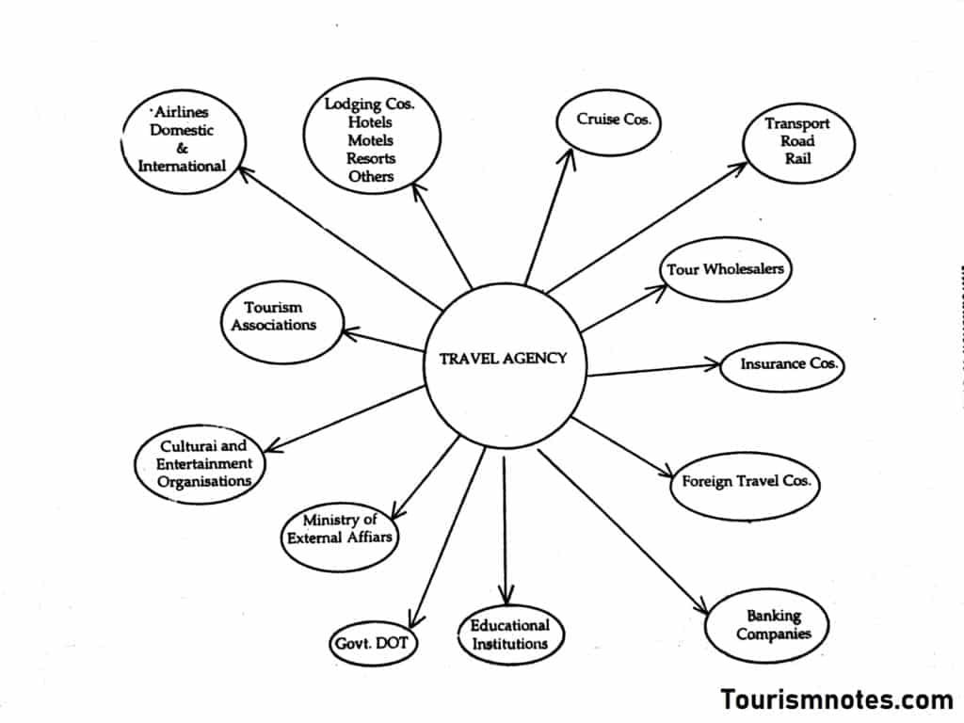
Figure 1: Travel Agencies
(source: Tourismnotes.com, 2025)

Key Stakeholders in a Travel Agency
Several key stakeholders influence the operations and success of a travel agency. Customers are the primary stakeholders, relying on agencies for itinerary planning, booking convenience, and travel support. Suppliers, including airlines, hotels, cruise lines, car rental companies, and insurance providers, form essential partnerships with travel agencies by offering commission-based agreements and exclusive deals. Regulators play a crucial role in ensuring compliance with industry standards and consumer protection laws. These include government authorities, international organizations such as the International Air Transport Association (IATA) and travel regulatory bodies that enforce legal requirements and operational guidelines (Almuqati, 2021).
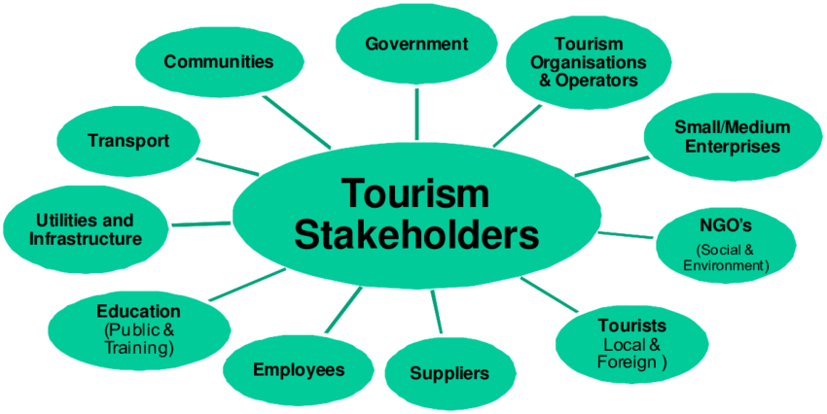
Figure 2: Key Stakeholders in a Travel Agency
(Source: Researchgate.net, 2025)

Revenue Streams and Business Risks
Travel agencies generate revenue through multiple channels. Commissions from travel suppliers serve as a significant source of income, where agencies earn a percentage of each booking made. Service fees are charged for trip planning, itinerary customization, and consultation services. Some agencies generate profits through markups on travel packages, where customized tours are created and sold at a premium. Additionally, subscription-based models are used by corporate travel agencies that offer exclusive benefits to long-term clients.
Despite their revenue potential, travel agencies face significant business risks, including fluctuating travel demand, economic downturns, regulatory changes, cybersecurity threats, and liability issues. Unforeseen crises such as pandemics, natural disasters, and geopolitical conflicts can severely impact operations and financial stability (Aldao et al. 2021).

Crisis Preparedness for Travel Agencies
The travel industry is predisposed to different everyday crises as they may endanger the Client or Influence operations/capacity, as well As affect financial and Company’s reputation losses. Travel agencies should also manage potential risks for the vulnerability that might threaten business operations. These controls comprise threat analysis, risk evaluation, assignment of the crisis management response teams, and ensuring adequate insurances are in place (Woltje et al., 2022). The travel agencies can avoid the negative impacts of a crisis since they will be ready to handle them and also work within the legal boundaries that are required.

Types of Crises in the Travel Industry
There is a literacy of crises that any travel agency may experience in business, and there are massive varieties of response approaches to the crises. A few of the risks include cancellation of flights due to natural disasters like hurricane, earthquakes or fire outbreaks that result to cases of abandonments, and contracts that might lead to severe losses in the company’s financial statement. Global travel reductions, as realized by COVID-19, have lasting impacts meaning that the agencies have to form suitable measures in consideration to restrictions, regulations, and refunds. This is due to the fact that there are factors that are beyond the business circles such as internal and external conflicts which can act as a limiting factor or even pose threats to anyone who is planning to travel to a given country or area of the world. Hacking, ransomware attacks and data steal risk is prevailing because travel agencies are processing the customer data, and it is crucial to protect them. The following are among some of the legal risks and monetary impacts: Payment fraud, stolen identity, fraudulent reservations are among the risks associated with fraud and financial crimes.
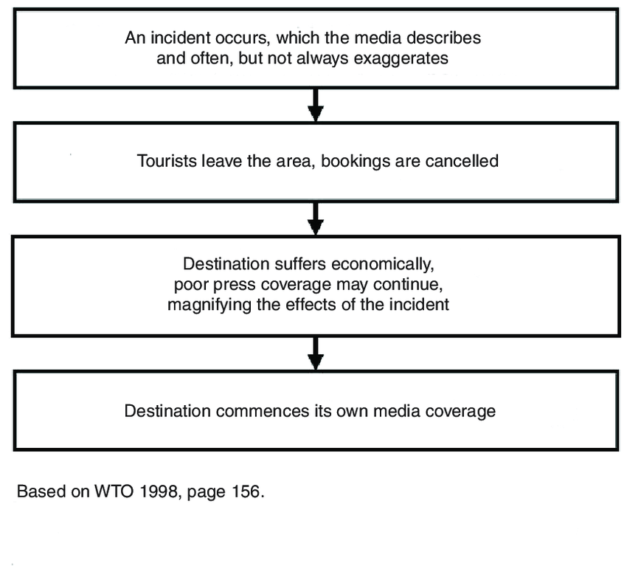
Figure 3: Crises in the Travel Industry
(Source: Researchgate.net, 2025)

Risk Assessment and Mitigation Strategies
In order to avoid terrible consequences, there is always a need to evaluate potential hazards that may arise in the future. Travel agencies’ first step should then involve the assessment of operation risk, supply chain risk and external risks. It is, therefore, evident that legal risk assessment is essential in defining contracting terms, regulations protecting customers and other liability issues. Compliance with industry regulations such as those set by the International Air Transport Association (IATA), consumer protection laws, and data privacy policies helps agencies reduce legal exposure. Mitigation strategies should include diversifying supplier partnerships, implementing cybersecurity measures, establishing transparent refund policies, and training employees on crisis response protocols (Ketter, 2022).

Crisis Response Plan
A structured crisis response plan enables travel agencies to act swiftly and efficiently during emergencies. Legal teams must be involved in drafting policies that define crisis procedures, contractual obligations, and dispute resolution mechanisms. A crisis response team should be established, comprising legal advisors, risk managers, customer service representatives, and public relations specialists (Su, Jia & Swanson, 2025). This team is responsible for executing the response strategy, coordinating with stakeholders, and ensuring regulatory compliance. Contingency planning is essential, including backup communication systems, alternative travel arrangements, and financial reserves to handle emergency costs. A well-prepared crisis response plan ensures that travel agencies can manage crises professionally while upholding their legal and ethical responsibilities.

Role of Insurance and Liability Coverage
Insurance plays a critical role in mitigating the financial impact of crises on travel agencies. Various types of insurance policies can provide coverage against specific risks. Business interruption insurance helps compensate for lost revenue during crises that force temporary closures or service disruptions. Professional liability insurance protects agencies against legal claims arising from errors, omissions, or negligence in travel planning. Cybersecurity insurance covers financial losses and legal expenses resulting from data breaches or cyberattacks. Travel insurance policies offered to customers can reduce refund liabilities and provide coverage for cancellations, medical emergencies, and lost luggage. Insurance is effective in enabling travel agencies mitigate risks and also cover their losses as they cater for their legal liabilities and other disasters (Choe & Di Giovine, 2021).

Legal Obligations During a Crisis
In the event of a crisis, the travel agencies have legal requirements to meet as far as constitutional consumer laws, industry standards, employees, and client’s information is concerned. This is potentially having legal repercussions since lack of compliance with these legalities comes with financial fines, legal suits, loss of reputation as well as customer erosion, (Granados et al. 2021).

Consumer Protection Laws
The rules of consumer protection contribute significantly to the travellers’ protection during the critical period. It is mandatory for travel agencies to establish and disclose appropriate policies in regard to refunds or cancellations due to any cancellation or change of plans that may occur at the time of travel. In certain countries, the clients may receive a full cash refund or a travel credit if their trip is cancelled due to circumstances out of control such as travel bans, or when the airline company goes bankrupt. It is legally mandatory for the agencies to state the cancellation policies, refund policies, and claims solution mechanisms clearly in their terms and conditions so that there is no legal controversy later (Goel et al. 2022).
Legal risks are also of great concern as travel agencies could be held responsible for any failures in service delivery or provision of wrong information, or even negligence. It is crucial to examine the responsibilities of travel agencies, their suppliers, and the clients in making sure that accountability is established or in enforcing a contract. Agencies must carefully draft contracts that specify liability limitations, force majeure clauses, and the scope of their responsibilities. In cases where third-party service providers fail to deliver, agencies must have legal safeguards in place to protect themselves from liability while ensuring fair treatment for customers.

Regulatory Compliance
The travel industry is subject to stringent regulations imposed by international and national authorities. The International Air Transport Association (IATA) sets global standards for air travel, including passenger rights, airline refunds, and safety protocols (Boukredine, 2025). Travel agencies that issue airline tickets must comply with IATA regulations, ensuring that customers receive appropriate compensation and assistance during flight cancellations or schedule changes.
Government advisories and travel restrictions also have significant legal implications for travel agencies. In times of geopolitical conflicts, pandemics, or natural disasters, governments may impose entry bans, quarantine requirements, or visa suspensions that directly impact travellers (Tsang & Wong, 2021). Agencies must stay informed about official advisories and communicate restrictions clearly to customers. Additionally, agencies operating in multiple jurisdictions must navigate varying legal requirements, ensuring that their policies align with the laws of each destination. Regulatory bodies such as consumer protection agencies, aviation authorities, and financial regulators may impose additional legal obligations during crises. Failure to comply with these regulations can lead to fines, license revocations, and legal actions, making it essential for travel agencies to establish compliance monitoring mechanisms.

Employment and Labor Laws
Crises often result in operational disruptions that impact employees, requiring travel agencies to comply with employment and labour laws. Employee rights during crises must be upheld, ensuring fair treatment, timely payments, and safe working conditions. If agencies need to implement workforce reductions, layoff procedures must comply with labour laws, including severance pay, notice periods, and non-discrimination policies. Agencies that fail to follow legal procedures may face wrongful termination lawsuits or employee disputes.
Remote work policies have become increasingly relevant, especially during crises such as pandemics or natural disasters. Employers must establish legally compliant policies that define work-from-home expectations, digital security protocols, and compensation adjustments for remote employees. Travel agencies must also address workplace safety concerns by implementing necessary health measures, providing paid leave where required, and ensuring compliance with occupational health regulations. In cases where agencies operate in multiple countries, they must adhere to local labour laws, which may vary in terms of employment contracts, sick leave, and social security obligations (McGrath, 2022). Legal counsel and HR compliance teams play a crucial role in ensuring that agencies fulfil their labour law obligations while maintaining business operations.

Data Privacy and Cybersecurity
Data security is a critical legal obligation for travel agencies, especially during crises when cyber threats and data breaches increase. This is true since agencies manage massive amounts of categorized customer data such as passport numbers, credit card details, and history among others. Policies and laws protecting the user’s data have become a significant limitation due to the GDPR rules adopted by the European Union and CCPA in the United States (Vlahou et al., 2021).
When this is the case, agencies should consider making the following changes in a bid to safeguard its customer’s information from invasion by hackers, fraudsters or any other unauthorized person. According to legal requirements organisations have to adopt measures like data encryption, use of passwords, and use of secure payment methods. In the case of a breach, agencies must inform their customers and regulatory bodies within the prescribed legal time in sound terms the type of breach, risks involved and the measures taken towards remedying the situation. Non-communication of data breaches in the manner that the law requires attracts severe consequences such as fines and loss of reputation.
It is also important to establish cybersecurity for employees especially the ones that are working from home. It is necessary that the employees in the travel agencies embrace security measures as the use of VPN, strong passwords as well as encrypted communication. Decision-makers should engage legal personnel to ensure IT policies developed for data protection bounds with the standards of the national and international laws to clear any legal barriers in the time of cyber-attack.

Communication and Public Relations Strategy
The two are communication and public relations and these are important elements especially when it comes to managing a crisis in the travel agencies. Communication ought to be well formatted so that everyone in the company right from the customers, employees and suppliers to the regulatory agencies is well informed. It implies that an organization must be transparent, consistent and adhere to the legal requirements in order to protect the organization’s reputation. There is need for travel agencies to prepare and have proper crises management communication strategies and guidelines to be followed especially in cases of a crisis this include engaging with media and social networks, internal communications, and legal obligations and statements in crisis situations.

Crisis Communication Plan
A crisis communication plan is therefore important in the development of any travel agency and it provides formulations in managing public relations during emergencies. It should cover basic information, adherence to the formula that makes information accurate, and simple based on the agency’s policies and legal requirements. Customers’ complaints should be responded to, and the messages should guide them to the type of solutions the agency provides and the extent of commitment.
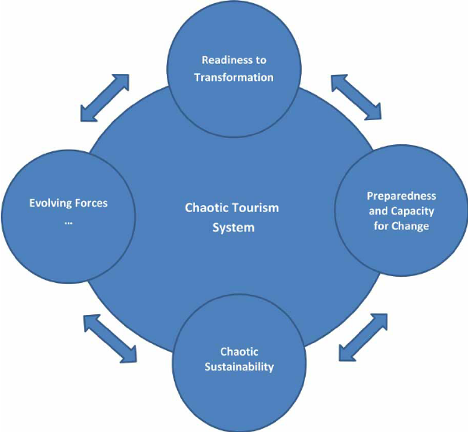
Figure 4: Crisis Communication Plan
(Source: Researchgate.net. 2025)
Issues of law matter a lot when it comes to formation of messages that is to be disseminated particularly in a crisis. The length of section viii on legal compliance may vary depending on the type and size of the organisation, travel agencies are obliged by the consumer protection regulations to ensure that the statements are accurate, legal, regulated, and contractual. For example, agencies should not give a false impression of refunding people the same amount they will spend, coming up with other means of travel, or offering them insurance that they never take when a policy is created only to leave the holidaymakers in the cold. Furthermore, the information contained in the customer base is of a confidential nature and should not be disclosed in public messages, as this can lead to violations of the law on the protection of the population’s private life. The management of travel agencies should ensure that any statement issued by the agency goes through legal department for scrutiny before being released to the public. There must be communication regarding the time interval at which certain updates are to have been communicated. Staging should first set the tone by addressing the existence of the crisis, the subsequent staging should monitor the advancements continually and subsequently. There should be clear contacts for media relations and customers’ complaints that should be followed by the agency leadership.

Engaging with Media and Social Media
In this emergency, the image of the travel agency may be influenced by the media in one way or the other. Agencies need to actively pitch to journalists and news sources to supply the correct information and stymie offenders. There should be media relations officer that is trained on how to coordinate and respond to the media in visor manner and give only factual, calming and legal responses. The press releases should be written in such a manner that addresses some of the issues that may concern the readers while avoiding such statements that may lead to legal actions.
People-use social media to enhance communication in the marketing places or for broadcasting information, which is essential in reaching out to the customers. Nevertheless, with more recognition comes the need to control social media to avoid risking the company’s reputation. To manage the perception and reputation of their agencies online, they should observe the following: There is a need to consider monitoring and participating in the online conversations and inquiries and where necessary give a professionally polished response with a view of correcting the misinformation in circulation. Any negative comment that is given means that there is something that needs to be changed and therefore it should be treated with respect as against giving random rebuttal or ignoring it. Also, legal implications like slander, invasion of rights to privacy or organizational codes of conduct failure are other issues to took into account while posting any crisis related information. A social media policy should thus be implemented to help its travel agencies to regulate its employees on how to conduct themselves on social media during the occurrence of such incidents.

Internal Communication Strategy
It is thus important for the agency to maintain a clear communication when dealing with internal dynamics in order to keep the employees, suppliers and other business partners informed about the new developments and the responses that have been taken in light of the crisis. Staff must be informed of the current affairs and the administrators’ efforts in addressing the crisis as well as theirs in handling the situation. Some of the recommendations include conducting briefings within the agency to address their concerns and for clarification on which questions to ask the customers and the company policies to sell to the customers.
Others include suppliers and business partners because they include companies such as airlines, hotels and insurance providers need to be informed as well for there to be proper coordination. Contractual clients should provide means of direct communicate with them to ensure that they are informed on the current contract agreement, service interruption s, and other possible solutions to the customers that may have been affected. Strong collaboration between travel agencies and suppliers ensures that consistent messages are delivered to travellers, minimizing confusion and service delays. Incorporating digital communication tools such as internal newsletters, instant messaging apps, and video conferencing platforms can enhance efficiency and accessibility. Establishing a dedicated crisis response team within the agency further ensures that all departments work together to manage communication effectively (Ketter, 2022).

Legal Aspects of Public Statements and Disclosures
All public statements made by a travel agency during a crisis must comply with legal standards to prevent potential lawsuits or regulatory actions. Defamation laws prohibit agencies from making false or damaging claims about competitors, government entities, or customers. Statements should be factual and avoid assigning blame prematurely, as this could lead to legal disputes. Consumer protection regulations require that agencies provide transparent and truthful information regarding customer rights, refunds, and alternative travel options. False advertising claims or misleading assurances could result in penalties and lawsuits. That is why all communications to the public should be taken through legal advice before being issued to the public.
If an event threatened data security then it is subjected to the General Data Protection Regulation (GDPR) and the California Consumer Privacy Act (CCPA). Legal requirements may require informing customers who were affected by the incident and informing the authorities about the occurrence of the event, indicating actions taken to address the problem. Moreover, it is necessary to check with the financial disclosure rules if the crisis impacts listed companies. Business houses who engage corporate investors should ensure that their travel agencies give proper and legal financial records to avoid complain of concealing important business data.

Case Studies and Best Practices
Analysing cases of management and resolution of crises in travel agencies, one can understand various practical measures that should be taken and legal issues that may occur in case of improper actions. Learning from the case studies on success and failure, the management of the travel agencies has the right strategy to improve preparedness, compliance, as well as reputation.

Successful Crisis Management: Expedia’s Response to COVID-19
Measuring how pandemic crises affected the company that runs one of the largest online travel agencies that has become obvious when the COVID-19 enrolled the tradition of cancellations across the globe. The organization responded quickly by shifting its focus towards serving customers; refunding them, being transparent-majorly when cancelling flights and allowing free change/exchange of bookings (Zhong et al., 2021).
To mitigate this risk, Expedia’s legal department was employed in a bid to seek to modify contract terms with hotels, airlines, and other travel-related service providers to incorporate and adhere to the protective laws on consumers. It also introduced an automated refund system in order to ease on processing time in order to do away with lots of time wastage from the clients. In addition, the company was keen in regularly keeping travellers informed through the different means, for instance through e-mails, social media platforms, and customer care telephone lines, regarding the changing measures on travel.
One of the points that can be learned from Expedia, is the necessity of readiness to respond to such actions legally, as well as providing customers with the quality service and supporting their decisions. Through the proper and legal policy structure and focus on the consumer rights, Expedia was able to rebuild the trust of its customers during the crisis (Lee &amp; Min, 2021).
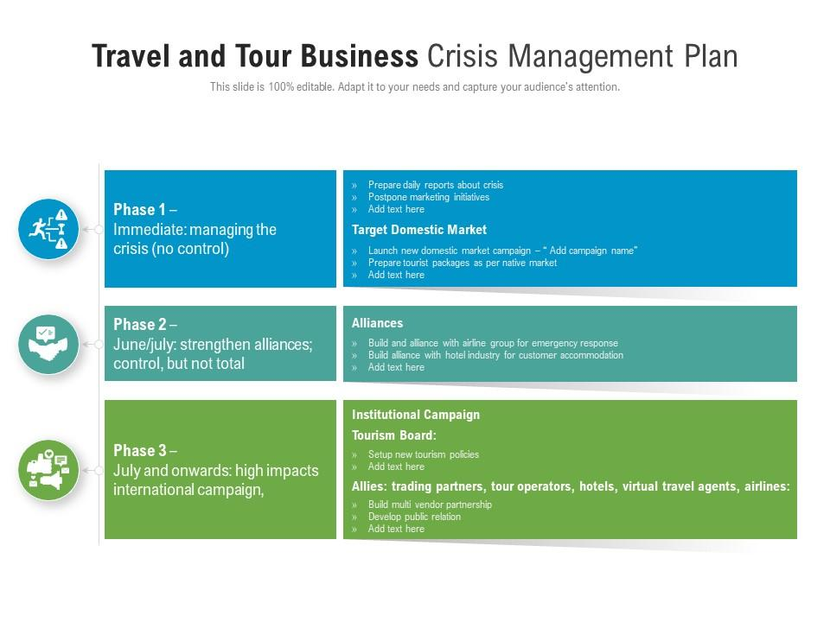
Figure 5: Crisis Management plan
(source: Slideteam.net, 2025)

Legal Mismanagement: Thomas Cook’s Bankruptcy
Thomas Cook travel company which was established in 1849 in United Kingdom is one of the oldest and well-known travel agencies faced the severe problems in 2019 as it went bankrupt owing to the flaws in the company’s accounts and legal affairs management. But the company had a mountain of debt and no plan for the crisis; consequently, tens of thousands of guests could not get the service — thousands more had to be relocated.
The first major legal mismanagement was excessive risks in financing where Thomas Cook did not meet the laid down legal requirements whereby agencies are supposed to have sufficient cash for refunding customers and sustaining their operations. A failure in the disclosure of financial information was also considered by regulators as an issue related to law violations of corporate governance.
In addition, there was poor communication as the customers and employees were informed about the collapse at the last instance with no preparedness.

Lessons Learned and Best Practices
Legal Standards – It is also important to determine if and how refund policies, crisis management as well as overall financial stability of the travel agency meets legal requirements in order to avoid legal risks.
Clear reporting – It is essential to give out updates to customers, employees, and shareholders in a timely and legal manner to forestall provision of wrong information.
Agencies need to revise their supplier relations policy, refunds policy, and liability conditions constantly so they are ready for an incident.
Financial report – The business should have enough capital and insurance to be able to go on with operations also to be in compliance with the financial standard so as to avoid penalties.
It is therefore important for travel agencies to try and implement these practices in order to improve body crisis management and minimize legal implications during calamities.

Recommendations and Conclusion
For the situation management in the sphere of the travel industry, several crucial components should be taken into consideration: legal activity, risk analysis, and the usage of communication channels. Thus, during the crises, travel agencies have to follow the legal regulation of consumer protection as well as regulatory requirements and data security measures to avoid possible legal risks.
One such recommendation is that there needs to be integrated strategies to accommodate for refund policy and the protection and compliance needed for the administration of legal liabilities. Another important area of risk management is the legal one which needs to be conducted to understand the weaknesses and threats that an agency could face and develop methods of preventing these incidents from happening before they do. Also, it is crucial to have clear and legal communication with customers, employees, and shareholders to avoid spreading fake information and legal issues. The best practices in legal issues for crisis management include contract clarity, cybersecurity, employment and labour laws during the disruption. In particular, agencies should involve legal consultants to keep abreast of the current legislation and new hazards in the sphere of tourism. Therefore, the following recommendations will apply for future planning: Further, getting back to the concept of ongoing improvement, the activity that will be critical in the following period is the regular legal audit, staff training, and implementing crisis management systems supported by technological advancements (Ivanov et al., 2022).

References
Aldao, C., Blasco, D., Poch Espallargas, M., & Palou Rubio, S. (2021). Modelling the crisis management and impacts of 21st century disruptive events in tourism: the case of the COVID-19 pandemic. Tourism Review, 76(4), 929-941. Retrieve from: https://www.emerald.com/insight/content/doi/10.1108/tr-07-2020-0297/full/html [Retrieve On: 28.03.2025].
Almuqati, M. (2021). Critical analyzed information of International Air Transport Association (Divulgation paper). Nexo Scientific Journal, 34(02), 1065-1074. Retrieve from: https://camjol.info/index.php/NEXO/article/view/11630 [Retrieve On: 27.03.2025].
Boukredine, H. (2025). Efforts of the international air transport association in addressing cyber threats. Journal of Law and Sustainable Development, 13(3), e04347-e04347. Retrieve from: https://ojs.journalsdg.org/jlss/article/view/4347 [Retrieve On: 29.03.2025].
Choe, J., & Di Giovine, M. A. (2021). Three ways to ensure ‘wellness’ tourism provides a post-pandemic opportunity for the travel industry. Retrieve from: https://digitalcommons.wcupa.edu/cgi/viewcontent.cgi?article=1135&context=anthrosoc_facpub [Retrieve On: 29.03.2025].
Crises in the Travel Industry Researchgate.net. (2025). Retrieve from: https://www.researchgate.net/publication/50281652/figure/fig2/AS:645367477583877@1530879005489/Phase-Model-of-a-Tourism-Crisis.png [Retrieve On: 29.03.2025].
Crisis Communication Plan. Researchgate.net. (2025). Retrieve from: https://www.researchgate.net/profile/Nikolaos-Boukas-3/publication/268147116/figure/fig1/AS:295395696627714@1447439230711/Tourism-crisis-management-as-a-chaotic-process.png [Retrieve On: 29.03.2025].
Crisis Management plan. Slideteam.net. (2025). Retrieve from: https://www.slideteam.net/media/catalog/product/cache/1280x720/t/r/travel_and_tour_business_crisis_management_plan_slide01.jpg [Retrieve On: 28.03.2025].
Garcia, G., Dos Anjos, S., & Doğan, S. (2022). Online travel agencies and their role in the tourism industry. Advances in Hospitality and Tourism Research (AHTR), 10(3), 361-386. Retrieve from: https://dergipark.org.tr/en/pub/ahtr/issue/72454/865546 [Retrieve On: 28.03.2025].
Goel, P., Kaushik, N., Sivathanu, B., Pillai, R., & Vikas, J. (2022). Consumers’ adoption of artificial intelligence and robotics in hospitality and tourism sector: literature review and future research agenda. Tourism Review, 77(4), 1081-1096. Retrieve from: https://www.emerald.com/insight/content/doi/10.1108/tr-03-2021-0138 [Retrieve On: 29.03.2025].
Granados, J. C., Pérez, L. M., Pedraza-Rodríguez, J. A., & Gallarza, M. G. (2021). Revisiting the quality-value-satisfaction-loyalty chain for corporate customers in the travel agency sector. European Journal of Tourism Research, 27, 2711-2711. Retrieve from: https://www.ejtr.vumk.eu/index.php/about/article/view/1921 [Retrieve On: 26.03.2025].
Ivanov, S. H., Webster, C., Stoilova, E., & Slobodskoy, D. (2022). Biosecurity, crisis management, automation technologies and economic performance of travel, tourism and hospitality companies–A conceptual framework. Tourism Economics, 28(1), 3-26. Retrieve from: https://journals.sagepub.com/doi/abs/10.1177/1354816620946541 [Retrieve On: 25.03.2025].
Ketter, E. (2022). Bouncing back or bouncing forward? Tourism destinations’ crisis resilience and crisis management tactics. European Journal of Tourism Research, 31, 3103-3103. Retrieve from: https://ejtr.vumk.eu/index.php/about/article/view/2748 [Retrieve On: 26.03.2025].
Key Stakeholders in a Travel Agency. Researchgate.net. (2025). Retrieve from: https://www.researchgate.net/publication/308315284/figure/fig3/AS:668944981557260@1536500320561/below-illustrates-the-range-of-potential-stakeholders-who-may-be-involved-in-sustainable.png [Retrieve On: 27.03.2025].
Lee, S. K., & Min, S. R. (2021). Effects of information quality of online travel agencies on trust and continuous usage intention: an application of the SOR model. The Journal of Asian Finance, Economics and Business, 8(4), 971-982. Retrieve from: https://koreascience.kr/article/JAKO202109554061592.page [Retrieve On: 27.03.2025].
McGrath, S. K. (2022). Hollywood at home: Applying federal child labor laws to traditional and modern child performers. Wash. & Lee J. Civ. Rts. & Soc. Just., 29, 291. Retrieve from: https://heinonline.org/hol-cgi-bin/get_pdf.cgi?handle=hein.journals/walee29&section=25 [Retrieve On: 29.03.2025].
Oleksandrovych, F. O. (2025). The Evolution of Business Models in the Travel Industry in the Context of Digitalization. The American Journal of Management and Economics Innovations, 7(03), 14-20. Retrieve from: https://inlibrary.uz/index.php/tajmei/article/view/73784[Retrieve On: 26.03.2025].
Su, L., Jia, B., & Swanson, S. R. (2025). Matching crisis event with destination response strategy. Journal of Travel Research, 64(3), 517-540. Retrieve from: https://journals.sagepub.com/doi/abs/10.1177/00472875231218267 [Retrieve On: 26.03.2025].
Travel Agencies.Tourismnotes.com. (2025). Retrieve from: https://tourismnotes.com/wp-content/uploads/2018/07/New-Doc-2018-07-23_1-1024x768.jpg [Retrieve On: 28.03.2025].
Tsang, N. K., & Wong, O. (2021). Traveler’s adoption of travel advisory system: a case of Hong Kong’s outbound travel alert system. Journal of Travel & Tourism Marketing, 38(2), 213-231. Retrieve from: https://www.tandfonline.com/doi/abs/10.1080/10548408.2021.1884637 [Retrieve On: 28.03.2025].
Vlahou, A., Hallinan, D., Apweiler, R., Argiles, A., Beige, J., Benigni, A., ... & Vanholder, R. (2021). Data sharing under the general data protection regulation: time to harmonize law and research ethics?. Hypertension, 77(4), 1029-1035. Retrieve from: https://www.ahajournals.org/doi/abs/10.1161/HYPERTENSIONAHA.120.16340 [Retrieve On: 29.03.2025].
Woltjer, R., Johansson, B. J., Oskarsson, P. A., Svenmarck, P., & Kirwan, B. (2022). Air transport system agility: The Agile Response Capability (ARC) methodology for crisis preparedness. Infrastructures, 7(2), 11. Retrieve from: https://www.mdpi.com/2412-3811/7/2/11[Retrieve On: 29.03.2025].
Zhong, L., Sun, S., Law, R., & Li, X. (2021). Tourism crisis management: Evidence from COVID-19. Current Issues in Tourism, 24(19), 2671-2682. Retrieve from: https://www.tandfonline.com/doi/abs/10.1080/13683500.2021.1901866 [Retrieve On: 27.03.2025].

