Operations Management in Hospitality

Assignment 13

Student Name: Kewal Kumar

Student ID: DE240138

How do non-pricing revenue management tools help hotels maximise revenue without changing room rates?
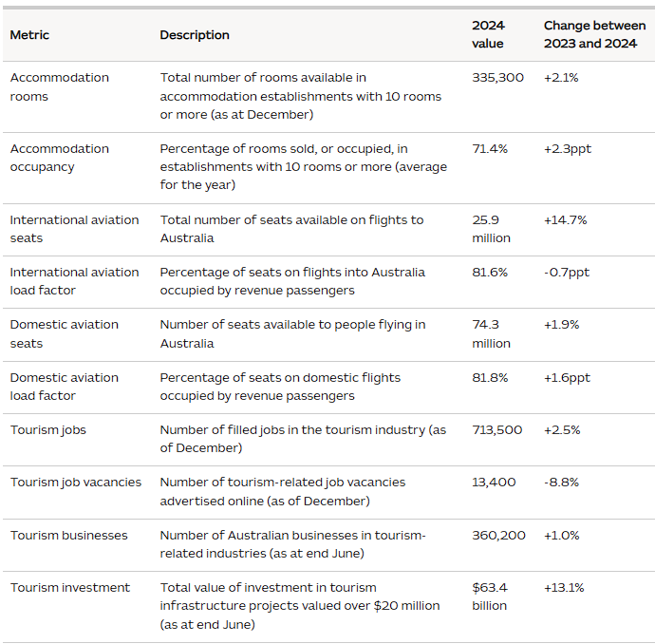
Figure 1: Key measures of supply and capacity
(Source: TRA, 2025)
Non-pricing revenue management instruments in Australian hotels can add revenue through improving the quality of the occupancy, expenditure per visitor, and inventory efficiency, as opposed to modifying the quoted room rate. It is significant in a market where average accommodation occupancy stands at 71.4% in 2024 in establishments with 10 rooms or above; this is 2.3 percentage points higher than in 2023; total available rooms increased to 335,300. In this regard, the strategy issue is to sell not just any room, but to sell the appropriate room, to the appropriate customer, via the appropriate channel, and at the most inexpensive cost of acquisition in all cases (TRA, 2025).
The initial significant tool is the segmentation and demand forecasting. Forecasts in Australian tourism suggest that international travel to Australia will be stronger than pre-pandemic in 2026, and that domestic travel will be stronger than it is in 2024–2025 but will be stable with a steady growth after that point. Forecast-based inventory controls thus help the hotels to give precedence to higher value segments like corporate, long-haul leisure and MICE guests even when the headline rate has not been lowered. This enhances the revenue as the same room can be derived more total value due to extended stays, reduced risk of cancellations, and increased ancillary expenditures (TRA, 2024).
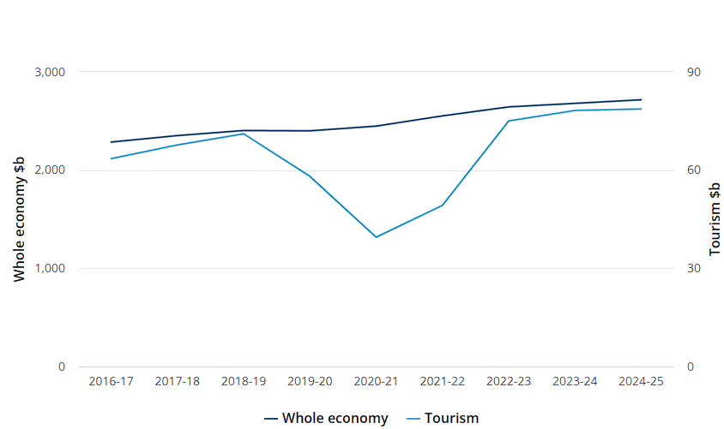
Figure 2: Tourism GDP rose
(Source: ABS, 2024)
Second, the channel management has a significant impact on net revenue. A room sold in one of the high-commission online travel agencies could not be as profitable as a direct rate booking. Other non-pricing activities like loyalty-member benefits, flexible cancellation policies, and inclusions, and direct-booking priority are employed by the hotels to channel the demand in less expensive, but non-discounted channels. This proves economically important as the tourism GDP in Australia has developed an increase of nearly 49.2 into 78.7 billion in 2021-22 into 2024-25 and therefore they have a bigger market where margin control is important as much as the topline growth (ABS, 2024).
Third, operational and inventory tools help hotels to cash in on peak demand. CBRE (2026) reports that in the key markets in Australia, the growth in the RevPAR is over 8% in most major markets and the ADR premiums measure around 40 per cent in the peak times even without taking broad rate changes into consideration. That signifies the business strength of stay limitations, room form optimisation, upgrade marketing, occasion-based packages engineering, and functionality-space integration. Importantly, the tools are better than a mere application of price increments since they safeguard brand positioning but get increased value out of each arrival. Even when there are only 5,143 rooms of construction in the country in 2026 and a future supply is less than the demand growth, the Australian hotels, which master non-pricing tools, will be able to maximise returns based on precision rather than discounting or an indisputable increase in prices (CBRE, 2026).

Reference
ABS. (2024). Australian National Accounts: Tourism Satellite Account, 2022-23 financial year. Retrieved from Australian Bureau of Statistics website: https://www.abs.gov.au/statistics/economy/national-accounts/tourism-satellite-account/latest-release
CBRE. (2026). Hotels Australia - Overview & Outlook 2026. Retrieved from Cbre.com.au website: https://www.cbre.com.au/insights/reports/hotels-australia-overview-outlook-2026
TRA. (2024). Tourism forecasts for Australia 2024-2029 | Tourism Research Australia. Retrieved from Tra.gov.au website: https://www.tra.gov.au/en/economic-analysis/tourism-forecasts-for-australia/tffa-2024-2029
TRA. (2025). Annual benchmark report | Tourism Research Australia. Retrieved from Tra.gov.au website: https://www.tra.gov.au/en/economic-analysis/annual-benchmark-report

