Employee Relations, Diversity and Ethical HRM Practices
M09 Human Resource Management
Assignment Option 3: Employee Relations, Diversity and Ethical HRM Practices
Student Name: ______________________________
Student ID: ________________________________
Module: Human Resource Management
Submission Date: 24 May 2026

Table of Contents
Table of Contents 2
Abstract 3
Introduction 4
Literature Review 5
Methodology 10
Findings 11
Discussion 16
Conclusion 19
References 21
Appendices 23

Abstract
This report critically analyses the importance of employee relations, diversity and ethical HRM practices in modern organizations. It argues that fair and inclusive employment systems are not only legal or reputational requirements, but also strategic conditions for trust, engagement and sustainable performance. The report uses a secondary qualitative methodology based on academic literature, CIPD guidance, public agency evidence and contemporary corporate practice. It explores workplace conflict, discrimination, wellbeing, labour relations, inclusion, psychological safety, biased recruitment, unfair dismissal, wage inequality, harassment and privacy concerns. The analysis finds that employee relations are strongest when organizations combine clear policies with employee voice, early conflict resolution, manager capability and procedural justice. Diversity creates value when inclusion changes decision making, opportunity access and workplace culture rather than remaining symbolic representation. Ethical HRM is necessary because people analytics, algorithmic recruitment and performance monitoring can improve efficiency while also creating bias and privacy risks. The report recommends an employee centred HR governance model built on inclusive recruitment, transparent pay systems, anti harassment procedures, wellbeing support, respectful labour relations, privacy protection and accountable leadership. The conclusion is that organizations cannot build high commitment cultures while tolerating unfairness. Ethical and diverse HRM practices protect employees, reduce risk and strengthen long term organizational legitimacy.

Introduction
Employee relations, diversity and ethics have become central to HRM because organizations are judged not only by what they produce, but also by how they treat employees. Modern workforces are increasingly diverse in gender, age, ethnicity, disability, nationality, caring responsibilities, education, beliefs and employment expectations. At the same time, organizations face conflict, work intensification, hybrid working challenges, union pressures, wellbeing concerns and legal scrutiny. HRM therefore has a responsibility to create workplaces where employees are treated fairly, can raise concerns, and are protected from discrimination, harassment and arbitrary decisions. This is not separate from performance. Trust and fairness influence engagement, retention and willingness to contribute.
The topic is especially important because technological change has created new ethical questions. Recruitment platforms, employee monitoring systems, people analytics and artificial intelligence can support efficiency, but they can also reproduce bias, invade privacy or reduce employees to data points. Pay transparency, social movements and employee activism have also increased scrutiny of wage inequality, inclusion and organizational values. The EEOC reported high levels of discrimination related inquiries and charges in fiscal year 2025, demonstrating that workplace fairness remains a live issue rather than a settled matter (EEOC, 2026). Ethical HRM is therefore a practical requirement for risk management and a moral requirement for responsible employment.
This report analyses the importance of employee relations, diversity and ethical HRM practices. It explores conflict, discrimination, wellbeing, labour relations and inclusion. It discusses the role of HR in promoting fairness, equal opportunity, psychological safety and respectful workplace culture. It also assesses ethical challenges including biased recruitment, unfair dismissal, wage inequality, harassment and privacy concerns. The report adopts a critical position. It recognizes that organizations often publish strong values, but the real test of ethical HRM is whether policies are implemented consistently, whether employees feel safe to speak, and whether power is exercised fairly in everyday decisions.
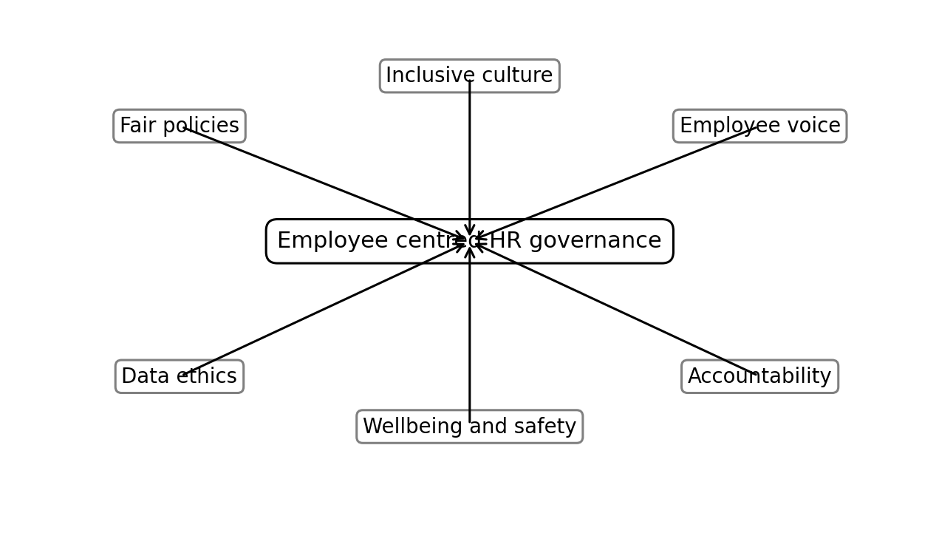
Figure 1. Conceptual model showing the report’s core HRM logic.

Literature Review
Employee relations refers to the management of the employment relationship between employer and employees, including communication, conflict resolution, participation, discipline, grievance handling and collective relations. CIPD (2025) emphasizes that positive employee relations are linked to employee voice, trust and better workplace outcomes. The employment relationship is both economic and psychological. Employees exchange labour for pay, but they also expect respect, fairness, development and security. When employees believe that the organization has violated these expectations, they may reduce effort, become disengaged or leave. Employee relations therefore affects both workplace climate and organizational performance.
Psychological contract theory is useful for understanding employee relations because it focuses on perceived mutual obligations. Formal contracts cannot specify every expectation in a workplace. Employees develop beliefs about what the organization owes them, such as fair treatment, career opportunity or honest communication. Employers develop expectations about loyalty, flexibility and performance. Conflict often arises when these expectations are misaligned or broken. For example, restructuring may be legally permitted but still experienced as unfair if communication is poor. HR has a role in making expectations explicit, managing change transparently and ensuring that employee voice is heard.
Diversity and inclusion are related but not identical. Diversity refers to workforce differences and representation, while inclusion concerns whether people are respected, valued and able to participate fully. CIPD (2026) states that effective equality, diversity and inclusion strategies should support business objectives as well as fairness. The business case suggests that diverse teams can improve decision making, creativity and market understanding. However, diversity can also create friction if inclusion is weak. Representation alone may not change power, promotion patterns or everyday behaviour. Ethical HRM therefore requires organizations to move beyond symbolic diversity statements toward inclusive systems that change opportunity access and workplace culture.
Psychological safety is another key concept. It refers to a shared belief that employees can speak up, ask questions and admit mistakes without fear of humiliation or punishment. Psychological safety supports learning, innovation and ethical reporting because employees are more likely to raise concerns before problems escalate. However, psychological safety is not the same as comfort or lack of accountability. It means employees can challenge ideas and report risks while still being expected to perform. HR contributes by training managers, protecting whistleblowers, creating reporting channels and ensuring that retaliation is not tolerated.
Ethical HRM is grounded in fairness, dignity, transparency and respect for employee rights. It requires attention to distributive justice, procedural justice and interactional justice. Distributive justice concerns fairness of outcomes such as pay and promotion. Procedural justice concerns fairness of the processes used to make decisions. Interactional justice concerns respect and honesty in communication. Employees may accept difficult decisions, such as redundancy or disciplinary action, if they believe the process was transparent, evidence based and respectful. This is why ethical HRM is not simply about avoiding legal claims. It is about maintaining legitimacy in the use of organizational power.
Workplace conflict is inevitable because employees have different interests, personalities and pressures. Conflict is not always negative. Task conflict can improve decisions when managed respectfully. However, relationship conflict, bullying and harassment damage wellbeing and performance. HR must distinguish between constructive disagreement and harmful conduct. Effective conflict management includes clear behavioural standards, trained managers, informal resolution options, mediation, grievance procedures and consistent disciplinary action. A purely legalistic approach may escalate conflict, while a purely informal approach may hide power imbalance. Balanced employee relations practice uses early intervention but preserves formal protection where needed.
Labour relations and employee voice remain important even in organizations with low unionization. Voice allows employees to influence decisions that affect their work. It can take the form of unions, works councils, consultation forums, surveys, speak up channels and team meetings. Voice is ethically important because employees are affected by managerial decisions and should have mechanisms to raise concerns. It is also practically useful because frontline employees often understand operational risks before senior leaders do. However, voice is credible only when organizations respond. Collecting survey data without action can increase cynicism.
The literature also identifies new ethical challenges from HR technology. Algorithmic recruitment can screen large applicant pools, but it can reproduce historical bias if trained on biased data. Employee monitoring can support security or productivity, but it can also create surveillance anxiety and privacy risks. People analytics can identify turnover risks, but it may encourage intrusive prediction about employees’ personal lives. Ethical HRM therefore requires governance, transparency, human oversight, data minimization and bias audits. Technology should assist HR decisions, not remove accountability for them.
Intersectionality is important for diversity analysis because employees do not experience identity categories separately. A woman of colour, a disabled migrant worker or an older employee with caring responsibilities may face overlapping barriers that are not visible when organizations analyse gender, ethnicity, disability or age in isolation. HR systems that focus on single categories may miss these combined disadvantages. Intersectional thinking does not require organizations to create endless categories, but it does require more careful listening and data interpretation. For example, average promotion rates for women may hide lower progression for minority women. Ethical diversity practice therefore requires attention to how different forms of inequality interact in recruitment, development, pay and employee voice.
Hybrid and remote work have created new employee relations and inclusion challenges. Flexibility can improve wellbeing and widen access for employees with disabilities or caring responsibilities, but it can also create proximity bias if office based employees receive more visibility and promotion opportunities. Remote employees may experience isolation or weaker voice. Monitoring technology may create privacy concerns if organizations attempt to control remote work through surveillance rather than trust and output clarity. HR should therefore design hybrid policies that address fairness, communication, performance expectations and inclusion. The question is not only where employees work, but whether different work arrangements create unequal access to information, development and recognition.
Stakeholder theory is also relevant to ethical HRM because employees are key stakeholders, not merely resources. Organizations affect employees’ income, identity, health, family life and future opportunities. Ethical HRM therefore requires more than compliance with minimum law. It requires responsible consideration of how decisions affect employee dignity and security. Redundancy, scheduling, monitoring, pay and disciplinary decisions may be legal but still ethically questionable if they are unnecessarily harsh or opaque. A stakeholder approach encourages HR leaders to consider employee interests alongside shareholder, customer and operational interests. This broadens HRM from risk control to responsible governance.
Table 1
Key Ethical HRM Risks and Controls
Risk area | Possible harm | Recommended HR control
Biased recruitment | Unequal access and reduced talent diversity | Structured criteria, adverse impact monitoring and manager training
Unfair dismissal | Loss of trust, legal claims and reputational damage | Evidence based process, right to respond and appeal
Wage inequality | Low motivation and fairness concerns | Pay equity audits and transparent reward criteria
Harassment | Psychological harm and unsafe culture | Safe reporting, investigation standards and leadership accountability
Privacy misuse | Surveillance anxiety and loss of trust | Data minimization, transparency and human review

Methodology
This report uses a secondary qualitative methodology. The method is appropriate because the task requires analysis of HRM concepts, ethical issues and best practices rather than primary empirical research. The evidence base includes academic HRM theory, practitioner guidance from CIPD, public agency data from the EEOC and selected examples of contemporary organizational practice. The sources were selected to cover both conceptual understanding and real world relevance. Academic sources provide theory on justice, psychological safety and inclusion, while practitioner and public sources show current workplace challenges.
The analysis was organized around 4 themes. The first theme is employee relations, including conflict, labour relations, wellbeing and employee voice. The second theme is diversity and inclusion, including discrimination, equal opportunity and psychological safety. The third theme is ethical HRM, including recruitment bias, dismissal fairness, wage inequality, harassment and privacy. The fourth theme is best practice, where recommendations are developed from the preceding analysis. Each theme is evaluated critically by considering both organizational benefits and employee protection.
The methodology has limitations. Secondary research cannot determine the actual ethical climate in a specific organization. Public data on discrimination also reflects reported cases and may not capture unreported experiences. Corporate examples may emphasize positive practice and understate failures. To address these limitations, the report avoids presenting any organization as a perfect model. It focuses instead on principles and governance mechanisms that can be applied across organizations. The recommendations are therefore practical but also cautious, recognizing that ethical HRM depends on consistent implementation and accountability.

Findings
The first finding is that employee relations are strongest when organizations manage conflict early and fairly. Workplace conflict often begins with workload pressure, unclear roles, poor communication or perceived disrespect. If ignored, it can become grievance, absenteeism, turnover or legal dispute. HR should therefore build manager capability in early resolution, active listening and documentation. However, early resolution should not be used to silence serious complaints. Issues involving harassment, discrimination or retaliation require formal investigation and protection. The best approach is a tiered system where informal resolution is available for suitable disputes, while formal processes are accessible and trusted for serious concerns.
The second finding is that employee wellbeing is a core employee relations issue. Wellbeing is affected by workload, job control, leadership behaviour, work life boundaries, safety, bullying and financial security. Organizations often offer wellbeing apps or awareness campaigns, but these are limited if the work system itself creates stress. Ethical HRM requires prevention as well as support. HR should analyse absence, turnover, workload data, employee feedback and manager behaviour to identify causes of wellbeing risk. Employee assistance programmes can help individuals, but they cannot substitute for fair staffing, respectful management and realistic performance expectations.
The third finding is that labour relations require respectful dialogue, not only legal compliance. Even where unions are absent, employees need voice mechanisms. Consultation during restructuring, policy change or technology implementation can improve legitimacy and reduce resistance. Employees are more likely to accept difficult decisions when they understand the reasons and have had an opportunity to be heard. HR should design voice channels that are accessible to different groups, including frontline staff, remote workers and employees who may fear retaliation. Voice mechanisms should also produce visible action, otherwise they become symbolic.
The fourth finding is that diversity recruitment must be supported by inclusive selection and progression. Organizations may broaden sourcing channels to attract diverse applicants, but this is insufficient if selection tools contain bias or promotion systems favour existing networks. Structured interviews, diverse panels, clear criteria and adverse impact monitoring can improve fairness. However, diversity should not be reduced to numerical targets without inclusion. Employees from underrepresented groups may be hired but still leave if they experience exclusion, microaggressions or limited advancement. HR should therefore track representation, progression, pay, retention and employee experience together.
The fifth finding is that psychological safety is a practical condition for ethical culture. Employees who fear punishment may avoid reporting errors, misconduct or discrimination. This creates hidden risk. HR can promote psychological safety through manager training, confidential reporting systems, whistleblower protection and fair investigation procedures. However, psychological safety must be backed by action. If employees raise concerns and nothing changes, trust declines. Organizations should communicate actions taken in response to employee feedback while protecting confidentiality. This makes voice visible and shows that speaking up has value.
The sixth finding is that biased recruitment remains a major ethical risk. Bias can occur through job advert wording, informal referrals, unstructured interviews, algorithmic screening and assumptions about career gaps or accents. Technology can reduce some human bias by standardizing processes, but it can also reproduce bias if historical data reflects discrimination. Ethical recruitment requires job relevant criteria, structured scoring, reasonable adjustments, transparency and regular audit. HR should also train hiring managers to evaluate evidence rather than similarity or instinct. Fair recruitment improves both equality and quality because it widens access to talent.
The seventh finding is that unfair dismissal and disciplinary processes damage trust even when organizations believe they are legally defensible. Employees expect evidence, consistency, the right to respond and respectful communication. Procedural justice is especially important in disciplinary cases because the organization holds more power than the individual employee. HR should ensure that managers document performance concerns, provide support before dismissal where appropriate, separate investigation from decision making and allow appeal. This does not prevent organizations from addressing misconduct or poor performance. It ensures that accountability is exercised fairly.
The eighth finding is that wage inequality is both a fairness issue and a performance issue. Pay gaps can arise from occupational segregation, biased promotion, negotiation differences, part time penalties and lack of transparency. If employees perceive pay as unfair, motivation and trust decline. HR should conduct pay equity audits, review starting salaries, monitor promotion rates and ensure that reward criteria are clear. Pay transparency should be implemented carefully because unexplained pay differences can create conflict. However, secrecy is not a sustainable solution. Ethical HRM requires organizations to understand and address unjustified differences.
The ninth finding is that harassment prevention requires culture change, not only policy documents. Anti harassment policies are necessary, but employees judge organizations by whether complaints are taken seriously and whether powerful individuals are held accountable. Training should go beyond legal definitions to include bystander action, respectful conduct and manager responsibility. Reporting channels should be safe and accessible. Investigations should be timely, impartial and trauma informed. Organizations should also monitor hotspots such as teams with high turnover, repeated complaints or poor engagement results. Prevention requires leadership signals as well as HR procedure.
The final finding is that privacy concerns are increasing as HR uses more data. Organizations collect information about attendance, performance, location, communication patterns, wellbeing and recruitment. Data can improve decisions, but excessive collection can feel intrusive. Ethical HR analytics should be based on necessity, proportionality, transparency and consent where appropriate. Employees should know what data is collected, why it is used and who can access it. Sensitive decisions should include human review. Privacy is not an obstacle to good HRM; it is part of responsible governance.
The eleventh finding is that diversity efforts can face backlash if they are poorly explained or implemented as symbolic targets. Some employees may believe that diversity initiatives reduce merit, even when the real objective is to remove bias from opportunity. HR should therefore communicate clearly that inclusion strengthens fairness and decision quality. Selection and promotion standards should remain rigorous, but the process for accessing opportunities should be equitable. Backlash is more likely when organizations use slogans without explaining criteria or when managers treat inclusion as a compliance burden. Effective HRM connects diversity to fairness, capability and respectful culture rather than presenting it as a separate political project.
The twelfth finding is that global organizations must adapt employee relations and diversity practices across legal and cultural contexts while maintaining core ethical standards. Employment law, union traditions, privacy expectations and cultural norms differ across countries. A policy that works in one jurisdiction may not be sufficient in another. However, organizations should not use local variation as an excuse for weak protection. Core principles such as non discrimination, respect, safe reporting and fair process should remain consistent. HR should distinguish between adaptable practice and non negotiable standards. This is especially important for multinational firms seeking legitimacy across diverse labour markets.
The thirteenth finding is that accountability is the missing link in many ethical HRM programmes. Organizations may have policies on harassment, diversity and privacy, but little changes if leaders are not accountable for outcomes. Accountability can include manager objectives, board reporting, independent audits, case review panels and transparent progress reporting. However, accountability should not become box ticking. The aim is to ensure that leaders examine evidence, act on problems and explain decisions. Ethical culture develops when employees see that values influence consequences, including consequences for high performing managers who behave unfairly.
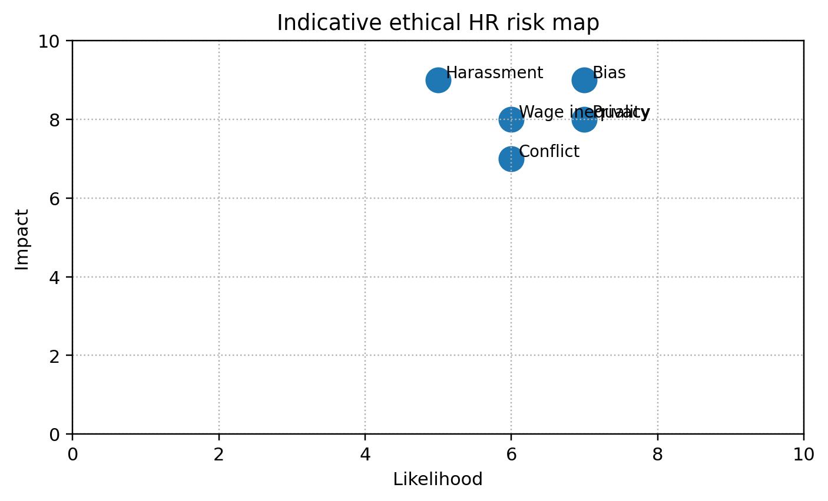
Figure 2. Indicative visual summary of key HRM priorities derived from the report analysis.
Table 2
Employee Centred HR Best Practice Framework
Practice area | Best practice | Success indicator
Employee relations | Early conflict resolution with formal protection for serious concerns | Reduced grievance escalation and improved trust
Diversity and inclusion | Inclusive hiring, progression and retention monitoring | Fair representation across levels and lower inclusion gaps
Psychological safety | Speak up channels and non retaliation rules | Employees report confidence in raising concerns
Wellbeing | Workload review, manager training and support services | Lower stress indicators and improved sustainable performance
HR technology | Privacy impact assessments and bias audits | Transparent and accountable people data use

Discussion
The findings show that employee relations, diversity and ethical HRM are interconnected. Conflict management is weaker when employees do not trust the fairness of processes. Diversity initiatives are weaker when employee relations systems fail to protect voice. Ethical HRM is weaker when inclusion is treated as branding rather than governance. Organizations therefore need an integrated employee centred model. This model should connect policy, culture, leadership behaviour, data governance and accountability. Isolated initiatives, such as a diversity statement or a wellbeing webinar, are unlikely to change employee experience if deeper systems remain unfair.
A key tension is that organizations often promote inclusion while maintaining systems that reward conformity or silence. For example, employees may be encouraged to speak up, but managers may punish dissent through appraisal or exclusion. Similarly, recruitment may seek diversity, but promotion may depend on informal sponsorship. HR should therefore examine hidden mechanisms of inequality, not only visible policies. This includes analysing who receives stretch assignments, who has access to mentoring, whose performance is labelled as potential and whose behaviour is judged as poor fit. Ethical HRM requires attention to the ordinary decisions through which advantage is created.
Another tension concerns technology. People analytics and algorithmic tools can help identify patterns that humans miss, such as pay gaps or adverse impact. Yet the same tools can intensify surveillance and bias. The ethical issue is not whether HR should use technology, but how it is governed. Human oversight, auditability, employee communication and data minimization are essential. HR should also avoid using predictive tools for decisions that employees cannot understand or challenge. Fairness requires explainability. If an employee is rejected, monitored or flagged as a risk by a system, the organization should be able to explain the basis and offer review.
The role of line managers is central. Policies are written by HR, but employees experience fairness through managers. A respectful workplace culture requires managers who can handle conflict, support wellbeing, give feedback, manage diversity and follow procedures. Manager capability should therefore be treated as an ethical risk control. Organizations should evaluate managers not only on output, but also on team climate, turnover, grievance trends and inclusion. Leaders who deliver results through fear, favouritism or disrespect should not be rewarded as high performers because their behaviour damages long term organizational health.
The report recommends 7 best practices. First, create transparent employee relations procedures covering grievance, discipline, mediation and appeal. Second, build inclusive recruitment and progression systems using structured criteria and adverse impact monitoring. Third, conduct pay equity audits and explain reward decisions clearly. Fourth, establish safe reporting channels for harassment, discrimination and ethical concerns. Fifth, integrate wellbeing into job design, workload planning and leadership accountability. Sixth, govern HR technology through privacy, bias audit and human review. Seventh, measure inclusion through employee experience, not only representation. These practices would help organizations build ethical, diverse and employee centred workplaces.
A further implication is that employee relations should be integrated with risk management and sustainability reporting. Workforce conflict, discrimination and wellbeing failures can create legal claims, operational disruption, reputational harm and loss of talent. These risks are as material as many financial or operational risks. HR should therefore report patterns to senior leadership and boards, including grievance trends, turnover hotspots, pay equity results, employee voice themes and culture risks. This does not mean exposing confidential cases. It means treating employee experience as organizational evidence. A board that sees only financial performance may miss the human risks that later damage performance.
The report also suggests that ethical HRM requires courage from HR professionals. HR teams can be pressured to protect management decisions even when processes are weak. They may also face pressure to minimize complaints or present overly positive engagement results. Professional HR practice requires independence, evidence and willingness to challenge unfair decisions. This does not make HR anti management. It makes HR credible. When HR protects fair process and employee dignity, it also protects the organization from hidden risk and loss of trust. Ethical HRM therefore depends on professional judgement as well as policy design.
Another practical issue is the relationship between employee relations and organizational change. Restructuring, automation and cost reduction often create fear because employees worry about job security, fairness and voice. HR cannot remove all negative consequences, but it can improve legitimacy through early communication, consultation, clear criteria and support for affected employees. Ethical change management also requires attention to survivors, not only those who leave. Employees who remain may experience guilt, workload pressure and reduced trust. Strong employee relations practice therefore treats change as a social process, not only a project plan.
Finally, organizations should recognize that ethical HRM is continuous rather than episodic. It is not enough to respond after a major complaint, public scandal or regulatory investigation. Ethical risks develop through small patterns, such as jokes that go unchallenged, informal promotion decisions, excessive monitoring or repeated workload pressure. HR should use regular audits, employee listening and manager development to identify these patterns early. This preventative approach is more effective than crisis response because it protects employees before harm becomes severe. It also strengthens the organization’s reputation as an employer that acts responsibly before it is forced to act.

Conclusion
Employee relations, diversity and ethical HRM practices are essential to responsible and effective people management. The report shows that fairness, voice, inclusion, psychological safety and privacy protection are not optional values. They are practical conditions for trust, engagement and sustainable performance. Workplace conflict, discrimination, wage inequality, harassment and intrusive data use can damage employees and expose organizations to legal and reputational risk. HR has a central role in preventing these harms through fair policies, inclusive systems, manager capability and accountable leadership. The strongest organizations will not treat ethics as a compliance checklist or diversity as representation alone. They will design employment systems that give employees fair opportunity, respectful treatment and meaningful voice. In conclusion, ethical and diverse HRM strengthens organizational legitimacy because it aligns business performance with human dignity and workplace justice.

References
Chartered Institute of Personnel and Development. (2025). Employee relations: An introduction. https://www.cipd.org/en/knowledge/factsheets/relations-employees-factsheet/
Chartered Institute of Personnel and Development. (2026). Equality, diversity and inclusion in the workplace. https://www.cipd.org/en/knowledge/factsheets/diversity-factsheet/
Edmondson, A. C. (2019). The fearless organization: Creating psychological safety in the workplace for learning, innovation, and growth. Wiley.
Equal Employment Opportunity Commission. (2026). EEOC highlights record breaking results in agency reports. https://www.eeoc.gov/newsroom/eeoc-highlights-record-breaking-results-agency-reports
Greenwood, M. (2013). Ethical analyses of HRM: A review and research agenda. Journal of Business Ethics, 114(2), 355-366. https://doi.org/10.1007/s10551-012-1354-y
Nishii, L. H. (2013). The benefits of climate for inclusion for gender diverse groups. Academy of Management Journal, 56(6), 1754-1774. https://doi.org/10.5465/amj.2009.0823
Rawls, J. (1999). A theory of justice (Rev. ed.). Harvard University Press.
Saks, A. M. (2006). Antecedents and consequences of employee engagement. Journal of Managerial Psychology, 21(7), 600-619. https://doi.org/10.1108/02683940610690169
Crenshaw, K. (1991). Mapping the margins: Intersectionality, identity politics, and violence against women of color. Stanford Law Review, 43(6), 1241-1299. https://doi.org/10.2307/1229039
Freeman, R. E. (1984). Strategic management: A stakeholder approach. Pitman.

Appendices
Appendix A provides an ethical HRM audit checklist covering recruitment, pay, voice, wellbeing, harassment prevention and data privacy. Appendix B provides a sample conflict resolution pathway for managers and HR advisers. These practical tools support the report recommendations and can be adapted for organizations of different sizes.
Appendix A
Ethical HRM Audit Checklist
Area | Audit question | Evidence source
Recruitment | Are criteria job relevant and consistently scored? | Interview forms and selection outcomes
Pay | Are unexplained pay gaps investigated? | Pay equity analysis and reward policy
Voice | Can employees raise concerns without retaliation? | Speak up data and employee survey results
Harassment | Are complaints investigated promptly and fairly? | Case records and resolution time
Privacy | Is employee data collection necessary and transparent? | Privacy impact assessments and data policy

