

Planning and Management of Sustainable Tourism Spaces
Assignment 7
12.11.2025
Student Name:
ID Number:
Table of Contents
Introduction 3
Significance and Values of Heidelberg Castle 3
Threats Facing the Site 4
Hebelberger Castle Proposed Adaptive Re -use 4
Values maintained in the Castle by the Adaptive Re-use 5
Advantages to the Local Community 6
Conclusion 6

Introduction
Heidelberg Castle (Heidelberger Schloss) of Baden-Wurttemberg is one of the most representative heritage sites of Germany that stirs the memory of the culture, architectural heritage, and historical identity of the country. Its theatrical introspection onto the River Neckar along with its Renaissance architect-practiced features together with its disintegrated ruins appearance makes it a place of unusual historic and cultural interest.

Significance and Values of Heidelberg Castle
Historical Value and Cultural Value.
Heidelberg Castle is a representation of over 800-year princely German history. Being the old seat of the Palatinate Electors, it took the center stage in the political scene of the Holy Roman Empire (Staatliche Schlösser und Gärten Baden-Württemberg, 2025). Its ruins also show evidence of war, such as lightning strikes in the destruction in the course of the 30 years’ war, and later lightning strikes, which further contributed to its stratified story.
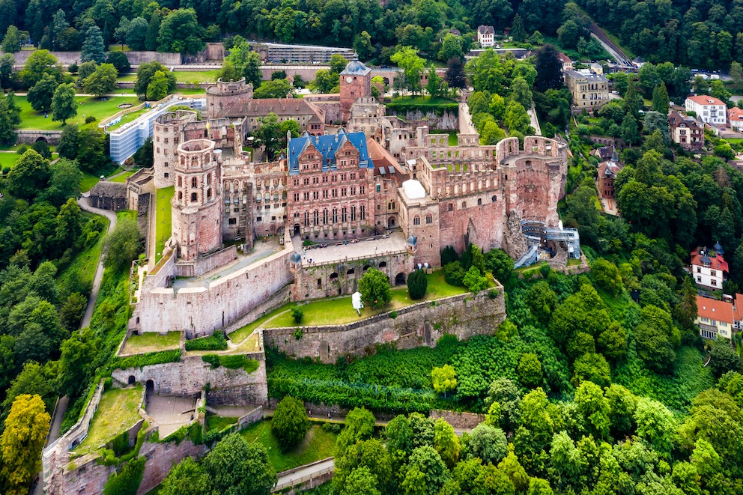
Figure 1: Heidelberg Castle
(Source: Staatliche Schlösser und Gärten Baden-Württemberg, 2025)
Architectural and Aesthetic Value
The castle is an example of a mixture of Gothic and the Renaissance architectural styles that can hardly be met in Germany. Other buildings like the Friedrich Building, the Ottheinrich Building have elaborate walls, sculptures, and masonry that are the representations of early Renaissance style. And even the castle gardens, which have been redecorated in the style of the Baroque, are of historic importance.
Symbolic and educational Value
The site acts as a classroom to the historians, the architects, the archaeologists, and the students. It is the representative of German Romanticism, and served as a source of inspiration to poets, painters, and philosophers, including Goethe or Turner. The museum collections, exhibitions and guided tours in the castle today play a significant role in the education of the culture.

Threats Facing the Site
Climate and Environmental Strains
Extreme weather is becoming one of the greatest dangers of the weak structures of the castle. The excessive floods are contributing to the erosion and frost and moisture damage weaken the facades of the sandstones.
Over-tourism and Tourist Pressure
The fact that it hosts more than one million tourists every year puts a lot of pressure on the castle grounds. Overcrowding causes pathways to wear and tear, historically perceived interiors to degrade, noise to be a nuisance, and puts extra pressure on the conservation resources. Issues of balancing between economic advantages and preservation of the heritage remain a common problem.
Material Degradation and Aging Structural
Being an old ruin, the castle has deteriorated with the course of nature. Weakened foundations, weathered sandstone and old drainage systems pose threats to the stability. Certain walls and towers have to be reinforced regularly in order to avoid collapsing.

Hebelberger Castle Proposed Adaptive Re -use
a. The Digital Heritage Interpretation Centre
An already existing building in an unused area or a digital centre situated inside a building could serve as an immersive experience in augmented reality (AR) and virtual reality (VR) (Safikhani et al., 2022). The historical look of the castle, the life of the prince, and the destruction of the castle in war could be visualized by the visitors without changing the physical fabric of the castle.
b. Cultural and Educational Hub Community
The underutilised rooms can be used as workshops, exhibitions, academic lectures, heritage-learning programmes in cooperation with the Heidelberg University. This would enhance community involvement in addition to maintaining cultural continuity.
c. November 2014 Sustainable Event Spaces to Controlled Use
Small, greener-friendly, cultural events (poetry nights, classical concerts, markets by local artisans can be held in selective areas, like the gardens or individual halls. These events are a generator of revenue and the results employ an area of the site that could handle the crowds with the least risk.

Values maintained in the Castle by the Adaptive Re-use
Architectural Integrity should be preserved
The reuse proposed does not involve the significant changes in structure (Bertin et al., 2022). Through the incorporation of digital technology instead of having to physically reconstruct the site, the original renaissance and Gothic aspects of the site remain. Redundant spaces used in education, or that of the community have minimum reversible interventions, which is conservation-friendly.
Improving Historical Literature
Digital interpretation does not upset the meaning of heritage but rather improves it. AR reconstructions enable the visitor to feel the lost architectural features without rebuilding or interfering with the ruin, preserving the authenticity of the ruin, which is a major principle of heritage conservation.
Lessening Visitor Impact and Pressure
The proposal spreads foot traffic throughout the site, by sending tourists to digital interpretation centres and other allocated spaces to do specific activities. This lessens the erosion of the sensitive regions and enhances long-term conservation.
Empowering the Cultural and Symbolic Value
The educational programmes and community activities support the figurative identity of the castle as a cultural lighthouse. Adaptive re-use means that Heidelberg Castle will be an active local identity element but not the dead monument.
Supporting Sustainability
Exhibits should be digitized and use energy-efficient lighting, and environmentally friendly-event principles are beneficial to environmental conservation. This is in line with principles of global sustainable tourism without disrespecting the historical importance that the castle holds.

Advantages to the Local Community
Cultural Interaction and Identity Survival
Reducing spaces to community benefit will promote civic pride and will reinforce intergenerational attachment to local heritage. Academic centres breed the local talents and enhance the understanding of the history of the region. Heidelberg has continued to bond the people together through the castle, which is the centre of the culture.
Better management of Tourism.
Various tourist experiences minimize congestion and improve the quality of tourism to both the locals and the tourists. Enhanced management of the sites lowers the inconvenience of the immediate neighbourhoods and guarantees an eco- friendly flow of tourists.
Environment- and Heritage Protection
Adaptive re-use helps in conserving over the long term by eliminating structural pressures and promoting sustainable visitor behaviour. This is good to the residents who consider the castle as a feature of their day-to-day scenery and the urban environment.

Conclusion
Heidelberg Castle is a historic structure that has a strong heritage site in Germany because of the historical village, aesthetic architecture, and culture. Nevertheless, it is highly vulnerable to climate change, dilapidation, and over-tourism. Careful adaptive re-use of digital interpretation, community space, sustainable events is a way to maintain its values and make it more relevant in the future generations. Such plans preserve the integrity of architecture, augment learning resources, cause less physical stress, and secure the castle to remain useful to the surrounding population in sustainable and significant manners.

References
Bertin, I., Saadé, M., Le Roy, R., Jaeger, J.M. and Feraille, A., (2022). Environmental impacts of Design for Reuse practices in the building sector. Journal of Cleaner Production, 349, p.131228.https://www.sciencedirect.com/science/article/am/pii/S0959652622008599
Safikhani, S., Keller, S., Schweiger, G. and Pirker, J., (2022). Immersive virtual reality for extending the potential of building information modeling in architecture, engineering, and construction sector: systematic review. International Journal of Digital Earth, 15(1), pp.503-526.https://www.tandfonline.com/doi/pdf/10.1080/17538947.2022.2038291
Staatliche Schlösser und Gärten Baden-Württemberg (2025) Heidelberg Castle. Available at: https://www.schloss-heidelberg.de/en/ [Accessed: 18 November 2025]

