Student ID: DE240142
Visitor Management at Angkor: An Analysis of the 2012–2020 Tourism Management Plan

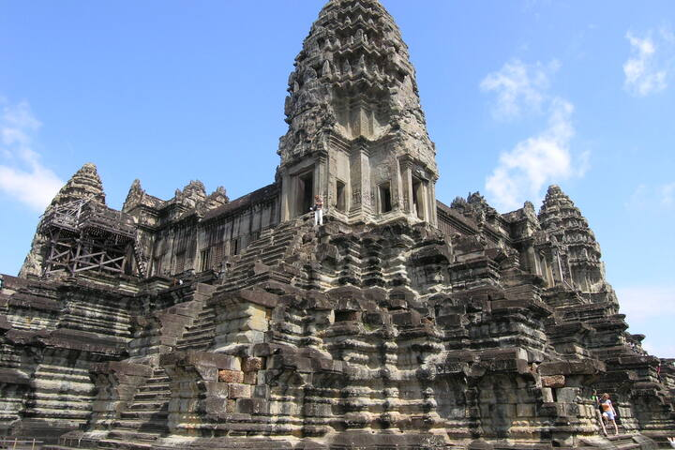
Source: UNESCO World Heritage Centre. (n.d.). Angkor – Case study: Angkor and The Tourism Development Strategic Plan 2012–2020. https://whc.unesco.org/en/sustainabletourismtoolkit/guide2/angkor/

Table of Contents
1. Introduction 3
2. Main Reason for Developing and Implementing the Visitor Management Plan
3
3. Key Challenges Faced by the Site
4
4. Strategies and Measures Implemented
5
5. Outcomes and Success of the Visitor Management Plan
6
6. Conclusion 7
7. References 7

- Introduction
Angkor, historically known as Yasodharapura, served as the capital of the Khmer Empire between the 9th and 15th centuries. Located in present-day Cambodia, the site encompasses remarkable monuments such as Angkor Wat and Angkor Thom, which together form one of Southeast Asia’s most significant archaeological landscapes. Recognized as a UNESCO World Heritage Site, Angkor attracts millions of visitors annually, making it both a cultural treasure and a tourism-dependent economy. However, its popularity has brought several conservation and management challenges. To address these, the Angkor World Heritage Area Tourism Management Plan (TMP) 2012–2020 was introduced under the broader Heritage Management Framework (HMF) project (UNESCO World Heritage Centre, n.d.).
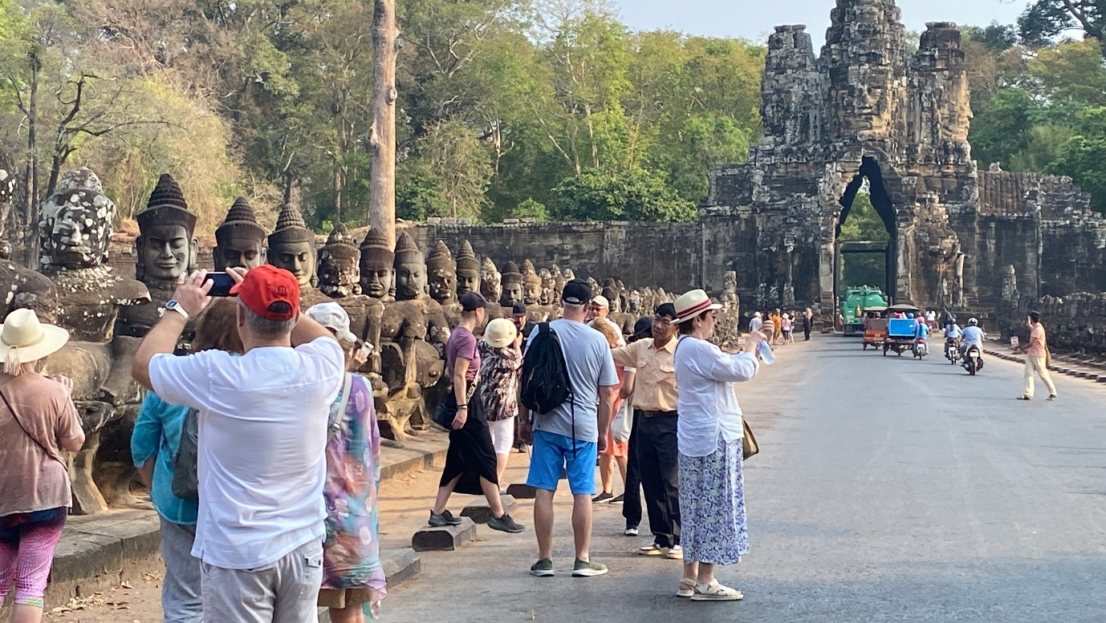
Source: Soklim, K. (2024, September 21). Enhancing visitors’ experience of Angkor beyond the temples. Cambodianess. https://cambodianess.com/article/enhancing-visitors-experience-of-angkor-beyond-the-temples
- Main Reason for Developing and Implementing the Visitor Management Plan
The rapid growth of international tourism to Angkor placed increasing pressure on the fragile sandstone structures and surrounding environment. Following its inscription as a World Heritage Site in 1992, Angkor was immediately placed on the List of World Heritage in Danger due to threats from regional conflict and inadequate management practices. Although the site was removed from this list in 2004, the escalating tourism numbers—exceeding two million visitors annually—emerged as a new and serious threat (Watson, 2008).
Tourism, while crucial to Cambodia’s economy, risked degrading the archaeological integrity of the monuments through physical wear, overcrowding, and disrespectful visitor behavior. Moreover, Angkor is a living landscape inhabited by local communities whose economic realities often conflicted with heritage preservation goals. Many residents of Siem Reap Province, one of Cambodia’s poorest regions, depended on tourism for survival, prioritizing short-term economic gain over long-term sustainability (UNESCO World Heritage Centre, n.d.). Recognizing that unmanaged mass tourism could cause irreversible damage, authorities determined that a structured and collaborative management approach was essential. The Angkor TMP (2012–2020) was therefore developed to protect the site’s cultural and natural values, enhance visitor experience, and support local livelihoods through sustainable tourism practices.
- Key Challenges Faced by the Site
Angkor’s management faced multiple interrelated challenges. First, the constant rise in tourist arrivals required greater regulation and limits on visitor access to certain areas. Overcrowding not only accelerated physical degradation but also diminished the spiritual and aesthetic experience of the site (International Coordinating Committee for the Safeguarding and Development of Angkor [ICC-Angkor], 2018).
Second, many visitors and tour operators lacked awareness of Angkor’s cultural and religious significance. The temples are sacred spaces, yet inappropriate dress, noise, and climbing behaviors were common, undermining their sanctity.
Third, tourism-related impacts included environmental degradation, waste accumulation, traffic congestion, and erosion of pathways. Broader urban pressures such as water scarcity, poor waste management, and increased air pollution further strained the fragile ecosystem (ICC-Angkor, 2018).
Visitor behavior and safety were also concerns. The absence of adequate first aid, poor infrastructure, and aggressive touting affected both safety and satisfaction. Infrastructure deficits—particularly in transport management, sanitation, parking, and rest facilities—intensified congestion and visitor discomfort.
Additionally, many local communities felt marginalized from the tourism benefits. Despite living within or near the heritage zone, they often lacked access to tourism-related income and faced social tensions as the influx of visitors altered traditional practices. Weak governance and insufficient coordination among government bodies, tourism operators, and local stakeholders further complicated the situation (ICC-Angkor, 2018).

- Strategies and Measures Implemented
In response to these challenges, the Angkor TMP (2012–2020) was collaboratively designed by the APSARA National Authority, the Ministry of Tourism, UNESCO, and the Government of Cambodia, with technical support from the Australian Government and consultants from Godden Mackay Logan (ICC-Angkor, 2018). The plan aimed to integrate conservation, tourism management, and community development through six strategic initiatives:
- Promoting Positive Visitor Experiences: The TMP emphasized improving the overall quality of the visitor experience by diversifying attractions and routes within and around the Angkor World Heritage Park. Alternative sites such as Chong Kneas and Koh Ker were promoted to disperse tourist flows and reduce pressure on the main temples. Enhanced signage, interpretation, and visitor services aimed to foster deeper understanding of Angkor’s heritage significance.
- Reducing Site Impacts: Visitor education campaigns and the introduction of a code of conduct sought to encourage responsible behavior. Measures such as limiting visitor numbers at vulnerable temples, managing pedestrian flows, and upgrading walkways and viewing areas helped minimize direct physical impacts.
- Partnerships with Industry: The TMP encouraged collaboration with tourism businesses to adopt sustainable practices. Regular dialogue with tour operators and guides aimed to align their activities with conservation objectives while enhancing service standards.
- Benefits for Local Communities: Local participation was central to the TMP. Initiatives were introduced to increase community involvement in tourism-related enterprises, from handicraft production to guided tours. These programs sought to distribute tourism revenue more equitably and reduce rural poverty, while also promoting respect for local cultural traditions.
- Improved Governance: Strengthening institutional capacity and ensuring transparent allocation of tourism revenue were critical components. The APSARA Authority was tasked with enforcing regulations and coordinating multi-agency management to ensure consistent implementation.
- Stakeholder Engagement: The TMP established mechanisms for consultation among government agencies, private sector partners, NGOs, and local communities. Regular communication and feedback loops helped build trust and ensure that all voices were considered in decision-making.
Together, these strategies represented a shift from reactive preservation to proactive, integrated management aimed at achieving both conservation and socio-economic goals.
- Outcomes and Success of the Visitor Management Plan
Although ongoing challenges remain, the 2012–2020 plan yielded notable achievements. The introduction of a visitor code of conduct improved public awareness and led to more respectful behavior within temple precincts. Enhanced signage and communication materials have helped visitors understand appropriate dress codes and conduct, reducing incidents of disrespect in sacred areas (UNESCO World Heritage Centre, n.d.).
The plan’s focus on regulating visitor numbers and distributing tourist flows has reduced crowding and physical stress at the most fragile monuments. For instance, time-based and route-based restrictions were applied to popular sites such as Angkor Wat, helping to manage daily carrying capacity effectively (ICC-Angkor, 2018).
Infrastructure improvements, including better pathways, sanitation facilities, and transport management, have enhanced visitor safety and comfort while minimizing environmental damage. The period of reduced tourism during the COVID-19 pandemic was also used effectively to undertake restoration work and upgrade facilities, reinforcing the site’s long-term sustainability.
The TMP has also strengthened coordination among management agencies and stakeholders, promoting a more unified governance structure. International observers, including UNESCO, have praised Angkor’s management as a model for heritage conservation in post-conflict nations. The site now demonstrates a clearer balance between conservation imperatives and tourism growth (UNESCO World Heritage Centre, n.d.).
Moreover, local communities have become more engaged through training, craft development, and small-scale tourism enterprises. While economic disparities persist, these programs have fostered a greater sense of inclusion and ownership among residents.
Nonetheless, long-term challenges remain, including ensuring equitable revenue distribution, enforcing visitor caps, and addressing urban development pressures in Siem Reap. Continued vigilance and adaptive management are required to sustain the progress achieved.

- Conclusion
The Angkor Tourism Management Plan (2012–2020) illustrates how a structured visitor management approach can reconcile the competing goals of conservation, tourism, and community development. Its success lies in adopting a multi-pronged strategy—combining education, infrastructure, regulation, and stakeholder collaboration—to manage one of the world’s most complex heritage landscapes. The Angkor case underscores that sustainable tourism management is an ongoing process that demands flexibility, community engagement, and long-term commitment rather than a single policy solution.

- References
Angkor. (n.d.). Wikipedia. https://en.wikipedia.org/wiki/Angkor. Wikipedia
Doherty, B. (2010, September 27). Private water raiding threatens Angkor's temples built on sand. The Guardian. https://www.theguardian.com
International Coordinating Committee for the Safeguarding and Development of Angkor. (2018). Tourism management plan: Angkor World Heritage Area 2012–2020. http://icc-angkor.org/wp-content/uploads/2018/09/Tourism-Managment-Plan.-Eng.pdf
Soklim, K. (2024, September 21). Enhancing visitors’ experience of Angkor beyond the temples. Cambodianess. https://cambodianess.com/article/enhancing-visitors-experience-of-angkor-beyond-the-temples
UNESCO — State of Conservation reports (2023). Angkor (Cambodia) SOC 2023. https://whc.unesco.org/en/soc/4521/. UNESCO World Heritage Centre
UNESCO World Heritage Centre. (n.d.). Angkor: Sustainable tourism case study. https://whc.unesco.org/en/sustainabletourismtoolkit/guide2/angkor/
Watson, P. (2008, July 19). Too much adoration at Cambodia’s Angkor temples. Los Angeles Times. https://www.latimes.com

