European Institute of Innovation, Entrepreneurship and Technology
Applied Campaign Strategy Report
Option 1: Integrated Advertising and Multi-Channel Media Campaign for Destination
Branding

Name-Satwinder kaur
Student ID- satwinder6015

Table of Contents
1. Introduction 4
2. Target Audience & Brand Positioning Analysis 5
2.1 Target Audience Segmentation 5
2.2 Audience Personas 6
2.3 Berlin’s Brand Positioning Analysis 7
3. Communication Strategy & Messaging Framework 9
3.1 Integrated Marketing Communication (IMC) Strategy 9
3.2 Campaign Message Development 11
3.3 Communication Framework 11
4. Integrated Media Plan & Campaign Execution 13
4.1 Traditional Advertising Channels 13
4.2 Digital and Social Media Strategy 14
4.3 Omni-Channel Media Mix 14
4.4 Destination Advertising Case Studies 15
4.5 Proposed 12-Month Campaign Plan 16
Crisis Communication & PR Strategy 18
5.1 Potential Tourism Reputation Risks 18
5.2 PR Response Strategy 18
5.3 Reputation Management 19
6. Budgeting & Measurable KPIs 20
6.1 Campaign Budget Allocation 20
6.2 Performance Measurement 20
7. Conclusion & Recommendations 22
References 23

Executive Summary
This report intends to develop a holistic advertising and multi channel media campaign plan to city of Berlin, Germany to come up with a unifying image of the world famous tourist destination. They will be proposed in the campaign Berlin Beyond the Ordinary, which will introduce the exceptional mix of the cultural heritage of Berlin, creative approaches, diversity and contemporary urban life. The report considers major target groups (cultural travellers, young and adventure travellers and premium urban holiday travellers) and their motivations and communication needs.
The suggested approach has an Integrated Marketing Communication (IMC) approach that incorporates classical advertising, online channels, social media, collaboration with people with fan bases through partnerships and PR activities. The campaign focuses on the vibrant nature of Berlin as a city that comes together with the past and the future and which will allow its tourists to explore more than the usual tourist attraction. The 12 month campaign strategy is intended to be realized in phases of recognition, participation and actions, structured and allocated budget with KPI that can be measured. The measurement of performance will be in terms of reach, engagement, traffic, and visitor interest and ROI. The report also looks at how crisis communication and reputation management played in maintaining the trust of visitors and long term competitiveness of the destination.

1. Introduction
The destination branding concept has increasingly become relevant in an effort to facilitate the tourism organisations create a great profile international image to attract international tourists. Integrated communication campaigns, public relations and advertising help Destination Management Organisations (DMOs) influence the perceptions of the travellers, emotionally appeal to them and urge them to go to the destination (Zhou et al., 2024). In the competitive world tourism industry where markets are highly competitive in cultures, destinations need to consider both the traditional and digital media in their endeavours to deliver to the tourists special experiences. The Berlin, Germany has developed an exclusive concept of tourism relying on its cultural background, innovation, history and modern city life. Being one of the world cities of interest, Berlin is appealing to various classes of visitors, such as cultural tourists, youthful travelers and experience-seeking foreign tourists. Nevertheless, the global presence should be maintained based on the indefatigable communication initiatives to respond to evolving traveller trends including changing traveller behaviours and digital trends (Ahmed, 2025).
This report gives a multimedia campaign of advertising and the media channel strategy to assist Berlin in the destination branding. It examines target audiences, positioning of the brands, communication strategies and the choice of the media. In addition, it provides an action plan of a 12 months campaign with performance indices that can be quantified on raising the international tourism attractiveness of Berlin, and enhancing visitor interaction.

2. Target Audience & Brand Positioning Analysis

2.1 Target Audience Segmentation
In order to come up with a successful destination brand, it is essential to establish different groups of visitors who can have their needs, inspirations and travelling habits fulfilled in Berlin. The integrated advertising campaign could be divided according to the demographic, geographic, Psychographic and behavioural characteristics. The primary target market will comprise of international cultural tourists who are interested in the historical, museums, architecture and native experiences of the locals in the area. Berlin prides itself with historical sites, artistic and cultural activities that appeal to tourists in need of informative and fulfilling travels (Zhou et al., 2025). Young experience-seeking travellers are another important segment, which are exposed to social media, digital storytelling and exclusive urban experiences. According to a report by Tufft et al. (2024) 41% of GenZ and 37% of millennials have show strong interest in travelling. Their priorities are the creativity, night life, sustainability and prospects to interact with local communities.
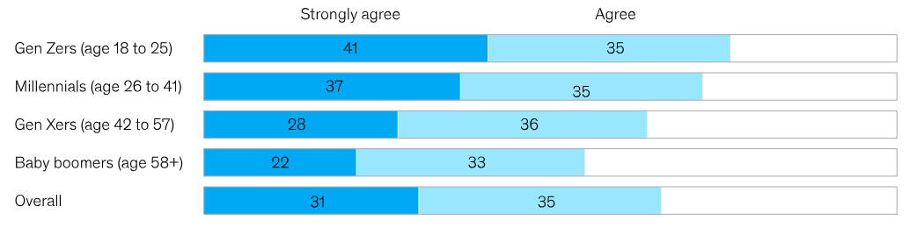
Figure 1: Growing travel interest among young generations
Source: (Tufft et al., 2024)
The other high value segment would be those who are the premium traveller or city-break visitors that represent European and global markets and interested in short yet memorable experiences. Another large intended group consists of business travellers who like to visit Berlin to hold conferences and events as Germany is one of the innovations and business centres of the world (Henn & Bathelt, 2025). Geographically, the campaign should be placed at major global destinations in Europe, North America and Asia where its target travelers have been found to be hugely motivated by European city tourism. Through catering to these diverse segments through the use of personalised communication with and utilising the media channels, Berlin will be in a position to improve on its image as a global destination.

2.2 Audience Personas
Establishing audience personas can assist the tourism campaign in Berlin to comprehend what motivates and gives preference to the visitor and communication requirements.
Category | Description
Name | Anna Müller
Age | 25–35 years
Location | Europe and North America
Travel Purpose | Cultural exploration and city experiences
Interests | History, museums, street art, nightlife, local experiences
Digital Behaviour | Uses Instagram, TikTok and travel blogs for inspiration
Expectations | Authentic experiences and creative urban environments
Table 1: Persona 1 – Young Cultural Explorer
Source: (Self-created)
Anna is a representative of young travellers around the globe who desire to experience meaningful and or unique experiences in the cities. It is an extremely sensitive population to internet content, reviews and anecdotes through social media. Their interest in travel perfectly fits with architectural neighbourhoods of Berlin, historical places and cultural events. In this way, digital campaigns, influencer collaborations and user-generated content can be effective to capture this audience.
Category | Description
Name | David Smith
Age | 38–45 years
Location | Global markets
Travel Purpose | Premium leisure and short city breaks
Interests | Heritage, gastronomy, architecture and exclusive experiences
Digital Behaviour | Uses travel websites and online reviews
Expectations | Quality services, convenience and memorable experiences
Table 2: Persona 2 – Premium Experience Traveller
Source: (Self-created)
David is an embodiment of higher-value travellers that pursue comfortable and organised tourism experiences. This segment responds to destination websites and high travel content, and professional storytelling. An orientation on the history of Berlin culture, including its cuisine and foreign festivals can be used to make it even more appealing to this audience.

2.3 Berlin’s Brand Positioning Analysis
The concept of Berlin destination brand positioning is a special blend of historical and cultural diversity, creativity and modern urban experiences. Unlike the traditional European centres where majority of them are heritage tourism, Berlin produces itself as a young and exciting city with history and innovation (Kalandides & Grésillon, 2021). The motif of freedom, diversity, multicultural experiences, technology and art are closely tied to the identity of the city. The country depends on a variety of attraction of the city and its historical sites, museums, galleries, music clubs and different food to be found in the city define its utility (Audretsch et al., 2021). These are the dimensions, which are attractive to the cultural tourists, and other international visitors who are already looking towards searching their informative and fun urban escapades. The emotional positioning of the city is all about exploration, individuality and authenticity because the city is encouraged to tour the city beyond the mainstream tourism.
The aspects which contribute to the Berlin as having the unique selling proposition (USP) are that it offers a genuine and dynamic urban environment. Street art culture and creative vibe sets apart the city in other European capitals due to the city creative districts (Barwick, 2022). This positioning can be concentrated by Berlin with the help of combined promotion and online storytelling, focusing more on the real life experience of the visitors and local storytelling. However, with the increasing rivalry of cities destinations in Europe, Berlin must have a concise and consistent brand message. By using a multi-channel communication approach it can be used to strengthen the image as a creative, inclusive and culturally diverse destination (Cooper et al., 2021).

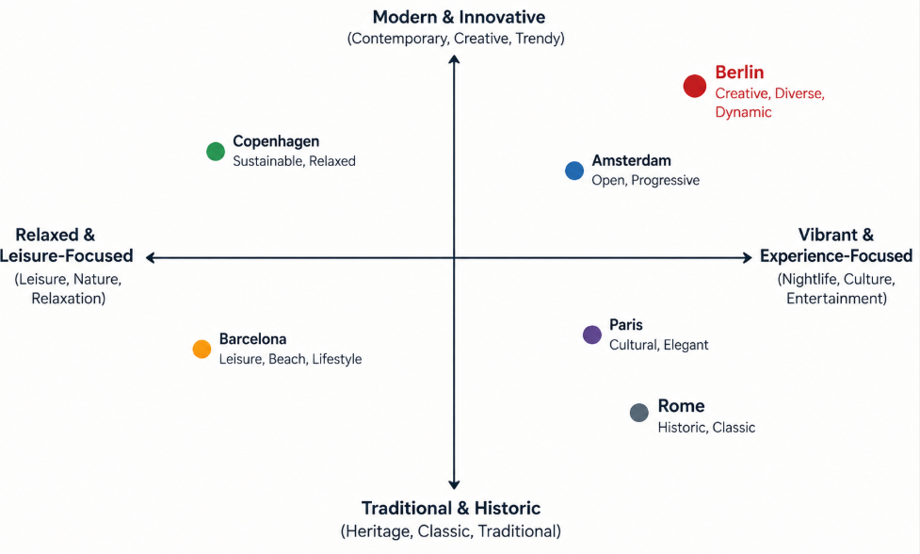
Figure 2: Positioning map for Berlin
Source: (Self-created)

3. Communication Strategy & Messaging Framework

3.1 Integrated Marketing Communication (IMC) Strategy
Integrated Marketing Communication (IMC) approach ensures that the message of communication is the same and meaning across the different communication channels (Rehman et al., 2022). In the case of destination branding campaign of Berlin, IMC will incorporate advertising, PR, e-marketing and social media communication to provide homogenous visitor experience.
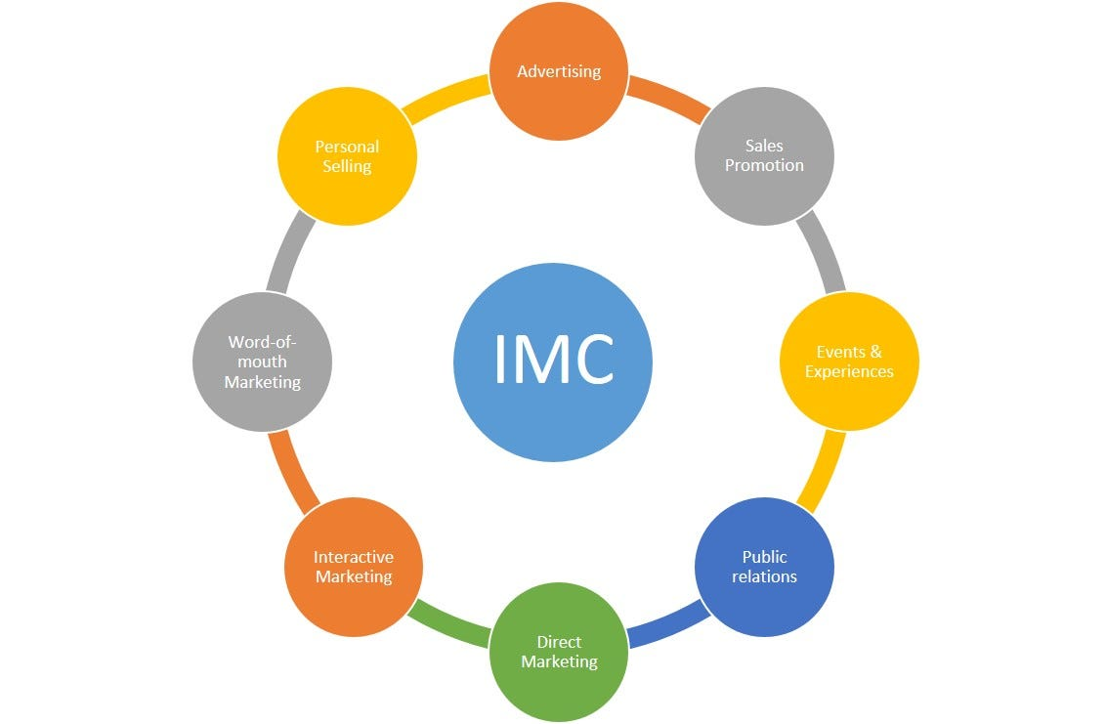
Figure 3: Components of IMC
Source: (Rehman et al., 2022)
The course of action will be to establish Berlin as a historical tourist destination, a diverse and a creative destination. Traditional media, such as television, print media and the outdoor media can raise destination awareness to more people in wider international settings (Skočajić et al., 2024). At the same time, there is a possibility of interactive narration and one-on-one interaction via digital media, such as Instagram, YouTube, TikTok and the special tourism page. Credibility and trust can be reinforced further by the PR actions such as media alliances and travel magazines (Dowling, 2025). The IMC strategy will encompass all stages of the tourist cycle which include destination awareness all the up to travelling selection and after promotion. Through the combination of various channels with the same branding, Berlin will be able to enhance global presence, foster emotional associations and assert its presence as one of the top city destinations in Europe.

3.2 Campaign Message Development
Campaign Theme
The theme of the campaign proposed is called Berlin Beyond the Ordinary. It serves to convey the message of the destination of Berlin being an opportunity to see beyond the city itself in the realms of its see-sightseeing. The message identifies the fusion of the historical experiences, innovative creativity, modernity and different communities that the city offers.
Core Message
The main concept is the capital city of Berlin in which past and present are blended and any visitor can discover their experience. This position statement indicates that Berlin is a freedom, real, cultural adventure destination. It will target travellers who want to undergo meaningful experiences.
The emotional appeal of the campaign is premised on questions, inspiration and discovery of oneself by showing the audience local events, various cultural events and the feeling of the city itself. Digital storytelling, such as videos, posts on social media, visitor-generated content will be a part of the campaign to offer the real experiences of the Berlin exploration (Varelas, 2022). The utilisation of local communities would allow the campaign to be natural and would force foreign viewers to perceive Berlin as a place worth visiting as it is a lively and an exciting city.

3.3 Communication Framework
AIDA Model Application
Attention stage will focus on creating global awareness of Berlin and this will be done through the use of eye catching adverts, promotion of Berlin in the social media and destination video adverts. The campaign theme will be Berlin Beyond the Ordinary where the theme of creativity, history and diversity of the city will be highlighted to attract international audiences. The Interest stage will entail informing communication, involving, communication about the attractions, events and unique experiences of Berlin (Wei et al., 2022). Travel media and influencer collaborations, online storytelling and blogs have the potential to influence viewers to discover more about the destination (Lee & Trim, 2022). The Desire phase is oriented upon building emotional relations showing the actual experience of a visitor, experience of the localities, and memorable moments. The Action step will facilitate practical travel decisions by offering the practical booking information, destination sites, travel packages and promotional packages.
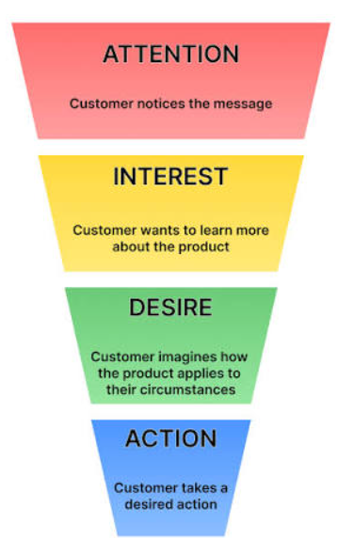
Figure 4: AIDA model
Source: (Lee & Trim, 2022)
Customer Journey Stages
The customer journey stage begins with the inspiration stage whereby the customers get to know about Berlin through advertising and social media. The consideration stage entails the comparison of experience, reading reviews and travel information (Nilashi et al., 2021). The reservation procedure is designed to streamline the travelling planning procedure through the assistance of online tools. Finally, post-visit stage assists visitors to share experiences with reviews and user generated content which will underpin the long term destination image of Berlin.
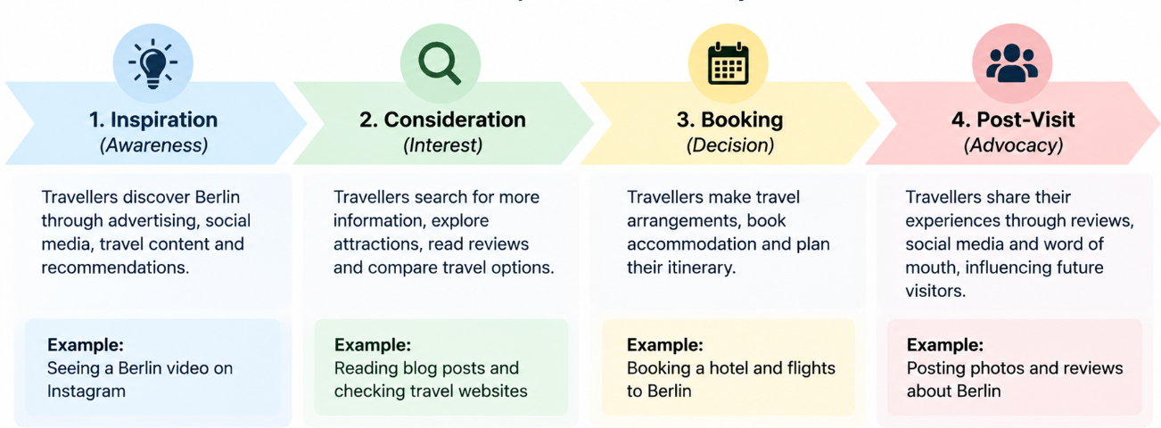
Figure 5: Stages of customer journey
Source: (Self-created)

4. Integrated Media Plan & Campaign Execution

4.1 Traditional Advertising Channels
The classic means of advertising are not obsolete to create wide awareness and reinforcement to the image of Berlin as an international destination. Television commercials can be employed in promotion of Berlin cultural sites, historical occurrences and innovative vibe using picturesque source tales. It is tremendously emotionally evoking and can reach a vast audience of people across the globe. Detailed communication can be enhanced by use of print advertisement that entails the travel magazines, brochures and tourism publishing and fronting the information regarding the attractions, events and travelling experiences (Santos & Mukminin, 2022). Advertisements at the airports, billboards, transporting advertisements and out-of-home (OOH) advertisements might be resorted to targeting travellers during the critical decision making stages. This traditional media can help to create a strong brand awareness and reputation when combined with online communication initiatives.

4.2 Digital and Social Media Strategy
It requires the Internet and social media to fulfill the demands of the new traveller and create the impression of everlasting communication with the destination brand Berlin. The marketing will be conducted on the official tourism site, search engine optimization (SEO) and online travelling information to provide easy to use information and to book travel easily (Ďaďová & Soviar, 2021). They will be communicated on social media platforms in Instagram, Tik Tok and YouTube including short video-based storytelling and in real life through visiting obstacles, visitor videos and experience. The generation of content by users and partnership with influencers will increase trust in proving the real picture of exploring Berlin. Digital advertising will be implemented by segmenting visitors with the paid advertising which will be based on interests, location and travel behavior. The audience can be helped to participate with interactive content such as polls, live sessions and virtual experiences (Gomes et al., 2023). This online-first plan will ensure Berlin becomes recognized all over the world and build a stronger connection with its potential customers.

4.3 Omni-Channel Media Mix
The media mix through omnichannel method of communication will be to incorporate a combination of the traditional media and the digital media in an attempt to come up with an integrated and comprehensive experience to the target markets of Berlin. This campaign will be a combination of television, print and outdoor advertisements and web platform, social media, influencer marketing and the official tourism site. Both the creation of the destination awareness and communication will occur through the digital channels whereas the traditional media will act as a key source of destination awareness. In a more indicative manner, travelers can have access to Berlin online with just a billboard in the country and abroad by scanning the QR codes which direct them to information regarding the campaign. The online dialogue might be additionally maintained in the social networks by publishing stories of visitors, videos and travel tips (Ghaderi et al., 2024). This combined approach offers continuity to the message which will be conveyed to the audience via different touchpoints to increase brand awareness, engagement and conversion along the customer journey.

4.4 Destination Advertising Case Studies
Successful Case Study: “Visit the world of Berlin” campaign
VisitBerlin, the destination marketing organisation of Berlin has come up with integrated campaigns aimed at enhancing the international tourist identity of the city. A combination of digital communication, storytelling, events and international marketing activities was the Visit the World of Berlin campaign that promoted Berlin as a city of diversity, culture and unique experiences (visitBerlin.de, 2023). The emotional stories were used in the campaign to showcase the appeal of Berlin, experiences and creative vibe of the city, which helps position Berlin as an open and creative destination. A good usage of integrated communication in connecting the online platforms, tourism partners and PR activities can be seen in the campaign.
Negative Case Analysis: Excessive use of Traditional Destination Image
Despite Berlin having a great reputation in various parts of the world, tourism communication is adversely challenged where the expectation of visitors conflict with the realities of the destination. The classic city attractions, such as the Berlin Wall, museums and nightlife, are featured in the portrait of the city but these traditional images may not get the viewer much engaged (Martyka et al., 2025). The current marketing campaigns are more localised with the neighbourhood experiences, sustainability and local stories to sell an extended destination brand. These instances indicate, the genuine use of stories, multi channel communication and continuous changes to new travelling requirements are fundamental to a successful destination advertisement.

4.5 Proposed 12-Month Campaign Plan
The strategic phases of Berlin Beyond the Ordinary will be carried out in three phases in order to create awareness, involvement of people and to make people visit.
Phase | Timeline | Key Activities | Main Objectives
Phase 1: Awareness Creation | Months 1–3 | - Launch TV, outdoor and digital advertisements  - Promote campaign theme through social media and tourism websites | Build international awareness and introduce Berlin’s unique cultural and creative identity
Phase 2: Engagement Building | Months 4–8 | - Collaborate with travel influencers; encourage user-generated content  - Share visitor stories, videos and interactive campaigns | Increase audience interaction, emotional connection and destination interest
Phase 3: Conversion & Loyalty | Months 9–12 | - Promote travel packages, events and booking opportunities  - Use retargeting campaigns and visitor advocacy content | Convert interest into visits and encourage repeat engagement
Table 3: Campaign timeline
Source: (Self-created)
The KPIs to be used in measuring the campaign will involve, reach, social media activity, number of visitors getting to the site, visitor enquiries and returns on investment (ROI). It is a gradual process that enables a continuous communication process across the customer journey (Liu et al., 2024). The Berlin 12 months campaign plan would be a progressive campaign that would bring about the promotion of Berlin as a worldwide tourist destination. The first stage is the awareness stage which focuses on creating awareness of the campaign message and international coverage done through a number of ways of adverts (Ketter & Avraham, 2021). The second step will be the process of generating the interest of the audience and this will be through the involvement of influencers to collaborate with, user-created stories, and interactive content. The last stage is aimed at turning the interest of the audience into the real visits by popularizing traveling possibilities and fostering loyalty of visitors. This facilitated process renders communication activities to be beneficial to every stage of customer experience, both during the initial awareness of the first and final destination promotions.

Crisis Communication & PR Strategy

5.1 Potential Tourism Reputation Risks
The tourism destinations have a number of reputation risks that could affect the perception and traveling of the people visiting the destination. The risk factors in the case of Berlin will be safety, transportation issues, political protests, environmental issues and bad visitors (Glock & Gerlach, 2023). It is a globally-recognised metropolis, and any news concerning crisis is available to share through digital interfaces, which impact the level of trust and destination image. Some of the risks include poor reviews, social media posts and misinformation among others. Since majority of the travellers visit the internet to make a decision about the travelling, destination attractiveness will be impacted by the negative perceptions (Teles et al., 2024). The other risk is on service interruptions like cancellation of flights, transport problems or unforeseen problems to the convenience of visitors.

5.2 PR Response Strategy
When there is a crisis in the tourism industry, an effective PR reply plan would be required in must make the concerned parties stay optimistic. The communication strategy that Berlin ought to embrace is a proactive one which is aimed at being transparent, fast and accurate. The first one should be to enable the identification of the issue, assess the implications and establish a special crisis communication department that will take charge in coordinating the responses. Official statements can be made through effective communication channels including destination site, social sites and through press releases (Casal-Ribeiro et al., 2025). Messages need to recognize the stakeholder issues and offer them factual updates and clarify to them what is being done to rectify the situation. Frequent interconnectedness via the various modes could contribute to a reduced amount of confusions and, consequently, contribute to the eradication of misinformation. Crisis management should also be enhanced by means of media relations (Wang et al., 2021). Establishing a good rapport with journalists, tourism partners and industry stake holders can enhance it to share information accurately. The ability to report to the executive by the tourism leaders can also be used to demonstrate responsibility and commitment in regard to visitor safety and trust. Immediacy crisis response should be followed by the PR efforts to reinstate confidence in the positive storytelling and evidence-based communication strategies.

5.3 Reputation Management
Reputation management involves a continuous review and improvement of the perception that the people have of Berlin when visiting or as a stakeholder. The online conversations, customer reviews and social media discussions pertaining to the destination can be tracked using digital monitoring tools. Early realisation of negative trends helps the tourism organisations to respond at an early stage when the situation is not too big to handle as far as reputation is concerned (Skovoroda et al., 2025). To promote the concept of positive visitor advocacy, Berlin must be involved in the aspect of authentic visiting by promoting user made content, testimonials and social media engagements. Stories of visitors could be shared by the local communities and tourism partners and provide a more balanced and reliable destination image. In addition, there should be good stakeholder relations with hotels, attractions, transport operators and locals communities, in the long run, to maintain a good reputation (Đurić et al., 2025). There will be joint communications to ensure that different stakeholders of tourism communicate as one and work towards the objectives of the destinations. Active risk planning, as well as fostering open communication about the disaster with active reputation inspection, will help Berlin save its destination image and retain the trust of the visitors.

6. Budgeting & Measurable KPIs

6.1 Campaign Budget Allocation
The budget that is suggested to the campaign of Berlin Beyond the Ordinary will be directed to assist with the mixed communication strategy both in traditional and in digital media. The total campaign budget will be 12 months with an estimated cost of 1,000,000 euro. The distribution considers the priority of advertising, digital, PR and performance measurement operation.
Campaign Activity | Purpose | Estimated Budget (€)
Digital Advertising & Social Media | Paid campaigns, content promotion and audience targeting | €300,000
Television & Video Advertising | International destination awareness campaigns | €250,000
Influencer Partnerships & Content Creation | Authentic storytelling and visitor engagement | €150,000
Outdoor & Print Advertising | Airport, city and travel media promotions | €150,000
PR Activities & Media Relations | Press communication and reputation building | €100,000
Analytics & Performance Monitoring | KPI tracking and campaign evaluation | €50,000
Total |  | €1,000,000
Table 4: Budget allocation
Source: (Self-created)

6.2 Performance Measurement
Awareness KPIs
The awareness stage indicators will be the reach of advertising, impressions, the number of visits to a web site, and destination search (Matusse et al., 2023). These indicators will show whether this campaign is successful in sensitizing the target groups about Berlin to the international masses.
Engagement KPIs
Engagement will be assessed through social media activities as likes, comments, shares, watching videos, engaging in user-created content. It will be high engagement that will show more interest and emotional attachment to the destination brand of Berlin.
Conversion KPIs
Measurements that will be converted will be used to find out whether communication activities have an impact on travel choices. These include as a booking query to a web site, campaign click-throughs, visitor counts and contact with travel packages. By tracking the indicators mentioned above, it will be possible to get answers to whether the campaign had been successful in attracting tourists to the destination (Florido-Benítez & del Alcázar Martínez, 2024).
ROI and Evaluation
The measurable performance will be ROI, which will be based on the expenditure of campaigns and the outcome like higher spending by the visitors, higher conversions owing to marketing campaigns. The changes of the campaign as well as future destination marketing decisions will be made periodically based on their analytics. It is a data-driven method to effectively and targeted promotion activities of Berlin and visitor-anticipated.

7. Conclusion & Recommendations
Berlin will also need a uniform and combined communication strategy in order to be competitive on the global tourism platform. The artificially created project Berlin Beyond the Ordinary is designed to promote a vision of Berlin as a versatile, innovative and culturally vibrant city through integration of conventional advertisement, e-marketing, narrative and PR. The campaign also has the potential of increasing awareness about the campaign, engagement, and intentions to travel, as the campaign is meant to capture the interest of the target audiences and applies to personalised communication measures.
Recommendations
Berlin needs to pour additional and additional investment into the digital narrative and story-telling through social media platforms, collaboration with influencers and user-created content to develop a real relationship with foreign tourists. In addition the destination must be in a more suitable position to execute personalised marketing, delivery of appropriate messages to the various segments of tourists. Berlin should also ensure its reputation management system is strong in order to monitor the online discussion and to respond quickly to any issues. Further, continual campaign evaluation, by measurement such as reach, engagement, counts of visitors and ROI must be set to improve further marketing and to maintain isolated competitiveness in the long-run.

References
Ahmed, S. (2025). Tourism today: Trends, challenges, and opportunities. Journal of Educational Studies, 3(1). https://ejournal.baleliterasi.org/index.php/JEs/article/view/1263
Audretsch, D. B., Lehmann, E. E., & Seitz, N. (2021). Amenities, subcultures, and entrepreneurship. Small Business Economics, 56(2), 571-591. https://doi.org/10.1007/s11187-019-00190-5
Barwick, C. (2022). Labour or lifestyle? Understanding urban incorporation of European middling migrants. Global Networks, 22(3), 466-482. https://onlinelibrary.wiley.com/doi/abs/10.1111/glob.12363
Casal-Ribeiro, M., Peres, R., & Boavida-Portugal, I. (2025). DMOs and social media crisis communication in low-responsibility crisis:# VisitPortugal response strategies during COVID-19. Tourism and Hospitality, 6(1), 49. https://doi.org/10.3390/tourhosp6010049
Cooper, M. A., Camprubí, R., Koc, E., & Buckley, R. (2021). Digital destination matching: Practices, priorities and predictions. Sustainability, 13(19), 10540. https://doi.org/10.3390/su131910540
Ďaďová, I., & Soviar, J. (2021). The application of online marketing tools in marketing communication of the entities with the tourism offer in 2020 in Slovakia. Transportation Research Procedia, 55, 1791-1799. https://www.sciencedirect.com/science/article/pii/S2352146521005925
Dowling, D. O. (2025). Conceptualizing the co-evolution of journalism and public relations: toward a theory of branded news content’s hybrid forms. Journalism Studies, 26(4), 423-440. https://doi.org/10.1080/1461670X.2024.2433637
Đurić, Z., Cvijanović, D., Petek, V., & Potočnik Topler, J. (2025). Sustainability struggle: Challenges and issues in managing sustainability and environmental protection in local tourism destinations practices—An overview. Sustainability, 17(15), 7134. https://doi.org/10.3390/su17157134
Florido-Benítez, L., & del Alcázar Martínez, B. (2024). How artificial intelligence (AI) is powering new tourism marketing and the future agenda for smart tourist destinations. Electronics, 13(21), 4151. https://doi.org/10.3390/su131910540
Ghaderi, Z., Béal, L., Zaman, M., Hall, C. M., & Rather, R. A. (2024). How does sharing travel experiences on social media improve social and personal ties?. Current issues in tourism, 27(21), 3478-3494. https://doi.org/10.1080/13683500.2023.2266101
Glock, J. P., & Gerlach, J. (2023). Berlin Pankow: a 15-min city for everyone? A case study combining accessibility, traffic noise, air pollution, and socio-structural data. European Transport Research Review, 15(1), 7. https://doi.org/10.1186/s12544-023-00577-2
Gomes, G., Conte, T., Castro, T., & Gadelha, B. (2023, April). Engagement, Participation, and Liveness: Understanding Audience Interaction in Technology-Based Events. In ICEIS (2) (pp. 264-275). https://pdfs.semanticscholar.org/9096/d35573e744e35a3733bec50589a82989c661.pdf
Henn, S., & Bathelt, H. (2025). Knowledge transfers from business conferences to firms’ permanent locations. Geografiska Annaler: Series B, Human Geography, 107(2), 194-212. https://doi.org/10.1080/04353684.2023.2296572
Kalandides, A., & Grésillon, B. (2021). The ambiguities of “sustainable” Berlin. Sustainability, 13(4), 1666. https://doi.org/10.3390/su13041666
Ketter, E., & Avraham, E. (2021). # StayHome today so we can# TravelTomorrow: tourism destinations’ digital marketing strategies during the Covid-19 pandemic. Journal of travel & tourism marketing, 38(8), 819-832. https://doi.org/10.1080/10548408.2021.1921670
Lee, Y. I., & Trim, P. R. (2022). Enhancing marketing provision through increased online safety that imbues consumer confidence: Coupling AI and ML with the AIDA model. Big Data and Cognitive Computing, 6(3), 78. https://doi.org/10.3390/bdcc6030078
Liu, S. Q., Vakeel, K. A., Smith, N. A., Alavipour, R. S., Wei, C., & Wirtz, J. (2024). AI concierge in the customer journey: what is it and how can it add value to the customer?. Journal of Service Management, 35(6), 136-158. https://doi.org/10.1108/JOSM-12-2023-0523
Martyka, A. M., Rościecha-Kanownik, A., & Torres, I. F. (2025, July). Mural painting across eras: From prehistoric caves to contemporary street art. In Arts (Vol. 14, No. 4, p. 77). MDPI. https://doi.org/10.3390/arts14040077
Matusse, S. S., Xi, X., & Joaquim, I. M. (2023). Assessment of strategies to enhance the online presence of the Mozambican government website on tourism destination marketing. International Trade, Politics and Development, 7(1), 16-35. https://doi.org/10.1108/ITPD-07-2022-0012
Nilashi, M., Asadi, S., Minaei-Bidgoli, B., Abumalloh, R. A., Samad, S., Ghabban, F., & Ahani, A. (2021). Recommendation agents and information sharing through social media for coronavirus outbreak. Telematics and Informatics, 61, 101597. https://doi.org/10.1016/j.tele.2021.101597
Rehman, S. U., Gulzar, R., & Aslam, W. (2022). Developing the integrated marketing communication (imc) through social media (sm): the modern marketing communication approach. Sage Open, 12(2), 21582440221099936. https://journals.sagepub.com/doi/abs/10.1177/21582440221099936
Santos, M. L., & Mukminin, A. (2022). Persuasiveness used in selected philippines’ and thailand’s tourism brochures. Studies in English language and education, 9(3), 1201-1220. https://doi.org/10.24815/siele.v9i3.25312
Skočajić, I., Pavković, V., Krstić, J., Kostić-Stanković, M., Vlastelica, T., & Rajić, T. (2024). Urban tourism appeal: The effectiveness of communication channels and multimedia formats in creating tourists’ expectations. Sustainability, 16(11), 4552. https://doi.org/10.3390/su16114552
Skovoroda, R., Yang, W., Chen, B., & Buck, T. (2025). Exploring serial patterns in negative hotel reviews. Annals of Tourism Research Empirical Insights, 6(2), 100199. https://doi.org/10.1016/j.annale.2025.100199
Teles, R., Martins, H., Pinheiro, A., & Gonçalves, E. (2024). Tourists’ perception of tourist destinations: The case study of Nazaré (Portugal). Sustainability, 16(4), 1387. https://doi.org/10.3390/su16041387
Tufft, C., Constantin, M., Pacca, M., & Mann, R. (2024). The way we travel now. [online] McKinsey & Company. https://www.mckinsey.com/industries/travel/our-insights/the-way-we-travel-now
Varelas, S. (2022). Virtual immersive platforms as a strategic innovative destination marketing tool in the COVID-19 era. Sustainability, 14(19), 12867. https://doi.org/10.3390/su141912867
visitBerlin.de (2023). Visit the world of Berlin: Tourism campaigns 2023 | about.visitBerlin.De. About.Visitberlin.De. https://about.visitberlin.de/en/visit-world-berlin-tourism-campaigns-2023
Wang, P. Y., Hao, H., & Platt, L. S. (2021). Examining risk and crisis communications of government agencies and stakeholders during early-stages of COVID-19 on Twitter. Computers in human behavior, 114, 106568. https://doi.org/10.1016/j.chb.2020.106568
Wei, M., Liu, M., Xu, J., Li, S., & Cao, J. (2022). Understanding the influence of sensory advertising of tourism destinations on visit intention with a modified AIDA model. Asia Pacific Journal of Tourism Research, 27(3), 259-273. https://doi.org/10.1080/10941665.2022.2061367
Zhou, L., Liu, X., & Wei, W. (2025). The emotional foundations of value co-creation in sustainable cultural heritage tourism: Insights into the motivation–experience–behavior framework. Sustainability, 17(15), 6961. https://doi.org/10.3390/su17156961
Zhou, Y., Jo, W., Flaherty, J., & Li, T. (2024). How travel vlogs contribute to destination marketing: A comparison with DMO promotional videos and the moderating role of destination competitiveness. International Journal of Tourism Research, 26(5), e2755. https://doi.org/10.1002/jtr.2755

