Strategic Human Resource Management and Organizational Performance
Option 1 Report
M09 Human Resource Management
Detailed Project Report
Submission deadline: 24 May 2026

Contents
Table of Contents 2
Abstract 2
Introduction 3
Literature Review 5
Methodology 9
Findings 10
Discussion 14
Recommendations 18
Conclusion 19
References 20
Appendices 22
Appendix A. Evidence based HR implementation checklist 22
Appendix B. Suggested structure for implementation review meetings 23

Abstract
This report examines strategic human resource management as a performance architecture rather than an administrative support function. The central argument is that modern organizations do not gain durable advantage from isolated recruitment campaigns, isolated training budgets or annual performance reviews. They gain advantage when workforce planning, talent acquisition, skills architecture, performance management, retention, engagement and ethical people analytics operate as an integrated system that converts business strategy into measurable workforce capability. The report focuses on the digital and artificial intelligence intensive context of 2025 and 2026, where workforce risk is no longer limited to headcount gaps. It includes skills obsolescence, managerial overload, algorithmic bias, psychological contract erosion, weak internal mobility and declining engagement. The discussion uses a secondary qualitative methodology based on recent professional reports, academic research and corporate examples, with Microsoft, Unilever and Costco used as contrasting cases of strategic HR alignment. The findings show that strategic HRM contributes to organizational performance through 5 linked mechanisms: strategic workforce segmentation, skill based planning, evidence based recruitment, capability development, and retention systems that protect firm specific knowledge. However, the report also argues that HRM can damage performance when metrics are superficial, when artificial intelligence is introduced without governance, or when performance systems produce compliance rather than contribution. The recommendations propose a technical HR scorecard, predictive workforce planning, transparent selection analytics, manager capability investment and retention architecture linked to critical roles.

Introduction
Strategic human resource management is the deliberate alignment of people systems with an organization’s competitive logic, operating model and future capability requirements. In a stable industrial environment, HR departments could focus on job descriptions, vacancy filling, payroll, compliance and employee administration. That model is insufficient in 2026 because most organizations are facing simultaneous disruptions in artificial intelligence, hybrid work, skills scarcity, productivity pressure and employee trust. The World Economic Forum (2025) shows that large employers now treat workforce transformation as a central strategic issue across the 2025 to 2030 period, while Microsoft (2025a) frames artificial intelligence literacy and human agent collaboration as major determinants of work design. Strategic HRM therefore has to move from reactive service delivery to workforce architecture.
The importance of strategic HRM is visible in the relationship between people systems and business performance. Organizations need people who can execute strategy, adapt processes, innovate with technology, protect customer relationships and make ethical decisions under pressure. These outcomes are not produced by recruitment alone. They require an integrated configuration of workforce planning, selection, onboarding, learning, performance management, compensation and employee relations. The strategic issue is not whether each HR practice is individually good. The strategic issue is whether the whole HR system creates the behaviours, skills and commitment required by the business model. A low cost retailer, a high innovation software company and a regulated healthcare provider should not use identical HR architectures because their performance drivers are different.
This report chooses Option 1 and critically analyses how strategic HRM contributes to organizational success. The analysis is intentionally specific and technical. It avoids treating HRM as a list of functions and instead evaluates how HR planning, recruitment, training, performance management and employee retention support business objectives. It also examines the relationship between HRM practices, productivity and competitive advantage. The main claim is that strategic HRM creates value when HR decisions are based on workforce segmentation, capability economics and evidence based metrics. It becomes weak when it is reduced to engagement slogans, generic training hours or vacancy filling targets.
The report is structured according to the required format. The literature review develops the strategic HRM theory base using recent studies and contemporary workforce evidence. The methodology explains the secondary research approach. The findings identify the main mechanisms through which HRM supports performance. The discussion critically evaluates real world examples and highlights risks. The conclusion summarises the argument and provides a concise set of recommendations for organizations that want HRM to become a source of competitive advantage rather than a compliance cost.

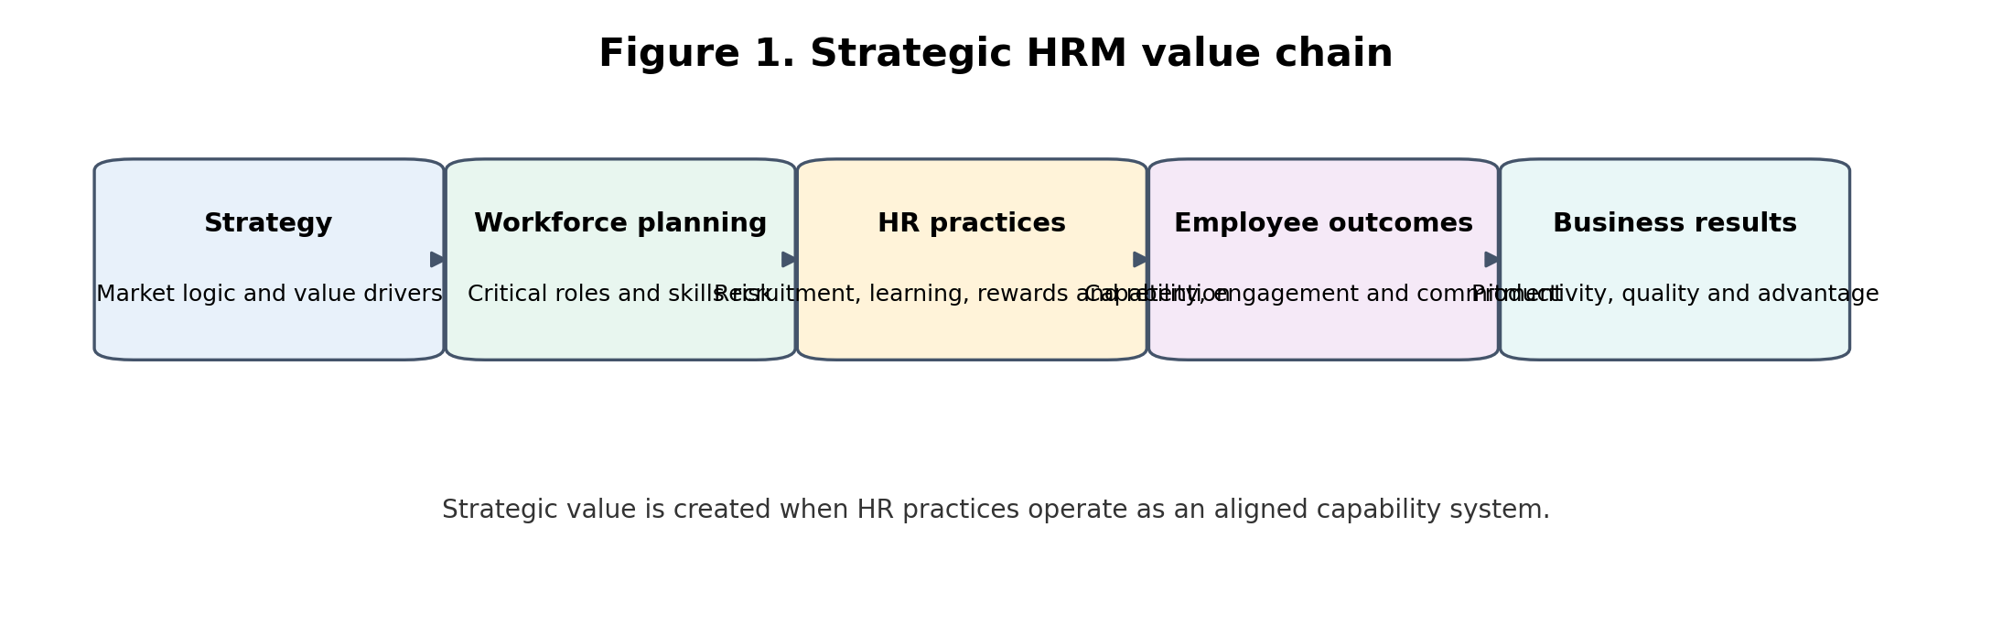
Figure 1. Strategic HRM value chain

Literature Review
Recent strategic HRM literature emphasises the shift from administrative HR to capability based people strategy. Nastase (2025) argues that in the digital era, human capital is not a passive input but a strategic enabler of sustainable advantage. This is important because many organizations still describe people as their most important asset while using HR systems that are slow, standardised and poorly connected to business outcomes. A strategic HRM perspective requires HR leaders to identify which workforce capabilities actually create value, where those capabilities sit in the operating model, and which practices protect or strengthen them.
A useful way to understand this issue is the distinction between HR activity and HR architecture. HR activity includes recruitment, training, appraisal and reward. HR architecture concerns how those practices are configured, sequenced and measured against strategy. Arokiasamy (2024) links HRM practices to organizational performance through employee engagement, retention, job satisfaction and productivity. However, the performance effect depends on the consistency and credibility of the system. Recruitment messages that promise autonomy will not improve performance if managers subsequently use restrictive control practices. Performance based pay will not motivate employees if targets are ambiguous, if managers lack feedback skill, or if employees perceive the process as politically biased.
The current workforce environment increases the strategic importance of HRM. The World Economic Forum (2025) identifies technological change, economic uncertainty and green transition pressures as factors reshaping jobs and skills. LinkedIn Learning (2025) similarly places artificial intelligence skills, career development and organizational adaptability at the centre of learning strategy. These reports are significant because they show that skills are becoming a dynamic portfolio rather than a static job requirement. HR planning must therefore forecast not only how many employees are needed but what combinations of technical, behavioural and managerial capability will be required by future workflows.
Strategic workforce planning is one of the most important mechanisms in SHRM because it converts strategy into labour demand and capability supply. A traditional headcount plan asks whether the organization has enough people. A strategic workforce plan asks which roles are critical to value creation, which roles can be automated, which capabilities are scarce, which teams face attrition risk, and where internal mobility can reduce external hiring dependency. In a software company, for example, senior platform engineers, AI safety specialists and enterprise sales architects may deserve different recruitment and retention treatment from roles that are easier to source or automate. Treating all roles as equal can produce poor allocation of HR investment.
Recruitment and selection also become strategic when they are linked to future capability and not simply immediate vacancy closure. Evidence based selection uses job analysis, structured interviews, validated assessments and adverse impact monitoring to improve quality and fairness. In the 2025 context, AI enabled recruitment tools can increase speed but can also reproduce historical bias if they are trained on distorted data. Chen (2023) and Sony (2025) show that algorithmic recruitment can create ethical and legal risk when opaque models influence screening, ranking or assessment. Strategic HRM therefore has to balance efficiency with transparency, explainability and human accountability.
Training and development are no longer peripheral benefits. They are central to strategic renewal. Li (2022) describes reskilling and upskilling as essential for the future ready workforce, while LinkedIn Learning (2025) emphasises the link between career growth, artificial intelligence skills and adaptability. The strategic implication is that training should be mapped to capability gaps, not distributed as generic learning hours. Organizations need skill taxonomies, proficiency levels, learning pathways, transfer mechanisms and evidence of business impact. Otherwise, learning becomes a visible activity without measurable capability conversion.
Performance management is another contested area. Annual appraisal systems often create documentation but not performance improvement. Strategic performance management should translate business objectives into role level goals, provide frequent feedback, identify barriers to performance, and connect rewards with contribution. The problem is that many appraisal systems are distorted by rating inflation, manager bias and insufficient calibration. A strategic approach uses goal quality, feedback cadence, manager capability and performance differentiation as system metrics. It also separates developmental feedback from punitive documentation where possible because employees often hide learning needs when appraisal is tied too tightly to threat.
Retention is strategically important because firm specific knowledge, customer relationships and team routines are difficult to replace. Gallup (2026) reports low global engagement, which reinforces the risk that employees may remain employed while psychologically withdrawing from discretionary effort. Retention strategy should therefore distinguish between regretted and non regretted turnover, critical role turnover, early tenure turnover, manager linked turnover and internal mobility leakage. High retention is not always good if it protects low performance or prevents renewal. The strategic aim is to retain value creating capability while maintaining performance discipline and learning agility.
Employee engagement connects HRM to productivity because engaged employees are more likely to contribute effort, quality and problem solving. However, engagement should not be treated as a soft sentiment score. It is an operational risk signal that can predict productivity loss, absenteeism, customer service weakness and turnover risk. Gallup (2026) estimates that low engagement has major global productivity costs, while ADP Research (2026) links engagement with trust, purpose and stress. Strategic HRM should therefore use engagement data diagnostically. A falling engagement score in a critical engineering team, for example, should trigger investigation into workload, manager behaviour, role clarity and career paths rather than a generic wellbeing campaign.
The literature also warns that strategic HRM can become harmful when metrics are poorly designed. For example, time to hire can encourage rushed selection. Training hours can reward attendance rather than skill transfer. Revenue per employee can encourage understaffing. Turnover targets can make managers retain poor performers. A technical HRM system must therefore use balanced metrics and interpret them in context. This is where HR analytics becomes strategic: not because it produces dashboards, but because it helps leaders make better workforce trade off decisions.
Table 1. Strategic HRM alignment matrix
Business objective | Required workforce capability | HRM practice | Critical metric
AI enabled productivity | AI literacy, workflow redesign and judgment | Role based reskilling and manager coaching | AI adoption quality and error reduction
Customer retention | Service consistency and relationship knowledge | Selection for service capability and retention planning | Customer satisfaction and critical role turnover
Innovation speed | Cross functional collaboration and psychological safety | Internal mobility and team based performance goals | Time from idea to prototype
Cost discipline | Workforce capacity and productivity control | Strategic workforce planning and work redesign | Labour cost per unit and workload risk

Methodology
This report uses a secondary qualitative research methodology. The evidence base consists of recent academic literature from 2022 to 2026, professional workforce reports, and publicly available corporate examples. The sources were selected because they address strategic HRM, skills transformation, engagement, AI enabled work, ethical recruitment and organizational performance. The approach is appropriate because the assignment requires critical analysis rather than primary survey data collection. It also reflects how HR leaders usually make strategic decisions: by combining internal metrics with external labour market evidence and comparable corporate practice.
The analytical method is thematic synthesis. First, the report identifies the main HRM practices required by the assignment: HR planning, recruitment, training, performance management and retention. Second, each practice is evaluated against strategic outcomes such as productivity, adaptability, competitive advantage and risk reduction. Third, corporate examples are used to test whether the practice is operationalised in a way that supports business objectives. Fourth, limitations are considered, including measurement bias, artificial intelligence governance risk, short term cost pressure and the gap between formal HR policy and managerial behaviour.
The methodology has 3 limitations. It does not measure a single organization’s internal HR data. It relies on public sources, which may emphasise positive corporate practice. It also cannot prove causality between HRM practices and performance because many organizational variables affect outcomes simultaneously. To manage these limitations, the report uses triangulation across academic, professional and corporate evidence and avoids claiming that any one HR practice directly causes performance. The analysis focuses on plausible mechanisms, system coherence and risk based interpretation.

Findings
The first finding is that strategic HRM contributes to performance by converting strategy into workforce segmentation. Workforce segmentation means identifying which roles, skills and employee groups have disproportionate value or risk. This is more precise than treating the workforce as a single cost centre. For example, a cloud computing company needs to protect scarce AI infrastructure engineering capability, while a hospitality chain may need to focus on frontline service consistency and supervisor retention. The HR architecture must reflect these different performance logics. Strategic HR planning therefore starts with value chain analysis and workforce risk mapping, not with a simple annual headcount spreadsheet.
The second finding is that recruitment supports business objectives when it is designed around capability quality rather than vacancy volume. In many organizations, recruitment metrics still prioritise time to fill and cost per hire. These metrics are useful but incomplete. Strategic recruitment should also measure quality of hire, first year performance, early attrition, diversity of qualified shortlist, candidate experience and hiring manager calibration. A technical HR team should also compare external hiring against internal mobility. External hiring is necessary for new capabilities, but excessive external dependency can signal weak succession planning or poor skills development.
The third finding is that training supports competitive advantage when it creates transferable capability and changes work behaviour. Training budgets are often defended by attendance volumes, completion rates and satisfaction scores. These measures are insufficient because they do not show whether employees can perform a new task or improve output quality. A strategic learning system uses skills diagnostics, proficiency ladders, practice based learning, coaching, assessment and performance transfer evidence. In artificial intelligence intensive work, this means moving beyond generic awareness sessions toward role specific prompt engineering, data literacy, risk recognition, workflow redesign and human judgment capability.
The fourth finding is that performance management supports productivity only when it combines direction, feedback, coaching and accountability. Traditional appraisal tends to be backward looking, episodic and document heavy. Strategic performance management is more continuous and evidence based. Employees need clear goals, early correction, behavioural feedback and fair evaluation. Managers need training in goal setting, difficult conversations, bias control and coaching. Without manager capability, even a technically advanced performance system becomes a compliance ritual. The system can then reduce trust and encourage defensive behaviour.
The fifth finding is that retention supports advantage through knowledge continuity and relationship stability. Retention should not be understood as merely keeping employees. It should be understood as retaining capability that would be costly, slow or strategically risky to replace. A technical retention system should identify critical skills, high performers, successors for key roles, career path bottlenecks and workload risk. For example, if high performing analysts leave because promotion criteria are vague, the root cause is not compensation alone. It is career architecture. If senior engineers leave after repeated emergency project cycles, the root cause may be workload design and manager planning rather than market pay.
The sixth finding is that employee productivity is shaped by the interaction of HR practices rather than by any single policy. Recruitment brings capability into the organization. Training develops it. Performance management directs it. Rewards reinforce it. Employee relations protect trust. Inclusion improves participation. Workforce planning aligns capacity with demand. If one part of the system is weak, the whole value chain suffers. High recruitment quality will not produce sustained productivity if onboarding is poor or if managers fail to provide feedback. Strong training will not improve output if employees return to teams where workload and incentives prevent new behaviours.
The seventh finding is that strategic HRM becomes a competitive advantage when it is difficult for competitors to imitate. Salary levels can be copied. Job advertisements can be copied. However, a coherent culture of managerial trust, internal mobility, deep skill development, effective team routines and credible performance differentiation is much harder to copy. This is why people systems can generate strategic value when they are embedded in operating routines. Costco is often discussed as an example of labour investment supporting service consistency and retention. Microsoft provides a different example, where generative AI skilling and LinkedIn pathways are positioned as part of human capital transformation rather than detached training activity (Microsoft, 2025b).
The eighth finding is that artificial intelligence changes the role of strategic HRM. AI can automate screening, provide workforce analytics, personalise learning and support manager decision making. However, it also creates new risks. The organization may become dependent on opaque tools, managers may over trust algorithmic recommendations, and employees may experience surveillance anxiety. The OECD (2025) notes both positive worker and employer perceptions of AI and concerns including job loss. Therefore, strategic HRM must design governance around transparency, consent, skill transition and human review. AI is not simply an HR technology purchase; it is a redesign of work, accountability and capability.
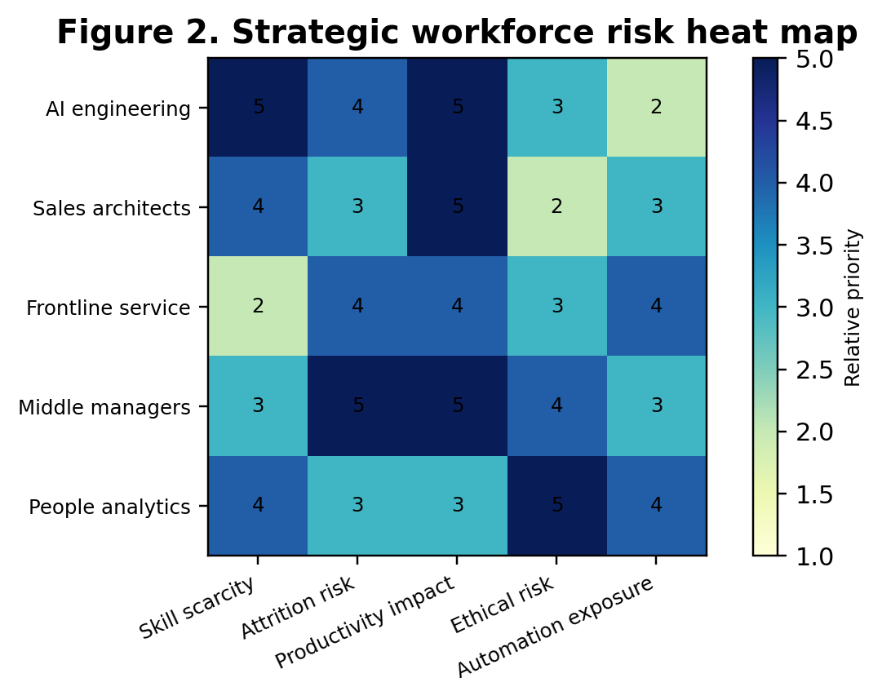
Figure 2. Strategic workforce risk heat map
Table 2. HR scorecard for strategic performance
Level | Metric cluster | Example indicators | Strategic purpose
1 | Capacity | Vacancy age, overtime intensity, critical role coverage | Shows whether the organization has enough capacity to execute strategy
2 | Capability | Skills proficiency, learning transfer, internal mobility | Shows whether employees can perform future work
3 | Climate | Engagement, trust, manager quality, psychological safety | Shows whether employees will contribute discretionary effort
4 | Impact | Productivity, quality, innovation speed, retention of critical talent | Connects HR activity to business value

Discussion
The contribution of strategic HRM to organizational success can be explained through a performance chain. At the first stage, business strategy defines the capabilities required for success. At the second stage, HR planning translates those capabilities into roles, skills, capacity and risk priorities. At the third stage, recruitment and internal mobility secure the capability. At the fourth stage, development and performance management convert capability into behaviour. At the final stage, retention, engagement and employee relations protect the capability over time. The logic is simple, but the execution is complex because each stage involves trade offs between cost, speed, quality, fairness and sustainability.
Microsoft illustrates the strategic HRM challenge in a digital organization. Its 2025 annual reporting emphasises generative AI training, digital learning resources and LinkedIn learning pathways as part of broad skilling activity (Microsoft, 2025b). This shows the connection between business model and HR architecture. A firm competing in cloud, AI platforms and productivity software cannot treat learning as an optional benefit. It must create organizational capability to use and develop AI responsibly. However, the critical point is that AI training must be role specific. A finance employee, a product manager and a software engineer do not require the same AI capability. Generic AI literacy is only the foundation.
Unilever provides a different lens because its human capital challenge is not only advanced technology but global operating consistency, brand trust and consumer market responsiveness. In a consumer goods firm, strategic HRM must create leadership pipelines, supply chain resilience, diverse market insight and ethical culture. The company’s annual reporting and people agenda are useful examples of how global organizations link people capability to strategy. However, the risk for large multinational organizations is that global HR programmes become symbolic. A leadership framework may look coherent at corporate level but fail locally if line managers lack time, incentives or competence to implement it. Strategic HRM therefore needs local execution metrics, not only global policy statements.
Costco is a useful comparative case because its people strategy is less associated with digital talent branding and more associated with retention, pay philosophy and operational service consistency. The critical lesson is that strategic HRM does not always mean sophisticated HR technology. It means fit between people practices and business objectives. In a membership retail model, employee knowledge, service reliability and operational discipline contribute to customer loyalty. Labour investment can therefore be understood as a strategic operating choice rather than a pure cost. The limitation is that not every organization can copy this model because labour economics, margins and customer expectations differ.
A core tension in strategic HRM is the balance between efficiency and commitment. Efficiency oriented HR systems reduce cost, simplify process and increase standardisation. Commitment oriented systems invest in development, voice, trust and retention. Modern organizations need both. If HRM focuses only on efficiency, it may produce short term cost improvement but long term capability erosion. If HRM focuses only on employee satisfaction, it may fail to support competitive discipline. The strategic task is to decide where standardisation is appropriate and where differentiation is necessary. Payroll should be efficient. Critical capability development should be differentiated. Compliance training should be standardised. Succession planning for strategic roles should be tailored.
Another major tension is data versus judgment. HR analytics can improve decisions by identifying attrition patterns, pay equity gaps, skills shortages and manager performance differences. However, people analytics can also create false precision. A predictive attrition model may identify risk factors but cannot fully explain personal motivation, team climate or external labour market opportunities. Strategic HRM should therefore use analytics as decision support, not as automated decision making. The most mature approach is a human in the loop model where data identifies signals, HR investigates causes, managers address local issues and outcomes are reviewed ethically.
Performance management deserves particular criticism because it is often described as strategic while operating as bureaucracy. Many organizations set annual goals, conduct mid year reviews and assign ratings, but employees still experience ambiguity, delayed feedback and unfair comparison. A strategic performance system should answer 5 questions. What outcomes matter? How will they be measured? What behaviours are non negotiable? How often will feedback occur? How will managers be calibrated? If these questions are not answered, performance management will not support productivity. It may even reduce productivity by consuming managerial time without improving role clarity.
Retention must also be more technical than broad employee satisfaction. Organizations should create a retention risk model that identifies critical roles, replacement difficulty, performance level, successor depth and market pay exposure. A high performer in a scarce role with no successor should trigger proactive retention action. A low performer in a non critical role should not receive the same investment. This is not unfair if the criteria are transparent and legally defensible. It is strategic resource allocation. However, organizations must avoid using criticality as an excuse for neglecting dignity, inclusion or wellbeing in less scarce roles. Ethical HRM requires fairness of treatment even where investment intensity varies.
The relationship between HRM, productivity and competitive advantage is also mediated by managerial capability. Many HR policies fail because line managers are the delivery mechanism. A sophisticated recruitment process can be damaged by unstructured interview behaviour. A strong learning strategy can fail if managers do not allow time for practice. Engagement initiatives can fail if supervisors create fear or overload. Gallup (2026) and CIPD (2025a) both point to the importance of manager quality and workplace experience. Strategic HRM therefore needs a manager capability model that includes selection into management, training, coaching, workload allocation and accountability for team climate.
The most critical risk is that strategic HRM becomes a narrative rather than a measurable system. Organizations often claim that people are central to strategy but cut learning budgets during downturns, promote technical experts without management training, tolerate toxic high performers and use diversity data only for reporting. These contradictions weaken the psychological contract. A credible SHRM system must make trade offs explicit. If an organization wants innovation, it must protect learning time. If it wants inclusion, it must audit promotion and pay outcomes. If it wants retention, it must fix career bottlenecks. If it wants productivity, it must address workload design and manager capability.
The recommended HR scorecard should include 4 levels. Level 1 is workforce capacity, including vacancy risk, overtime intensity and critical role coverage. Level 2 is workforce capability, including skills proficiency, internal mobility and training transfer. Level 3 is workforce climate, including engagement, psychological safety and manager quality. Level 4 is business impact, including productivity, customer quality, innovation speed and retention of critical talent. This structure prevents HR from reporting only activity metrics. It also helps executives see where workforce weakness threatens strategy.
In practical terms, HR leaders should redesign the annual planning cycle. Instead of beginning with budgeted headcount, the cycle should begin with strategic capability questions. Which markets, technologies or customer propositions are changing? Which skills will become more or less important? Which roles carry excessive dependency risk? Which teams have unsustainable workload? Which managers are producing repeated attrition or low engagement? The outputs should be a capability gap plan, recruitment plan, learning plan, retention plan and manager development plan. This is the difference between HR administration and strategic HRM.

Recommendations
Organizations should introduce a capability based workforce planning cycle rather than a vacancy based planning cycle. The first step is to define the strategic capabilities needed for the next 12 to 36 months. The second step is to map current employees against proficiency, performance, retention risk and replacement difficulty. The third step is to decide whether each gap should be closed through hiring, internal mobility, automation, outsourcing or development. This prevents HR from treating all labour demand as recruitment demand and makes workforce investment more precise.
Recruitment should be redesigned around quality, fairness and future capability. The recommended controls are structured interviews, job relevant work samples, transparent selection rubrics, adverse impact review and first year quality of hire tracking. AI screening tools should be used only where the organization can explain the selection logic, audit bias and retain human accountability. This is technically important because a fast hiring process that selects weak or unfairly filtered candidates creates hidden performance costs.
Retention strategy should focus on critical capability segments. HR should identify high value roles, scarce skills, vulnerable successors and teams with repeated regretted turnover. Stay interviews, manager review and workload analysis should be used before employees resign. Compensation should be part of the solution, but it should not be the only solution. Career visibility, manager quality, workload sustainability and meaningful work are often the deeper causes of retention or exit.
The board or senior executive team should receive a quarterly people risk dashboard. This dashboard should not be a long HR activity report. It should highlight 5 strategic risks: critical role vacancy, skills obsolescence, manager quality, employee trust and ethical technology risk. Each risk should have an owner, a threshold and a corrective action. This turns HRM into a governance discipline and makes people strategy visible at the same level as financial, operational and cyber risk.

Conclusion
Strategic HRM contributes to organizational success when it operates as an integrated performance system. The analysis shows that HR planning, recruitment, training, performance management and retention create value only when they are aligned with business objectives and measured through capability outcomes. The most important contribution of SHRM is not the completion of HR processes but the creation of workforce capability that competitors cannot easily imitate. In 2026, this requires technical attention to skills obsolescence, AI governance, engagement, manager capability and ethical people analytics.
The report also shows that strategic HRM has limits. HR systems can become symbolic, data can create false precision, AI tools can reproduce bias, and performance management can become bureaucracy. The most effective organizations will therefore treat HRM as a disciplined strategic capability. They will segment the workforce, invest in critical skills, use structured selection, train managers, monitor retention risk, and evaluate HR contribution through business impact. The final recommendation is that organizations should replace generic people plans with capability based HR scorecards that link workforce decisions directly to productivity, adaptability and competitive advantage.

References
ADP Research. (2026). People at work: A global workforce view. https://in.adp.com/resources/insights/people-at-work.aspx
Arokiasamy, L. (2024). Role of HRM practices in organization performance. Journal of the International Council for Small Business, 5(2), 150 to 166. https://doi.org/10.1080/26437015.2024.2328342
Chen, Z. (2023). Ethics and discrimination in artificial intelligence enabled recruitment practices. Humanities and Social Sciences Communications, 10, 567. https://www.nature.com/articles/s41599-023-02079-x
CIPD. (2025a). Good Work Index 2025. https://www.cipd.org/uk/knowledge/reports/goodwork/
CIPD. (2025b). Resetting EDI and reaffirming inclusion. https://www.cipd.org/uk/knowledge/reports/Resetting-EDI-reaffirming-inclusion/
Deloitte. (2026). 2026 Global Human Capital Trends. https://www.deloitte.com/us/en/insights/topics/talent/human-capital-trends.html
Gallup. (2026). State of the Global Workplace 2026. https://www.gallup.com/workplace/349484/state-of-the-global-workplace.aspx
Hosen, S., Hamzah, S. R., Ismail, I. A., Noorman, N. H., Yusof, F. M., & Rahman, M. M. (2023). Training and development, career development, and organizational commitment as the predictors of work performance. Heliyon, 9(1), e12918. https://pmc.ncbi.nlm.nih.gov/articles/PMC10796978/
Li, L. (2022). Reskilling and upskilling the future ready workforce for industry 4.0 and beyond. Information Systems Frontiers, 24, 1451 to 1469. https://pmc.ncbi.nlm.nih.gov/articles/PMC9278314/
LinkedIn Learning. (2025). Workplace Learning Report 2025. https://business.linkedin.com/learn/resources/workplace-learning-report
Microsoft. (2025a). 2025 Work Trend Index Annual Report. https://www.microsoft.com/en-us/worklab/work-trend-index/2025-the-year-the-frontier-firm-is-born
Microsoft. (2025b). Annual Report 2025. https://www.microsoft.com/investor/reports/ar25/index.html
Nastase, C. (2025). Strategic human resource management in the digital era. Businesses, 5(4), 23. https://www.mdpi.com/2673-8104/5/4/23
OECD. (2025). AI and work. https://www.oecd.org/en/topics/sub-issues/ai-and-work.html
Sony, M. M. A. A. M. (2025). Bias in AI driven HRM systems: Investigating discrimination and legal accountability in employment decision making. Journal of Responsible Technology, 22, 100124. https://www.sciencedirect.com/science/article/pii/S2590291125008113
World Economic Forum. (2025). The Future of Jobs Report 2025. https://www.weforum.org/publications/the-future-of-jobs-report-2025/
Zhao, Z. (2025). Impact of ambidextrous human resource practices on employee innovation performance: The roles of inclusive leadership and psychological safety. Frontiers in Psychology, 16, 1491930. https://pmc.ncbi.nlm.nih.gov/articles/PMC12696671/

Appendices

Appendix A. Evidence based HR implementation checklist
Control area | Evidence to collect | Review frequency
Workforce planning | Critical role list, vacancy risk, skills gap and workload data | Quarterly
Recruitment fairness | Structured interview evidence, shortlist diversity and adverse impact check | Every campaign
Learning transfer | Pre and post skill assessment, manager observation and application evidence | 30, 60 and 90 days
Performance quality | Goal audit, feedback cadence and rating calibration by manager | Quarterly and annual
Retention risk | Regretted turnover, critical role turnover and stay interview themes | Monthly
Ethical governance | Privacy review, AI tool audit and grievance trend analysis | Quarterly

Appendix B. Suggested structure for implementation review meetings
The HR review meeting should begin with the strategic workforce risk dashboard. The agenda should prioritise decisions rather than updates. Each metric should be linked to a named owner, a target, an exception threshold and a corrective action.
The review should include one case example from a business unit where the HR system is working and one case example where the system is failing. This prevents the meeting from becoming a generic dashboard presentation and forces discussion of root causes.
The review should end with an action log showing the decision, responsible person, deadline and evidence required at the next review. This protects accountability and prevents HR recommendations from remaining aspirational.

