M03 – FUNDAMENTALS OF FINANCIAL ACCOUNTING

**THE ACCOUNTING CYCLE AND PREPARATION OF FINANCIAL STATEMENTS:
A CASE STUDY OF TATA CONSULTANCY SERVICES LIMITED**

Submitted By

Student Name: _______Manpreet Kaur_____________________

Student ID: ________ DE240252____________________

Table of Contents
1. Introduction 3
1.1 Background of the Study 3
1.2 Importance of the Accounting Cycle 3
1.3 Case Company 4
1.4 Objectives of the Study 4
1.5 Scope of the Study 4
2. Literature Review 5
2.1 Meaning of Financial Accounting 5
2.2 The Accounting Cycle 5
2.3 Double-Entry Bookkeeping 6
2.4 Financial Statements 6
2.5 Accounting Standards and Reporting Quality 7
2.6 Ratio Analysis 7
3. Methodology 8
3.1 Research Design 8
3.2 Sources of Data 8
3.3 Method of Analysis 9
3.4 Ratios to be Calculated 9
3.5 Limitations 10
4. Findings and Analysis 10
4.1 Stages of the Accounting Cycle 10
4.2 Financial-Statement Preparation 12
4.3 Case Company: Tata Consultancy Services Limited 13
4.4 Financial Data Used for Ratio Analysis 13
4.5 Ratio Calculations and Workings 14
4.6 Interpretation of Findings 17
5. Discussion 19
6. Conclusion 22
References 23

1. Introduction

1.1 Background of the Study
Financial accounting involves recording, categorising, structuring and reporting business transactions in a logical and systematic way in monetary terms. It presents a structured journaling of an organisation's financial transactions and assists those taking part in understanding their sources of resources, usage and controls. Business transactions are put into meaningful information in financial statements as a result of financial accounting. These statements are useful to stakeholders including managers, investors, creditors, employees, regulators and shareholders to determine the profitability, liquidity, solvency and general financial standing of the entity. Therefore, financial accounting is not only about bookkeeping but also plays a crucial role in enhancing transparency, accountability and informed decision-making within business organisations (Atrill and McLaney, 2025).

1.2 Importance of the Accounting Cycle
It is essential to have the accounting cycle because it gives the accounting process a logical order for working through financial transactions from the transaction to the reporting. The first step is to identify and analyse the transactions, the second is to make journal entries, the third is to post the entries to a ledger, the fourth is to produce a trial balance, the fifth is to make the adjusting entries and the sixth is preparing financial statements and passing closing entries. The cycle helps to guarantee that all monetary deals are recorded exactly and that earnings and expenses are recognized in the proper accounting period. According to OpenStax (2019), the first few steps in the accounting cycle involve analysing the transactions, journalizing, posting to the general ledger and preparing the unadjusted trial balance (OpenStax, 2019).

1.3 Case Company
Tata Consultancy Services Limited is the case company of this project. TCS is a leading IT firm in India, which is conducive to this study as they publish the detailed annual report in addition with the audited financial statements. These reports deliver dependable monetary facts to examine the functionality and monetary position of the organization. TCS is also suitable since consolidated financial statements are available and two-year financial ratios could be calculated (Tata Consultancy Services Limited, 2026).

1.4 Objectives of the Study
The overall goal for this research is to enlighten the accounting cycle and how it helps in preparation of correct financial accounts. Specific Objectives: Identify the steps in the accounting cycle, describe how all accounting records are put into financial statements, explain the purpose and content of an income statement, balance sheet, and cash flow statement, present financial ratio analysis of TCS for the past two years, and understand how accounting information helps businesses and other stakeholders with decision making.

1.5 Scope of the Study
Since the scope of this study is limited, it goes only till the accounting cycle and making financial-statement along with financial analysis of TCS. The work will be based on the consolidated financials of TCS for FY2025–26 and FY2024–25. It brings theoretical aspects of accounting and financial analysis to hand with a hands on approach on secondary data obtained from published company reports and accounting literature.

2. Literature Review

2.1 Meaning of Financial Accounting
Financial accounting is an organized method that allows the organization to track and document financial transactions, as also classify, summarise and report them. To provide in an organized manner of financial information to both internal and external user. Inside accounting information is used by inside users like managers and employees for planning, control and performance evaluation purposes. Financial Accounting information is used by external users (investors, creditors, regulators and shareholders) to determine profitability, liquidity and solvency, and long-term business stability. Therefore, financial accounting plays an important role in promoting accountability, transparency and informed decision-making (Atrill and McLaney, 2025).

2.2 The Accounting Cycle
The accounting cycle is the entire procedure of accounting performed in order to get an accounting statement. The business cycle starts with business transactions, including the purchase and sale of goods, payment of salaries, purchase of assets, and receipts of cash. Once identified, the transactions are examined in order to ascertain the related accounts and whether the transactions would be debited or credited. Journal entries are taken in the next step which involves recording of the transactions chronologically in the books of accounts. These journal entries are then transferred to ledger accounts where transactions of the similar nature are recorded under a particular account like cash, revenue, expense, asset, liability and equity.
An unadjusted trial balance is prepared after the ledger posting to determine if the total of the debits is equal to the total of the credits on the Ledger. But there are still some accounts that may be in need of some corrections or adjustments at the end of the period. So, accruals like accrued income, accrued expenses, unearned revenue and depreciation etc. are recorded as adjusting entries. An adjusted trial balance is then prepared and will be used to create financial statements. Perform adjusting entries in the accounting cycle, OpenStax (2019) states that the last step is to prepare financial statements based on the adjusted trial balance. The numbers are then recorded in the financial statements and closing entries are made to move the temporary numbers, including revenues and expenses, to retained earnings or capital. Finally, a post-closing trial balance is drawn up to ensure that all the permanent accounts are closed for the upcoming accounting period (OpenStax, 2019).

2.3 Double-Entry Bookkeeping
The modern system of accounting is based on double entry bookkeeping. In this type of system, two or more accounts are involved in a single transaction, in one account a certain amount is deducted and another amount is credited in a different account. After each transaction the accounting equation is balanced with the help of Debit and Credit system. Basic accounting equation states that:
Assets = Liabilities + Equity
Business assets are financed by creditors and owners is illustrated through this equation. One asset goes up while the other goes down, for instance when a business purchases equipment with cash. Likewise, if a business took out a loan, cash would increase and so would liabilities. Hence Double entry system enhances the accuracy and diminishes the chances of errors and in addition helps to prepare dependable financial statements (Weygandt, Kimmel and Kieso, 2019).

2.4 Financial Statements
Financial Statements are the end result of the accounting cycle. They provide a summary of the results businesses basic activities and their financial position in a standard format. Income statement is a financial report that displays income, expenses and profit or loss in the period covered by the income statement. It assists users to assess the operating performance and profitability. The balance sheet is a snapshot of the business at a specific moment in time, reporting on the financial position of the business in terms of assets, liabilities and equity. The cash-flow statement lists the inflows and outflows of cash in the company's operating, investing and financing activities making it easy for users to evaluate the liquidity and cash management of the company. According to OpenStax (2019), financial statements are used to provide information to stakeholders and consists of the following: income statement, statement of equity, balance sheet, and statement of cash flows (OpenStax, 2019).

2.5 Accounting Standards and Reporting Quality
Standards of accounting are required to make financial statements more useful, informative and reliable. They offer general guidelines and procedures for the recognition, measurement, presentation and disclosure of financial information. Standards are important for consistency; businesses are using the same accounting methods over the years. They also enhance the comparability since the user can compare between financial statements of a company and for various accounting periods. Also, accounting standards enhance transparency by compelling adequate disclosure of the detailed financial information. Relevance and faithful representation are two general principles of useful financial information as defined in the Conceptual Framework (IFRS Foundation, 2021). Faithful representation assists the user in making decisions as it is presented in a manner that is neutral and free from material error while relevant information is complete.

2.6 Ratio Analysis
The ratio analysis is one of the approaches of financial analysis which change information of accounts into meaningful information. Profitability ratio is a measure of Profit generated in relation to its revenues, assets and equity. Liquidity ratios are used to measure the ability to pay short-term debts. Solvency Ratios look at long-term finances and their reliance on liabilities. Efficiencies Ratios are measures of asset utilization to contribute to revenue. Cash flow ratios are used to measure whether earnings are being backed up by cash flow. Ratio analysis can be of value since looking at the numbers alone might not provide an immediate indication of the financial strength or weakness of a company. Users can compare ratios and see the trends in performance, liquidity, solvency and the operational efficiency of the company from the first year to the second year (Brigham and Ehrhardt, 2020).

3. Methodology

3.1 Research Design
The approach of this research is descriptive and analytical of a case study. The descriptive component covers the accounting cycle, the preparation of financial statements, and how accounting information is used to report the results of business performance. The analytical aspect uses the various financial ratio analysis to interpret the financial performance of Tata Consultancy Services Limited in the course of two year. The approach of this study is through case-study technique as the main characteristic of this approach is the link between theory and real financial statements that belong to an existing listed company.

3.2 Sources of Data
The study is based completely on secondary data. The main sources comprise of TCS annual reports, TCS audited financial Results, Accounting textbooks, IFRS/Ind AS related sources and academic or professional accounting sources. TCS's annual reports and audited financial statements are chosen because they offer comprehensive consolidated financial data which is essential for ratio analysis and financial interpretation (Tata Consultancy Services Limited, 2026).
Source Type | Data Used in the Study
TCS annual reports | Revenue, profit, assets, liabilities, equity and cash-flow data
TCS audited financial results | Latest financial figures for FY2025–26 and FY2024–25
Accounting textbooks | Concepts of accounting cycle, double-entry system and financial statements
IFRS and Ind AS sources | Reporting quality, accounting standards and disclosure principles
Professional sources | Support for financial analysis and interpretation

3.3 Method of Analysis
The method of analysis comprised of both theoretical aspects of accounting cycle and practical case-study analysis of the TCS. First, the study discusses how accounting records are transferred from journal entries to ledgers, to making a trial balance, to making adjustments, to preparing financial statements, and to close the books. Secondly, TCS's financial statements are analysed to determine and interpret financial ratios. Thirdly, the ratio analysis has been made to find out the variation in the level of the profitability, liquidity, solvency, efficiency and cash-flow quality in the year FY2025–26 compared to the year FY2024–25.

3.4 Ratios to be Calculated
The following ratios are used in the study:
Ratio Category | Ratios
Growth ratio | Revenue growth
Profitability ratios | Net profit margin, operating margin, return on assets, return on equity
Liquidity ratios | Current ratio, quick ratio
Solvency ratio | Debt-to-equity ratio
Efficiency ratio | Asset turnover ratio
Cash-flow ratio | Operating cash flow to net income ratio

3.5 Limitations
This study has certain limitations. First of all, it is based on secondary data, and analysis relies on the accuracy of published reports. Second, ratio analysis is conducted on TCS's financial statements that are publicly available and hence might not be in sync with the information that is internally recorded. Third, this study is limited to consolidated statements and not individual statements. Finally, and most importantly, only little attention is given to external economic and industry aspects, which are not analysed in-depth.

4. Findings and Analysis

4.1 Stages of the Accounting Cycle
The accounting cycle is a systematic approach that is followed when business transactions are transformed into financial statements. It starts with a financial transaction and stops when the temporary accounts are closed and the permanent accounts are carried over to the next accounting period. This process is crucial as it leads to providing a complete and accurate financial information that can be used to make decisions (OpenStax, 2019).
Stage | Explanation | Simple Example
Transaction identification | A financial event is identified and measured in money terms. | Service provided to a customer for ₹50,000.
Journal entry | The transaction is recorded first in the journal. | Debit Receivables, Credit Service Revenue.
Ledger posting | Journal entries are transferred to account-wise ledgers. | Receivables ledger and revenue ledger are updated.
Trial balance | Debit and credit balances are listed to check arithmetic accuracy. | Total debits must equal total credits.
Adjusting entries | Adjustments are made for accruals, depreciation, prepayments and outstanding expenses. | Depreciation on equipment is recorded.
Adjusted trial balance | Updated balances after adjustments are prepared. | Final balances become ready for statement preparation.
Financial-statement preparation | Income statement, balance sheet and cash-flow statement are prepared. | Profit, assets, liabilities and cash flows are reported.
Closing entries | Temporary accounts such as revenue and expenses are closed. | Revenue and expenses are transferred to retained earnings.
Post-closing trial balance | Only permanent accounts remain open for the next period. | Assets, liabilities and equity balances continue.

For example, if a company provides services worth ₹50,000 on credit, the journal entry will be:
Date | Particulars | Debit ₹ | Credit ₹
— | Trade Receivables A/c Dr. | 50,000
 | To Service Revenue A/c |  | 50,000

This entry shows that the company has earned revenue but has not yet received cash. Later, when the customer pays, the entry will be:
Date | Particulars | Debit ₹ | Credit ₹
— | Bank A/c Dr. | 50,000
 | To Trade Receivables A/c |  | 50,000

The examples illustrate the accounting records which are prepared prior to posting into the ledger and subsequently are utilized to prepare financial statements. Financial statements are created from the adjusted trial balance, closing the entries and post-closing trial balance (OpenStax, 2019).

4.2 Financial-Statement Preparation
Financial statements are produced based on the accounting records in a logical order. Journal: This is the first entry made that records the transactions; Ledger: This is where transactions are grouped under individual accounts. The trial balance is used to ascertain that the total debits and total credits are the same. Once adjusted, the adjusted trial balance serves as the direct starting point to develop financial statements (Weygandt, Kimmel and Kieso, 2019).
Accounting Record | Use in Financial-Statement Preparation
Journal | First chronological record of transactions
Ledger | Account-wise classification of transactions
Trial balance | Verification of debit-credit equality
Adjusted trial balance | Corrected balances used for final accounts
Income statement | Measurement of revenue, expenses and profit
Balance sheet | Presentation of assets, liabilities and equity
Cash-flow statement | Analysis of cash inflows and outflows

The income statement shows if a business is profitable, by comparing revenue with expenses. Balance Sheet shows the financial position on a date and consists of Assets, Liabilities and Equity. A cash-flow statement tells if profit is backed by the actual cash generation from operations, investing and financing activities. Combined, these statements give investors, creditors, management and other parties financial information that will be useful (OpenStax, 2019).

4.3 Case Company: Tata Consultancy Services Limited
Tata Consultancy Services Limited is chosen as the case company due to availability of detailed audited financial statements and annual reports and investor disclosure. This enables the company to apply accounting-cycle concepts and do a ratio analysis. The study bases on the consolidated financial statements of TCS which give a financial performance and position of the group as a whole. TCS's audited consolidated financial results for FY2025–26 are in line with Indian Accounting Standards for increased consistency and reliability in reporting (Tata Consultancy Services Limited, 2026).

4.4 Financial Data Used for Ratio Analysis
The following data are used for calculating ratios. Amounts are in ₹ crore.
Particulars | FY2025–26 | FY2024–25 | Source
Revenue from operations | 267,021 | 255,324 | TCS audited consolidated results
Profit for the year | 49,454 | 48,797 | TCS audited consolidated results
Operating income | 61,085 | 61,369 | TCS segment information
Current assets | 135,705 | 123,011 | TCS consolidated balance sheet
Inventories | 29 | 21 | TCS consolidated balance sheet
Current liabilities | 60,914 | 53,001 | TCS consolidated balance sheet
Total assets | 182,372 | 159,629 | TCS consolidated balance sheet
Total equity | 108,478 | 95,771 | TCS consolidated balance sheet
Total liabilities | 73,894 | 63,858 | Calculated as current + non-current liabilities
Operating cash flow | 52,094 | 48,908 | TCS consolidated cash-flow statement

To calculate FY2024-25 Average Ratios require the opening balances for FY2023-24 as well. As per TATA Consultancy Services Limited (2025), TCS's total assets were ₹146,449 crore and total equity was ₹91,319 crore as of FY2023–24 (Tata Consultancy Services Limited, 2025).

4.5 Ratio Calculations and Workings
Ratio | Formula | FY2025–26 | FY2024–25 | Interpretation
Revenue growth | Change in revenue ÷ previous year revenue × 100 | 4.58% | 5.99% | Revenue increased in both years.
Net profit margin | Profit ÷ revenue × 100 | 18.52% | 19.11% | Profitability remained strong but slightly declined.
Operating margin | Operating income ÷ revenue × 100 | 22.88% | 24.04% | Operating efficiency reduced slightly.
Current ratio | Current assets ÷ current liabilities | 2.23 | 2.32 | TCS had strong short-term liquidity.
Quick ratio | Current assets – inventory ÷ current liabilities | 2.23 | 2.32 | Immediate liquidity was also strong.
Debt-to-equity ratio | Total liabilities ÷ total equity | 0.68 | 0.67 | Solvency position remained stable.
Return on assets | Profit ÷ average total assets × 100 | 28.92% | 31.89% | Asset profitability declined.
Return on equity | Profit ÷ average equity × 100 | 48.43% | 52.16% | Shareholder return remained high but declined.
Asset turnover | Revenue ÷ average total assets | 1.56 times | 1.67 times | Asset-use efficiency declined.
CFO to net income | Operating cash flow ÷ profit | 1.05 times | 1.00 times | Earnings were supported by cash flow.

Main Workings
Revenue growth FY2025–26:
= (267,021 – 255,324) ÷ 255,324 × 100
= 4.58%
Net profit margin FY2025–26:
= 49,454 ÷ 267,021 × 100
= 18.52%
Operating margin FY2025–26:
= 61,085 ÷ 267,021 × 100
= 22.88%
Current ratio FY2025–26:
= 135,705 ÷ 60,914
= 2.23 times
Quick ratio FY2025–26:
= (135,705 – 29) ÷ 60,914
= 2.23 times
Debt-to-equity ratio FY2025–26:
= 73,894 ÷ 108,478
= 0.68 times
Return on assets FY2025–26:
= 49,454 ÷ [(182,372 + 159,629) ÷ 2] × 100
= 49,454 ÷ 171,000.5 × 100
= 28.92%
Return on equity FY2025–26:
= 49,454 ÷ [(108,478 + 95,771) ÷ 2] × 100
= 49,454 ÷ 102,124.5 × 100
= 48.43%
Asset turnover FY2025–26:
= 267,021 ÷ [(182,372 + 159,629) ÷ 2]
= 267,021 ÷ 171,000.5
= 1.56 times
Operating cash flow to net income FY2025–26:
= 52,094 ÷ 49,454
= 1.05 times

4.6 Interpretation of Findings
The financial situation of TCS in FY2025–26 is revealed to be strong, based on the analysis. The revenue grew by 10.4 per cent from ₹255,324 crore to ₹267,021 crore, depicting business growth. But growth in revenue slumped in comparison to FY2024 – 25. When viewed by the net profit margin, it would be found that the net profit margin grew from 19.11% to just 18.52%, indicating a lower increase of profit compared to increase in the revenue. It's a sign that the company has been spending more or unusually high expenses for the year. TCS also guided us about the restructuring expenses, labour-code impact and provision towards legal claim as exceptional items in FY2025–26 (Tata Consultancy Services Limited, 2026).
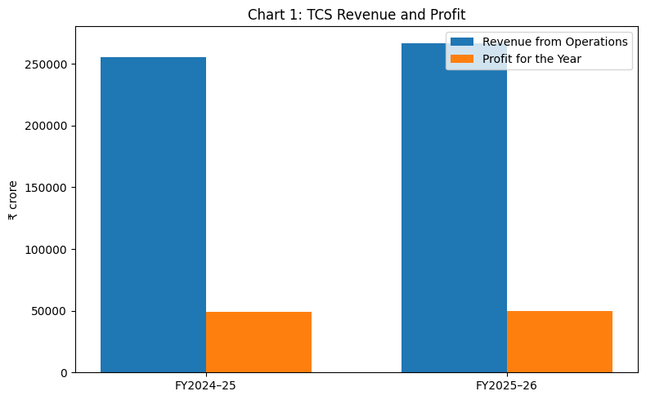
Figure 1 TCS Revenue and Profit
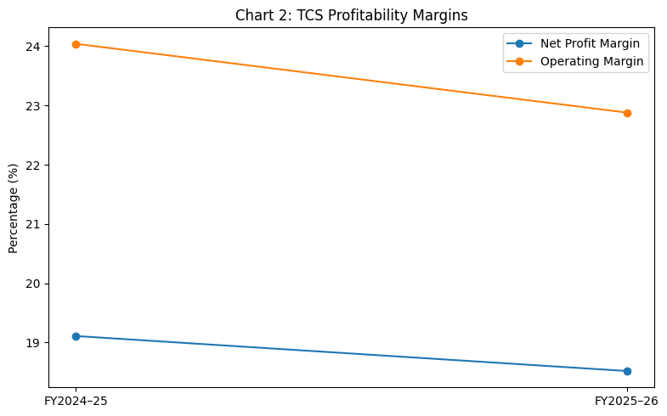
Figure 2 TCS Profitability Margins
TCS' liquidity was extremely healthy. The current ratio 2.23 indicates that the company had ₹2.23 of current assets when its current liabilities were at ₹1. Quick ratio was virtually unchanged due to low level of inventory in an IT company. This indicates that TCS is not much reliant on stock to remain liquid.
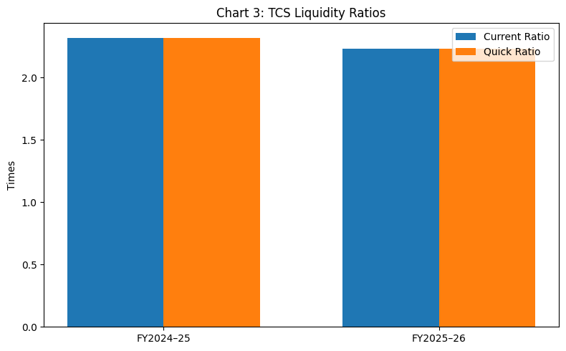
Figure 3 TCS Liquidity Ratios
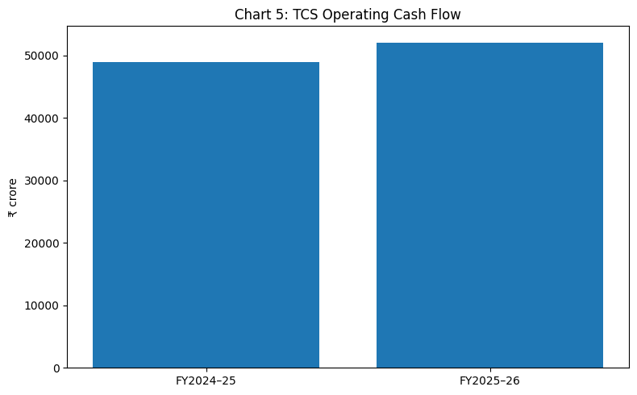
Figure 4 TCS Operating Cash Flow
The debt-to-equity ratio remained stable at 0.68 in FY2025–26 compared with 0.67 in FY2024–25. This means that the company was moderately levered. The ROA went down from 31.89% to 28.92%, indicating that assets grew at a higher rate than profit. The ROE has also declined from 52.16% to 48.43%, nonetheless, it remains very high suggesting investors are getting value from them.
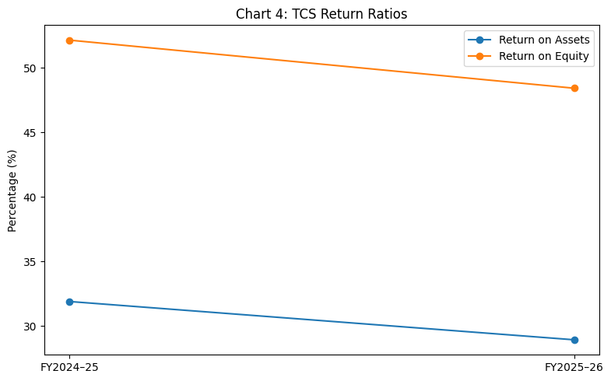
Figure 5 TCS Return Ratios
The net cash-flow was positive. The operating cash flow amounted to ₹52,094 crore against profit amounting to ₹49,454 crore. The actual cash generation to reported profit (CFO to net income) ratio of 1.05 demonstrates that actual cash has been generated from the reported profit. This enhances the earnings quality and boosts trust on the company's financial performance. Thus, the ratio analysis validates that TCS had good profitability and good liquidity along with the quality of cash flow despite seeing a slight dip in some profitability and efficiency metrics during the fiscal year FY2025–26.

5. Discussion
This accounting cycle helps in reliable financial reporting as it creates a systematic method of recording, processing, and presenting all the business transactions. Financial statements can only be relied upon if all the phases of the accounting cycle are adhered to properly. Uneven identification, recording, classification, adjustment and closing of transactions could lead to incorrect or misrepresentative financial statements. Hence, accounting cycle is like the basic backbone of financial accounting which ensures that the information contained in the accounts is organised, complete and of value to the stakeholders (OpenStax, 2019).
Transfers are first documented in the accounting system with journal entries. They make sure that the double entry principle that lumps each and every monetary event in two accounts is adhered to. This will keep the accounting equation in check and minimize incomplete recording risks. An example is when a revenue takes on credit, the account trade receivables is debited and revenue is credited. Both the growth of assets and the growth of income are shown. If no entries are made in the books the financial statements would be of no real value as they would not show what the business was really doing.
Ledger accounts also help to improve the quality of reporting as they segregate transactions into various category headings like cash, revenue, expenses, assets, liabilities and equity. This classification facilitates the business to group large number of transactions in an organized manner. The trial balance can be used to test ledgers afterward ledger posting to see if ALL debits are EQUAL ALL credits. While not foolproof to detect all accounting errors, a trial balance can be used to look for mathematical mistakes and as a starting point to prepare final accounts (Weygandt, Kimmel and Kieso, 2019).
The proper disclosures of adjusting entries are particularly significant for the true reporting as they assist in accrual accounting and the matching principle. An accrual accounting system is one where income and expenditures are committed to the books in the period that they are earned or incurred and not necessarily when the money is collected or paid associated with those revenues and expenditures! Depreciation, prepaid items, outstanding items, accrued assets and unearned assets and liabilities assist in identifying an adequate amount of profit on the income statement and proper asset and liability amounts on the balance sheet. Useful financial information must possess the qualities of being relevant and faithfully represented and, adjusting entries are also necessary for this to be achieved in that they enable completeness and accuracy of information (IFRS Foundation, 2021).
Closing entries are also important as they set the books up for the next accounting period. Only temporary accounts (like revenues and expenses) are closed and permanent accounts (like asset, liability and equity) are not closed. Thus, each accounting period can be measured independently and comparisons of meaningful periods can be made over time. Upon closing accounts, a post-closing trial balance will only contain permanent accounts that will open in the next period (OpenStax, 2019).
When financial statements are prepared using this financial cycle they help to assess profitability, liquidity, solvency & cash performance. An income statement indicates if the business is making a profit or not. The balance sheet indicates the financial position, then, by listing the assets, liabilities and equity. A cash-flow statement provides the reader with an explanation for the way cash is generated and used based on operating, investing and financing activities. These statements assist in management planning, investor decision making, credit analysis, dividend decisions, performance evaluations and regulatory compliance.
With respect to the TCS case, ratio analysis relates the data on the accounting books to real reality of the business. For instance, profitability ratios can be used to determine the size of TCS's profit based on its after-tax earnings, liquidity ratios can be used to determine if the company can pay its short-term obligations, solvency or gearing ratios can be used to determine the financial stability of TCS and cash flow ratios can be used to determine whether TCS' earnings are cash generating. The audited consolidated financial data of TCS thus illustrates how accounting records can serve as valuable information to analyse and make decisions for stakeholders. In sum, the accounting cycle does not only represent a technical bookkeeping operation, but it is a complete reporting process which add value to make the information more reliable, comparable and helpful in making decisions.

6. Conclusion
The purpose of the accounting cycle is that it gives a step-by-step methodical process to record, classify, summarise, and report financial transactions which is the foundation of financial accounting. It helps to convert the day-to-day business operations to organised accounting statements and then to financial statement. Journal entries, ledger posting, trial balance, adjustments, financial-statement preparation, and closing the books at each stage add to the accuracy and reliability of financial reporting.
Financial statements are used by stakeholders to evaluate a business as they show the profitability, liquidity, solvency and cash position. It's information that managers use for planning and control, investors use to check the returns, creditors use to check the capability to repay, and regulators use to check the compliance. Thus, financial statements are vital to business decision-making and business accountability.
A practical illustration on accounting data for financial analysis is given in the case of Tata Consultancy Services Limited. The study demonstrates the application of published accounting information to meaningful ratios in the case of TCS's consolidated financial statements. The two-year trend analysis assists in understanding the changes in profitability, liquidity, solvency, efficiency and cash-flow quality from FY2025–26 when compared to FY2024–25. Some of the profitability and efficiency ratio went down a bit, but overall TCS was financially healthy.
Thus, the accounting cycle is not a procedure that belongs to the domain of bookkeeping but is rather a systematic process that ensures financial information is accurate, comparable, reliable and useful for decision making.

References
ACCA (2024) The Conceptual Framework for Financial Reporting. Available at: https://www.accaglobal.com/gb/en/student/exam-support-resources/professional-exams-study-resources/strategic-business-reporting/technical-articles/conceptual-framework.html (Accessed: 23 May 2026).
Atrill, P. and McLaney, E. (2025) Accounting and Finance for Non-Specialists. 12th edn. Harlow: Pearson. Available at: https://www.pearson.com/en-gb/subject-catalog/p/accounting-and-finance-for-non-specialists/P200000003619/9781292741734 (Accessed: 23 May 2026).
Harrison, W.T., Horngren, C.T., Thomas, C.W. and Tietz, W.M. (2024) Financial Accounting IFRS, Global Edition. 12th edn. Harlow: Pearson. Available at: https://eu.pearson.com/products/9781292744230 (Accessed: 23 May 2026).
IFRS Foundation (2021) Conceptual Framework for Financial Reporting. London: IFRS Foundation. Available at: https://www.ifrs.org/content/dam/ifrs/publications/pdf-standards/english/2021/issued/part-a/conceptual-framework-for-financial-reporting.pdf (Accessed: 23 May 2026).
IFRS Foundation (2026) Conceptual Framework for Financial Reporting. Available at: https://www.ifrs.org/issued-standards/list-of-standards/conceptual-framework/ (Accessed: 23 May 2026).
Institute of Chartered Accountants of India (2025) Companies (Indian Accounting Standards) Rules, 2015 and amendments. Available at: https://www.icai.org/post.html?post_id=12125 (Accessed: 23 May 2026).
Kieso, D.E., Weygandt, J.J. and Warfield, T.D. (2020) Intermediate Accounting: IFRS Edition. 4th edn. Hoboken: Wiley. Available at: https://www.wiley.com/ (Accessed: 23 May 2026).
Ministry of Corporate Affairs (2015) Companies (Indian Accounting Standards) Rules, 2015. Government of India. Available at: https://thc.nic.in/Central%20Governmental%20Rules/Companies%20%28Indian%20Accounting%20Standards%29%20Rules%2C2015.pdf (Accessed: 23 May 2026).
OpenStax (2019) Principles of Accounting, Volume 1: Financial Accounting. Houston, TX: Rice University. Available at: https://openstax.org/details/books/principles-financial-accounting (Accessed: 23 May 2026).
OpenStax (2019) Define and Describe the Initial Steps in the Accounting Cycle. Available at: https://openstax.org/books/principles-financial-accounting/pages/3-3-define-and-describe-the-initial-steps-in-the-accounting-cycle (Accessed: 23 May 2026).
OpenStax (2019) Prepare Financial Statements Using the Adjusted Trial Balance. Available at: https://openstax.org/books/principles-financial-accounting/pages/4-5-prepare-financial-statements-using-the-adjusted-trial-balance (Accessed: 23 May 2026).
OpenStax (2019) Describe and Prepare Closing Entries for a Business. Available at: https://openstax.org/books/principles-financial-accounting/pages/5-1-describe-and-prepare-closing-entries-for-a-business (Accessed: 23 May 2026).
Tata Consultancy Services Limited (2025) Integrated Annual Report 2024–25. Mumbai: Tata Consultancy Services Limited. Available at: https://on.tcs.com/Annual-Report-2025 (Accessed: 23 May 2026).
Tata Consultancy Services Limited (2026) Financial Results for the Quarter and Year Ended March 31, 2026. Mumbai: Tata Consultancy Services Limited. Available at: https://www.tcs.com/content/dam/tcs/pdf/discover-tcs/investor-relations/corporate-actions/2025-26/financial-results-qr-mar-31-2026.pdf (Accessed: 23 May 2026).
Tata Consultancy Services Limited (2026) Integrated Annual Report 2025–26. Mumbai: Tata Consultancy Services Limited. Available at: https://www.tcs.com/content/dam/tcs/investor-relations/financial-statements/2025-26/ar/annual-report-2025-2026.pdf (Accessed: 23 May 2026).
Weygandt, J.J., Kimmel, P.D. and Kieso, D.E. (2019) Financial Accounting: IFRS Edition. 4th edn. Hoboken: Wiley. Available at: https://www.wiley.com/en-us/Financial+Accounting+with+International+Financial+Reporting+Standards%2C+4th+Edition-p-00018597 (Accessed: 23 May 2026).

