

Crafting a Digital Communication Strategy for Emerging Tourism Hubs: Engaging and Supporting the Global Digital Nomad Community

Student Name: Ajay Kumar
Student ID: DE240022
Due Date :28th of May

Contents
1. Introduction 3
2. Email Flows 5
2.1 Welcome/Onboarding Sequence 5
2.2 Community-Building Drip Campaign 6
2.3 Departure & Feedback Loop 7
3. Multilingual Chatbot Scripts 7
3.1 Use-Case Scenarios 7
3.2 Language Variants & Localisation Notes 7
4. Web Content 8
4.1. Hub Landing Page 8
4.2 Resource Hub 9
4.3 Blog & Newsletter Section 9
5. Onboarding Information Kits 10
5.1 Digital Welcome Packet 11
5.2 Local Logistics Guide 12
6. Co-Working Etiquette Guidelines 12
6.1 Shared-Space Best Practices 13
6.2 Cultural Sensitivity Pointers 13
6.3 Infographic Quick-Reference 14
7. Digital Safety Tips 14
7.1 Secure Connectivity & VPN Usage 14
7.2 Data Backup & Device Security 15
7.3 Emergency Contacts & Insurance 15
8. Localisation & Cross-Cultural Personalisation 16
8.1 Tone, Style & Visual Adaptations 16
8.3 A/B Testing & Continuous Optimization 16
9. Conclusion & Recommendations 17
10. References: 18

1. Introduction

The emergence of remote-work technologies and changing lifestyles has led to the global spread of digital nomadism. Between 2018 and 2024, there has been over 50% growth in the number of workers who have completely/ slowly moved to remote jobs, with many of them wanting flexible co-working spaces in various places. On the other hand, the new tourist centres throughout the world, e.g., Lisbon and Bali, are altering their approach to visitors so that they can fully experience this community by offering the most suitable infrastructure, the smoothest digital services, as well as the most harmonious experiences.
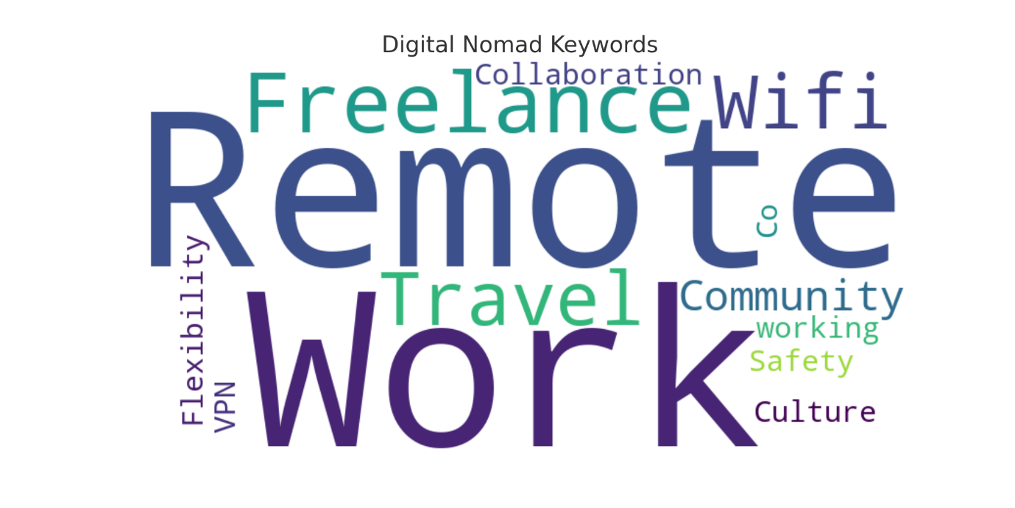
This report is about a digital communication strategy that is quite extensive in scope for the tourism hubs, and it emphasizes not only the task of localisation but also the creation of a localised omnichannel ecosystem that will be most engaging and consistent. The production includes email automation flows, multilingual chatbot scripts, optimised web content, onboarding kits, co-working etiquette guidelines, and digital safety tips. Furthermore, we discuss the strategies of localisation and cross-cultural personalisation so that the language used mirrors the variety of the target audience.
Objectives & Scope
- Create automated email sequences that are going to be the cornerstone of the welcome process, customer engagement, and staying engaged after leaving the hotel.
- Show the chatbot dialogue trees in multiple languages for a 24/7, culturally friendly support service.
- Write content that can be easily used by website visitors, such as landing pages, resource sections, and blogs, not only to buy but also to serve themselves.
- Write digital onboarding kits and local logistics guides to help users quickly become familiar with the place.
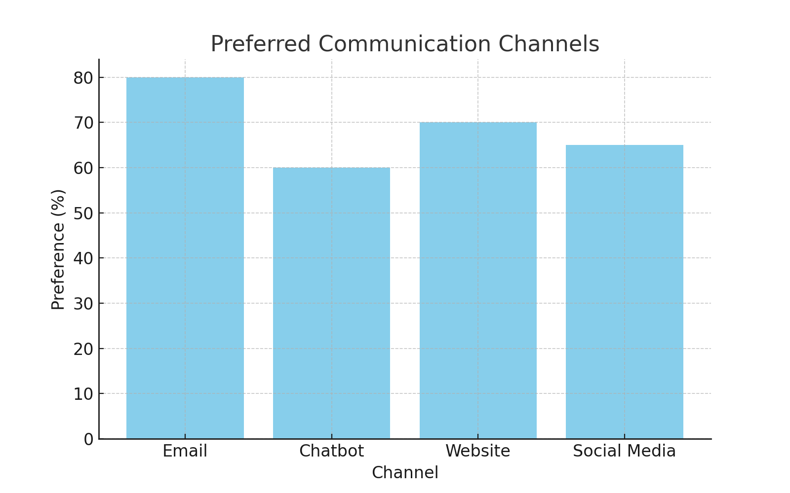
Source: (Created by me)
- Suggest some rules for sharing workspace which can make healthy and polite co-working environments and emphasize the point that everyone can be comfortable.
- Recommend some steps to the users of the internet to ensure that their information and devices are safe from cyber-criminal attacks.
- Localize the content in such a way that the language and cultural specificity, and other differences as well, including the format and visual elements, will guarantee the achievement of the brand's message in different countries (World Economic Forum, 2024a).
With the support of these materials in a consolidated communication plan, globetrotter-inhabited places will improve the travel adventurer experience, construct more solid teams, and proactively speak of the places.

2. Email Flows

2.1 Welcome/Onboarding Sequence

The situation of the Nomad Subscription: The subscriber subscribes through the landing page form or books a co-working pass.
Timing & Structure:
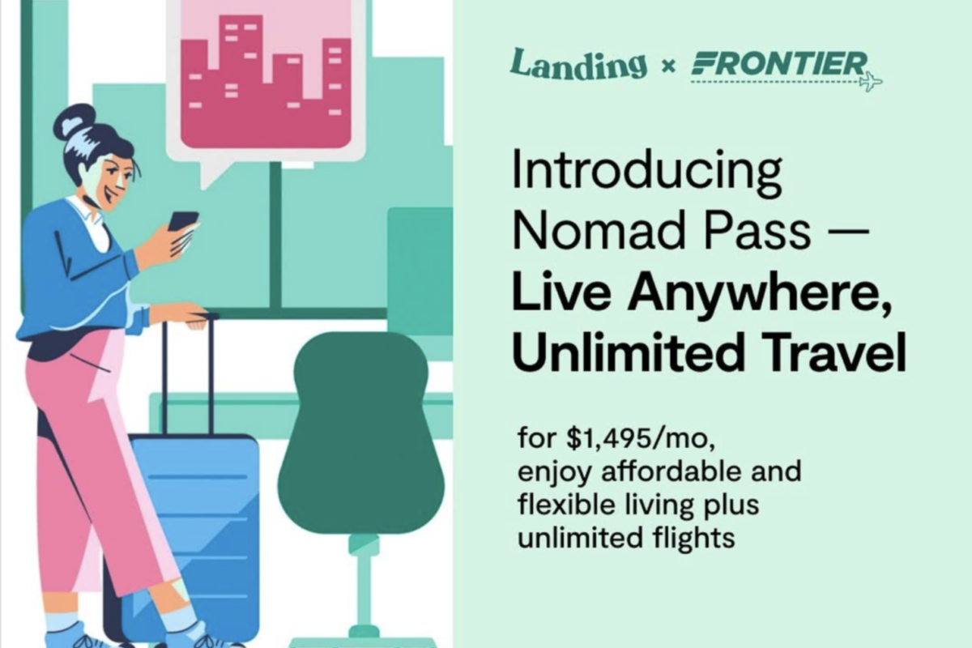
Source: https://www.hellolanding.com/blog/introducing-nomad-pass/
- Immediate (0 minutes): "Welcome to [Hub Name]!"
- A welcome note, a map link, and log-in information for the community portal.
- A digital onboarding kit (PDF & microsite) for download.
- Day 1: "Getting Started Guide"
- Services: The creator enumerates SIM card vendors, transport apps, and workspace access codes.
- Access to the Hub Slack/Discord channel for the Nomad.
- Day 3: "Community & Events Calendar"
- A list of the weekly events of the community (language exchanges, coding sessions, yoga).
- Link to RSVP & add to calendar.
- Day 7: "Pro Tips from Fellow Nomads"
- Testimonials on hidden cafés and after-work spots based on short interviews.
- CTA (Call-to-action) asking if you have any good recommendations you would like to share with the community.
Personalisation Tokens:
- First name, arrival dates, home time zone.
- Your workplace preference (a private office or an open desk).

2.2 Community-Building Drip Campaign

Objective: Encourage user communication and excitement through peer-to-peer interaction.
- Week 2: "Skill-Swap Sessions"—The registered users are enrolling themselves for the workshops facilitated by their peers.
- Week 3: "Photo Challenge" on Instagram, along with hub-specific hashtags.
- Week 4: "Local Culture Deep Dive"—Conversations in languages, as well as cooking classes, are some examples of events that will be there.
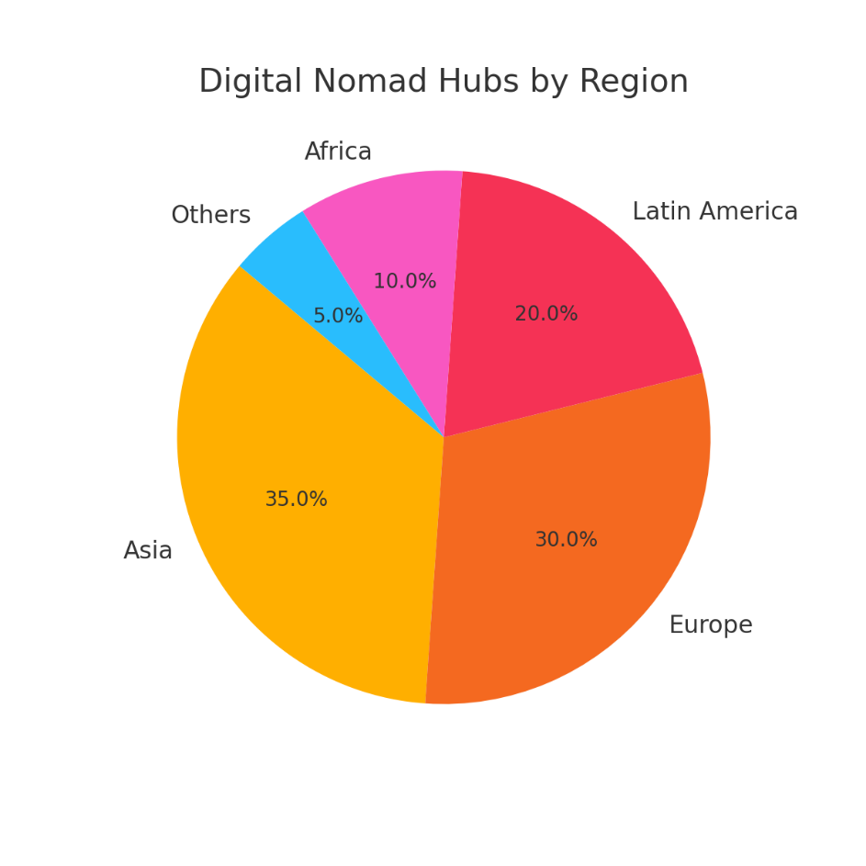
Source: (Created by me)

2.3 Departure & Feedback Loop

Trigger: The customer's access pass is about to finish, or the booking end date is getting closer.
- 3 Days Before
  - Usage stats: worked hours, attended sessions.
  - Discount code for coming back.
- 1 Day After Departure: “We Would Like Your Feedback”
  - NPS surveys several questions, linking to a feedback form with opportunities for improvement.
- 7 Days Post-Departure: “Share A Guest Experience”
  - Request to share a blog post or video testimonial.
  - A gift card lottery for completing the survey.

3. Multilingual Chatbot Scripts

3.1 Use-Case Scenarios

- Workspace Availability
  - “What's open right now?” → It shows the availability of live desk/room occupancy.
- Booking & Payment
  - “Reserve a conference room for me from 2 pm to 4 pm.”
  - “What are the steps to change from a hot desk to a dedicated desk?” (Global Workplace Analytics, n.d.)
- Local Recommendations
  - “Where can I get a quick bite nearby?”
  - Technical Support
  - “Wi-Fi is not working for me, the VPN setup will solve it.”—Step-by-step VPN setup.

3.2 Language Variants & Localisation Notes

- English (US/UK): Neutral, accurate.
- Spanish (Spain/Latin America): Formal (“usted”) vs. informal (“tú”) modes.
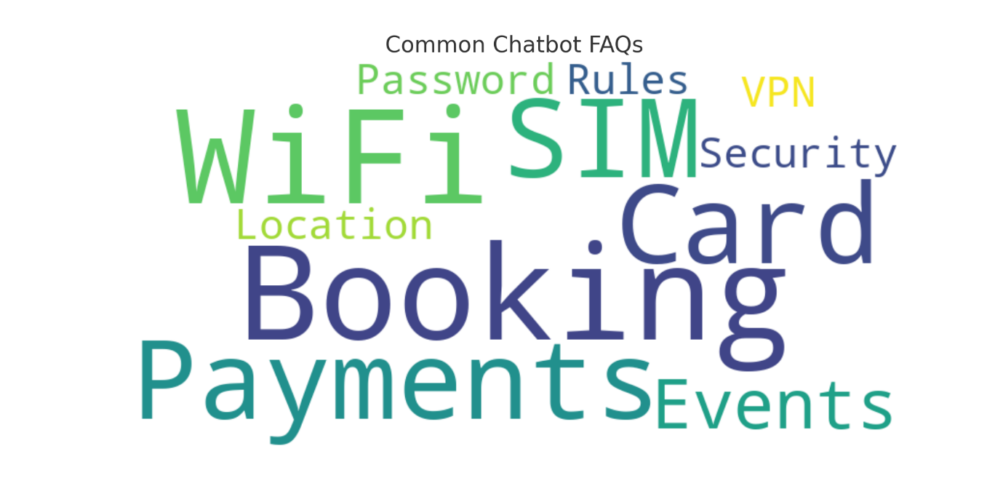
Source: (Created by me)
- Mandarin (Simplified): Show respect, using full
- Portuguese (Brazil): Friendly tone, colloquial expressions (e.g., “Beleza?”)
Localization Annotations:
- Time format: “2:00 pm” (US), “14:00” (EU/Asia).
- Date format: “MM/DD/YYYY” vs. “DD/MM/YYYY.”
- Currency: display base price in USD with local conversion and icon.

4. Web Content

Having a website that is very presentable and at the same time effective is very important in the attempt to bring and keep digital nomads interested. The strategy suggested below enables mere mortals to get the information they need, book, and be part of the community without problems and with joy (Cybersecurity & Infrastructure Security Agency [CISA], n.d.).

4.1. Hub Landing Page

- Picture Right at the Top:
- Captions: "Create. Discover. Interact."
- Subheading: "A co-working space in [City] set up for digital nomads, by digital nomads."
Decide on the Next Step:
Find a Pass
Schedule a Virtual Tour
Main Characteristics of the Service (USPs):
- Capacity for 24 hours with Wi-Fi and phone boot, and the support of a private network
- Regularly organised community get-togethers and discounts on various merchandise at several local spots
- Immediate Digi-Support and Guided Yoga/Mindfulness Practices

4.2 Resource Hub

Urban Map:
- A wide range of the following is seen on it: co-working spaces, cafés, a gym, public transportation, and emergency services.
- Downloadable Guides:
- Start-up kits in PDF
- City-specific safety and workplace etiquette guides
Banner inquired about FAQs:
- "Are there options for monthly billing available to me?"
- "May I let other people into the space?"
- "How can I cancel my booking?"

4.3 Blog & Newsletter Section

- Users as Guest Authors:
- Weave authentic tales like "__I__[balance]Work & Surfing in Bali__."
Local Features:
- They contain interviews of museum coffee shop owners, cultural icons, and voices that should be heard in the nomad community.
Newsletter Archive:
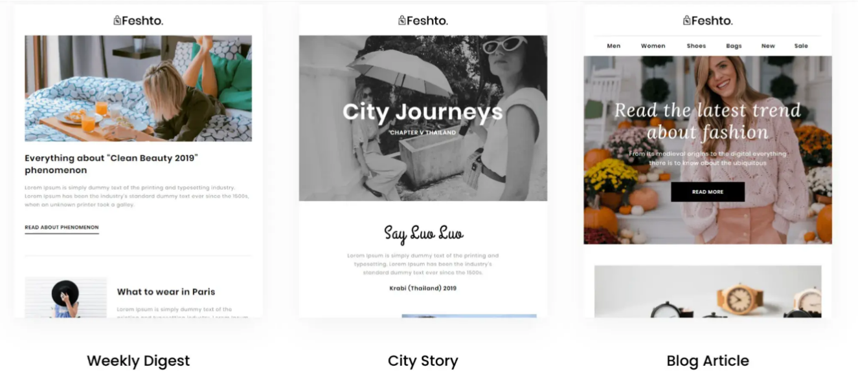
Source: https://blog.hubspot.com/marketing/email-newsletter-templates
- You can retrieve past writings from the categories of technology, culture, remote work, and personal health.
- This architecture forms a lively and enlightening user experience, and it also establishes trust and allows long-term engagement.

5. Onboarding Information Kits

For the purpose of ensuring new members of the hub have a smooth and uninterrupted experience, the organisation has designed individualised and digital kits that contain the onboarding materials that the members can use. These materials are designed to make users familiar with the co-working space and the local area quickly. Such familiarity provided by the kits is a reason for the users to have confidence and independence, and thus be more engaged from their first day onward.
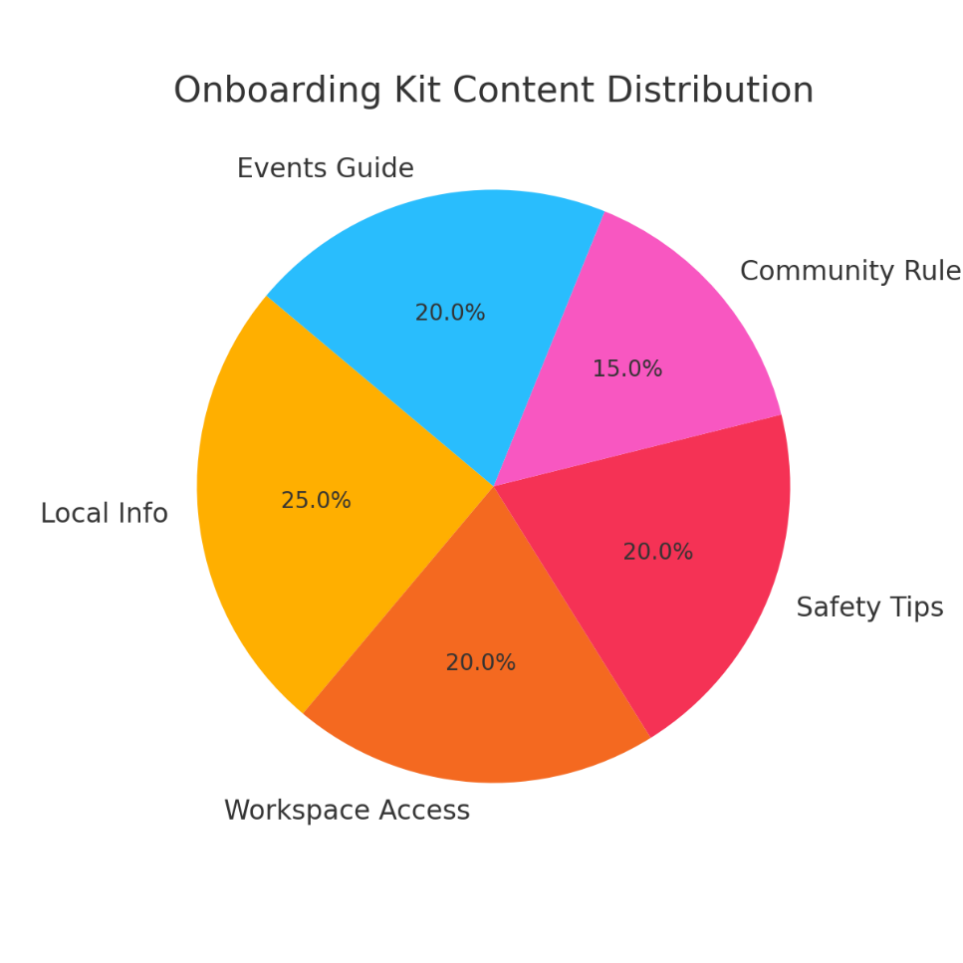
Source: (Created by me)

5.1 Digital Welcome Packet

Format:
- Available through a flash microsite, which is also interactive
- Also, in the form of a PDF, the mobile version is quite friendly
Contents Include:
- The Hub: An introduction to resources and services provided by facilities
- Broadway shows of: Different areas in the workspace, such as the phone booths, kitchens, and even the relaxing lounge
- Wi-Fi Codes: Login details on how to securely connect to the main and guest wireless networks
- The Civic Society: Codes of conduct, silent areas, and event etiquette
Quick Access Links:
- Chatbot for answering questions
- Helpdesk ticket submission
- Accessibility to social media and getting an invite to the member group of the organisation

5.2 Local Logistics Guide

- Cell Phone Card & eSIM Providers:
- Comparison of leading brands
- Details of the latest offers and vacation packages
- Top-up apps and steps in the SIM registration process
- Variety of Transport Solutions:
- Time Bike Program
- Ride-hailing and Taxi Services
- Underground and buses, and how they work
Membership Area Access Information:
- Benefits of day passes vs monthly memberships
- Taking reservations for hot desks and private rooms
- Locker rental process and availability
Essential Apps for Nomads:
- Currency converter (e.g., XE)
- Language translation (e.g., Google Translate)
- Offline maps and local navigation tools (e.g., Maps.me)
- The kits mentioned are supportive when it comes to having the newcomers go to the place and the city in a hassle-free manner.

6. Co-Working Etiquette Guidelines

Creating a respectful, inclusive, and productive environment is very important for shared working spaces. This list of etiquette guidelines helps digital nomads in understanding the cultural differences and learning about the expectations of the shared space, also it gives a culture of harmony in the community.
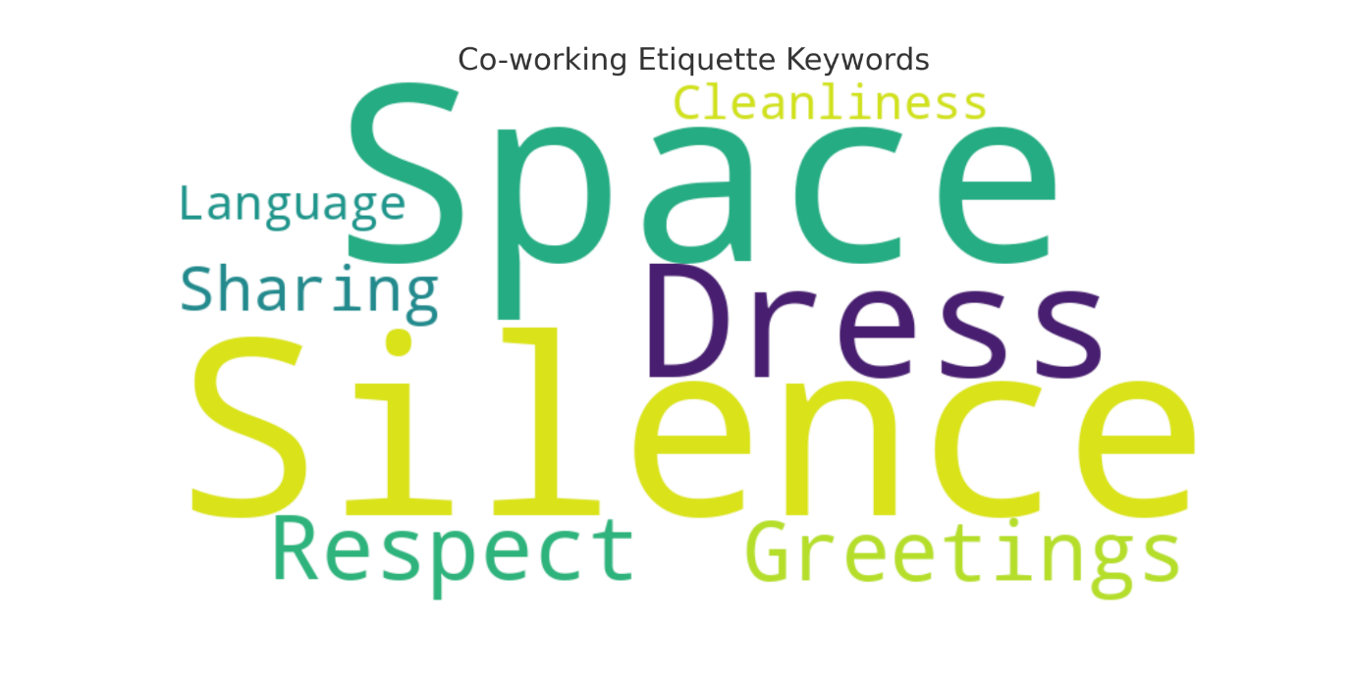
Source: (Created by me)

6.1 Shared-Space Best Practices

Noise Management:
- Set aside telephone booths for all your voice/video calls
- While listening to music or watching content, wear your headphones
Resource Sharing:
- Do the prior booking of the meeting rooms through the online booking system
- After the equipment and spaces are used, leave them clean and well-organised
Food & Drink Etiquette:
- Use cups with lids to prevent liquids from spilling and getting into the computer equipment
- Tidy up all the leftover food, also, don't eat in open places where the food's smell can disturb other people

6.2 Cultural Sensitivity Pointers

Respect for Personal Space:
- Be mindful of the customs of that particular region (e.g., handshake, cheek kiss, etc.)
- Avoid gathering or standing around a person in a way that is looked upon as offensive in communal areas
Tipping Etiquette:
- Supply both printed and digital explanations of the tips, i.e., 10-15% in the U.S., tipping in Japan is not part of the culture
Dress Code Expectations:
- Wear office-casual clothes while you are working
- Do not put on flip-flops and sportswear in the formal meeting room

6.3 Infographic Quick-Reference

Visual Layout:
The top 5 dos and don’ts in the layout should be highlighted with colour-coded icons
The icons used can be of volume and cleanliness of the items, as well as the personal space and dress code
Placement:
Print and display the hard copies of the posters near the entrances, kitchens, and phone booths
Have a downloadable version of the poster in the digital welcome kit and community portal
The inclusive and clear guidelines not only make all co-workers feel respected and valued but also promote high productivity among them.

7. Digital Safety Tips

7.1 Secure Connectivity & VPN Usage

- Suggest Trustworthy VPNs: Detail and where to get them, and make sure that the top three products are listed with affiliate links.
- Step-by-Step Setup: Show details and illustrate Windows, macOS, iOS, and Android screenshots.
- Public Wi-Fi Precautions: Inform them about the use of SSL sites, not just the SSL encryption, and at the same time, tell them to avoid sensitive transactions so that no personal information will be shared with the wrong people.
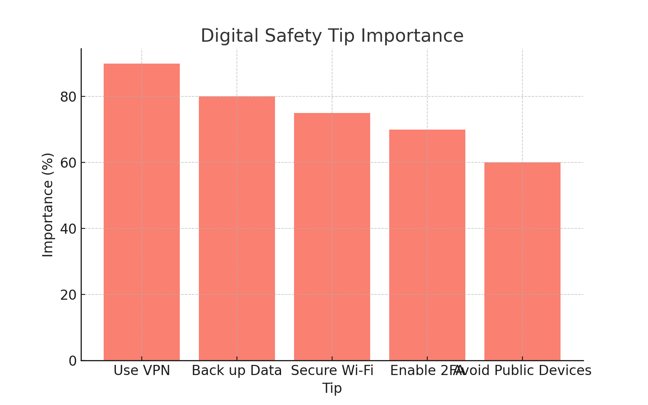
Source: (Created by me)

7.2 Data Backup & Device Security

- Automated Backup Tools: Go through the steps to Google Drive, iCloud, and Dropbox setups.
- Password Hygiene: Get password managers (e.g., LastPass, 1Password) that will do the remembering for you.
- Two-Factor Authentication: It should be set up for your email, social, and banking.

7.3 Emergency Contacts & Insurance

- Local Emergency Services: Write down the police, ambulance, and fire numbers.
- Travel Insurance Providers: Tell whoever is that this is the method of claiming money most quickly, or know who to get in touch with this very moment.
- Incident Reporting: On this matter, they should tell hub management how to handle such incidents as the destruction of their property or the theft of data.

8. Localisation & Cross-Cultural Personalisation

8.1 Tone, Style & Visual Adaptations
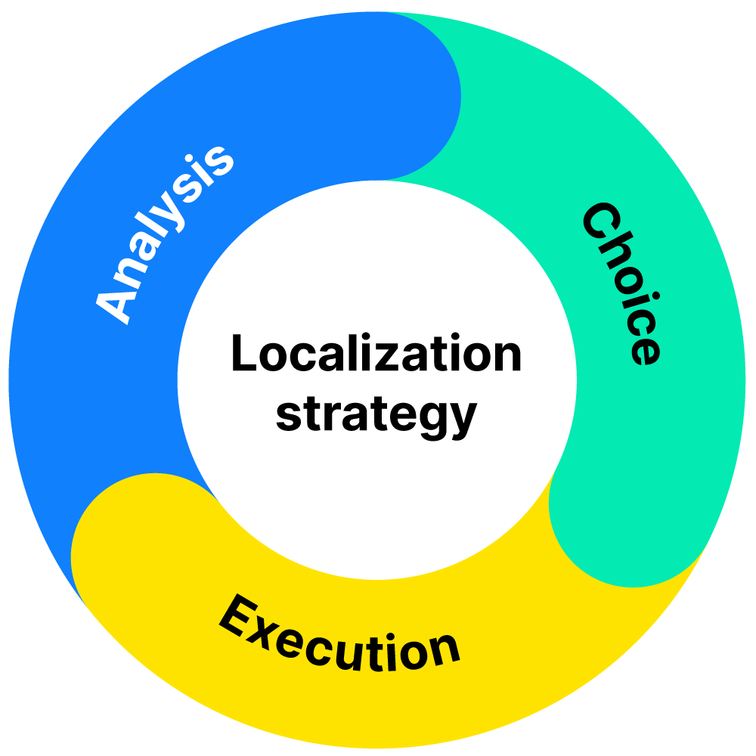
Source: https://phrase.com/blog/posts/how-important-is-localization-for-your-business/
- Tone Guidelines:
- North America: Relaxed, chatty.
- Europe: To the point-and-shoot is the norm.
- Asia: Very humble, and they like to know every tiny detail.
- Visual Assets:
- Main visual subject pictures depicting local architecture and the local

8.3 A/B Testing & Continuous Optimization

- Test Variants: Subject lines (e.g., "Welcome!" vs. "你好, 欢迎!") and hero images.
- Metrics to Track: Open rates, click-throughs, chatbot deflection, and booking conversions.
- Feedback Loop: Quarterly reviews; design new scenarios, change voice lines and content by customer survey and analytics.
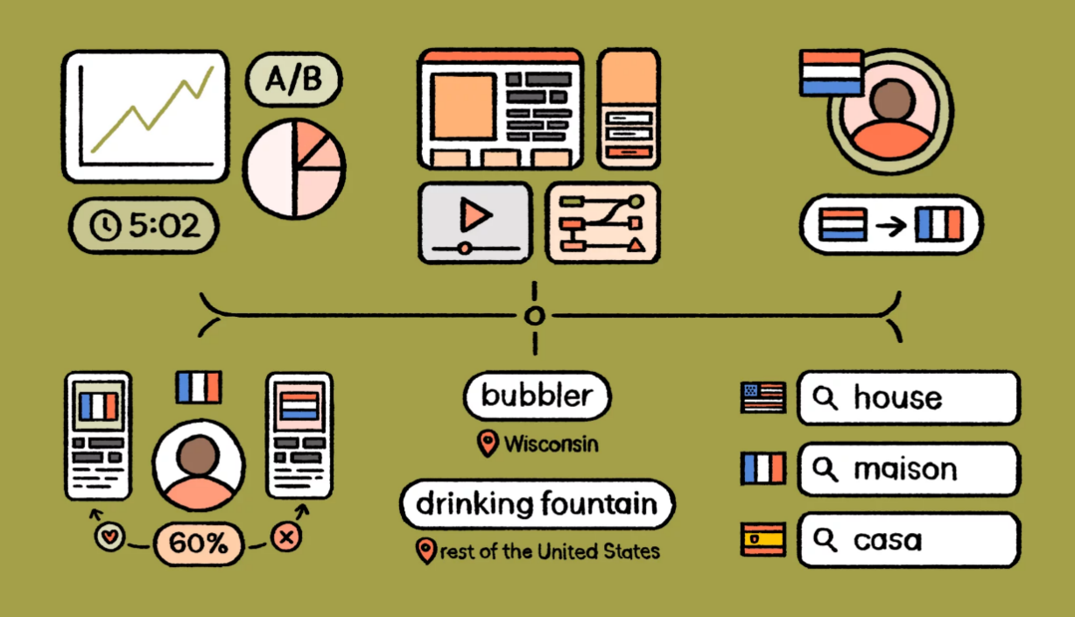
Source: https://lokalise.com/blog/marketing-localization/

Conclusion & Recommendations

It's not sufficient for the tourism hubs of the future to just offer a working environment with desks and Wi-Fi; they must create a digital experience that not only remains seamlessly connected to the culture of the place but also gives rise to a shared feeling of productivity and community. Apart from the above-mentioned communication channels, this is the perfect set of components that, when put together, represents a full-colour picture of how to draw in, hold, and serve digital nomads. This strategy on the communication journey through such channels as email, chatbots, web content, onboarding kits, etc., and the privacy and safety protocols it sets up is the best way representatives can address digital nomads' needs to the maximum.
Next Steps:
- Implementation Roadmap: According to the technical complexity and user impact, determine the priority of the projects (e.g., it will be a good idea to send the initial email campaigns at the same time when the landing page is launched).
- Technology Stack Selection: Examine CRM (e.g., HubSpot, Mailchimp), chatbot platform (e.g., Intercom, Drift), and CMS (e.g., WordPress, Webflow) integrations.
- Pilot & Iterate: Plug one hub, get feedback both qualitative and quantitative, revise the copy and flows, and then and only then expand to the global level.
- Governance & Maintenance: Entrust a main owner of the content calendar, assign the “local champions” to keep the regional resources up to date, and establish a schedule for multilingual audits.
The rental of such a strategy as expressed here would set new and upcoming tourism places as primary targets for the increasing community of digital nomads around the world, creating not only the available working space but also the vibrant, culturally accommodating experiences that tirelessly feed long-term customer loyalty.

10. References:

Global Workplace Analytics. (n.d.). Latest work-at-home/telecommuting/remote work statistics. Retrieved May 26, 2025, from https://globalworkplaceanalytics.com/telecommuting-statistics
World Economic Forum. (2024, October). How digital nomads can transform tourism and the economy of Small Island Developing States. Retrieved May 26, 2025, from https://www.weforum.org/stories/2024/10/how-digital-nomads-can-transform-tourism-and-the-economy-of-small-island-developing-states/
Intercom. (n.d.). Use Fin AI Agent in multiple languages. Retrieved May 26, 2025, from https://www.intercom.com/help/en/articles/8322387-use-fin-ai-agent-in-multiple-languages
Mailchimp. (n.d.). Email marketing benchmarks and metrics businesses should track. Retrieved May 26, 2025, from https://mailchimp.com/resources/email-marketing-benchmarks/
Nomads.com. (n.d.). Best places to live for digital nomads. Retrieved May 26, 2025, from https://nomads.com/
HubSpot Community. (n.d.). Email automation and deliverability best practices. Retrieved May 26, 2025, from https://community.hubspot.com/t5/Tips-Tricks-Best-Practices/Email-Automation-and-Deliverability-Best-Practices/m-p/675998
Slack. (n.d.). Slack is the place for remote work. Retrieved May 26, 2025, from https://slack.com/solutions/remote-work
Cybersecurity & Infrastructure Security Agency. (n.d.). Cybersecurity best practices. Retrieved May 26, 2025, from https://www.cisa.gov/topics/cybersecurity-best-practices
Dropbox. (n.d.). Secure cloud storage for all your files. Retrieved May 26, 2025, from https://www.dropbox.com/features/cloud-storage
United Nations World Tourism Organization. (n.d.). Digital transformation. Retrieved May 26, 2025, from https://www.unwto.org/digital-transformation
Grunig, J. E., & Grunig, L. A. (2000). Public relations in strategic management and strategic management of public relations: Theory and evidence from the IABC Excellence Project. Journal of Public Relations Research, 12(1), 1–28. https://doi.org/10.1207/S1532754XJPRR1201_1

World Economic Forum. (2024, January). Remote digital jobs are expected to rise 25% to 92 million by 2030. Retrieved May 26, 2025, from https://www.weforum.org/stories/2024/01/remote-global-digital-jobs-whitepaper/

